**AcoustiQ: Acoustic Chamber Intercom**

Final Report

**Team Name: Hertz So Good**

Members:

Kayla Gardner, Nikolas Gonzalez, Neftaly Lara, Moises Loera Martinez, Thomas Tran

Date:

May 7, 2025

**Work Contribution**

|  |  |  |  |  |  |  |  |  |
| --- | --- | --- | --- | --- | --- | --- | --- | --- |
| **Component** | **Contributor(s)** | **Component** | **Contributor(s)** | **Component** | | | **Contributor(s)** | |
| Acknowledgements | Kayla | Engineering Requirements | All | Final Design | | | | |
| Abstract | Kayla, Neftaly, Moises | Objective Tree | All | *System Descriptions* | | All | | |
| Overview | | Engineering Design Alternatives | All | *Circuit Designs* | | Niko | | |
| *Goals* | All | Design Alternatives Evaluation Criteria | All | *Printed Circuit Boards* | *CAD Designs* | All | Neftaly | |
| *Needs Statement* | All | Selection of Design Alternatives and Justification | All | Product Cost Analysis and Budget *(Bill of Materials)* | | Kayla | | |
| *Objective Statement* | All | Preliminary Design | All | Task Allocation and Timeline | | | Kayla | |
| *Basic Theory* | Moises, Niko, Thomas | Testing | | Contribution of Work & Lessons Learned | | | All | |
| *User Survey* | All | *Unit* | Moises | Conclusions | | | | |
| *Marketing Requirements* | All | *Integration* | Niko | *Introduction & Future Improvements* | *CAD Designs* | | Kayla | Neftaly |
|  | | *Acceptance* | Thomas | User Manual | | | Thomas, Neftaly | |
|  |  |  |  | Proofreading, Formatting | | | All | |

## Acknowledgements

We gratefully acknowledge the invaluable support and guidance provided by Dr. Ryan Corey, as well as the mentorship and expertise of Ph.D. students Rashen Fernando and Rajesh Rameshbabu throughout the development of our acoustic chamber communication system. Their insight, encouragement, and patience were instrumental to our success.

We also extend our sincere thanks to Dr. Renata Revelo Alonso for her ongoing support, and to Ms. Elsa Soto, Director of Equity and Inclusion in Engineering Programs, for her dedication to fostering inclusive opportunities in engineering.

Special thanks go to Mr. Anthony Flowers from the ECE Project Labs, the UIC Senior Design Laboratory, and the UIC Makerspace for their generous technical assistance, access to resources, and collaborative spirit. This project would not have been possible without their contributions.

# Table of Contents

Abstract 5

Overview 6

Project Goals 6

Needs Statement 7

Objective Statement 8

[Background](#_Background ) 8

Research Survey 8

Basic Theory  8

Current Solution 9

Limitation of Current Design and Technology 9

Similarities and Differences Between Proposed Solutions and Current Products 10

Existing and Relevant Patents and Designs 10

[Competitors](#_Competitors ) 10

User Survey 11

Marketing Requirements  13

Engineering Requirements 14

Objective Tree 19

Engineering Design Alternatives 20

Team Member Contributions 20

Design Alternative Evaluation Criteria  22

Selection of Design Alternative & Justification  22

Preliminary Design 24

Testing 25

Unit Testing 25

Integration Testing 27

Acceptance Testing 28

Final Design 30

System Descriptions 30

Circuit Designs & Features 32

Printed Circuit Boards (PCBs) 43

Product Cost Analysis and Budget  48

[Contribution of Work](#_Contribution_of_Work ) 50

Lessons Learned 54

Conclusion 57

Future Improvements 57

CAD Designs 58

[Works Cited – Background Research](#_Works_Cited_(Background)  59

[Work Cited – Engineering Requirements](#_Works_Cited_(Engineering) 61

[Works Cited – Design Alternatives](#_Works_Cited_(Design) 64

[Works Cited – Preliminary Design](#_Works_Cited_(Preliminary)  65

Appendix A – User Interview 66

Notes from 10/9 Meeting with Dr. Corey 66

Note from 9/25 Meeting with Dr. Corey 70

Appendix B – Concept Map 71

Appendix C – Individual Pairwise Comparisons 72

Appendix D – Datasheets  73

Audio Processor 75

Speakers 76

Amplifier 77

Antenna 79

[Microphones](#_Microphones ) 80

Gooseneck 80

Electret 81

Battery  82

Appendix E – Team Task Management Document  86

Appendix F – Task Allocation and Timeline 98

Appendix G – User Manual 105

User Manual for Acoustic Chamber Intercom 105

Table of Contents 105

Introduction 106

System Overview 106

Safety Instructions  106

Components Overview  107

Troubleshooting 109

Maintenance Guide for Acoustic Chamber Intercom  113

General Precautions 113

Battery Maintenance  113

Audio System Maintenance  114

Communication System Maintenance  115

Power Supply Maintenance  115

[PTT Switch](#_6._Push-to-Talk_(PTT)) 116

Technical Schematic  117

# Abstract

Our interdisciplinary team, collaborating closely with Dr. Ryan Corey, the director of the Listening Technology Lab (the Lab), is currently developing an innovative wireless communication system intended to replace the outdated Motorola PIP11 Audio Monitor currently utilized in the acoustic chamber. This new system, named AcoustiQ, aims to enhance the functionality of the Lab while advancing research initiatives at both UIC and the Discovery Partners Institute. The existing audio monitor is limited by inadequate sound quality and functionality, primarily due to the chamber's meticulously engineered sealed construction and robust steel walls, which interfere with its Bluetooth connectivity and voice transmission. The user interface of the PIP11 is unintuitive, making device pairing difficult and time-consuming. AcoustiQ provides reliable half-duplex audio transmission between an external observation unit and an internal device located within the chamber, maintaining the chamber’s integrity throughout its use. In our design, the external device continuously receives and processes audio signals from a secondary unit inside the chamber when activated, with a focused emphasis on enhancing the intelligibility of human speech sounds—an essential component for effective communication during research sessions. To enhance usability, there is an option to select from three LED indicator buttons corresponding to the clearest and least congested frequencies within the 2.4 GHz band, optimizing their auditory experience. Additionally, the system includes a push-to-talk feature that enables researchers outside the chamber to communicate with participants inside, active solely during specified communication to eliminate any background noise. The design incorporates audio output capabilities to headphones and internal or external speakers, catering to a diverse array of research requirements and preferences. The materials used for construction, sourced from the UIC Makerspace, are selected for their durability and reliability, ensuring the system can withstand extensive use. Importantly, our design prioritizes user-friendliness and seamless connectivity. We anticipate the intercom system will maintain low latency for real-time voice communication with less than a 100-millisecond delay. By focusing on enhancing audio clarity while minimizing noise interference, we aim to create an effective communication tool that is both cost-effective and scalable, effectively addressing the limitations of existing consumer-grade solutions. It not only represents a significant technological advancement for the Lab but also sets a new benchmark for research in auditory technology.

# Overview

## Project Goals

*We aimed to develop and implement a tailored and scalable communication system for an acoustic chamber that wirelessly transmits reliable and high-quality sound, prioritizes user friendliness, and can be used as a long-term solution.*

**Tailored**: Since the acoustic chamber in question is used strictly for research purposes, it is unique in its needs (it differs, for example, from a baby monitor, recording studio, or intercom system). We wanted to ensure that we addressed the specific needs of the Listening Technology Lab headed by Dr. Ryan Corey.

**Scalable**: While reliable communication is at the forefront of our project, we wanted to give ourselves room to grow by creating a modular system that allows for expansion. We wanted to ensure that we would be able to add peripheral devices and additional features as we progressed with the project (e.g. LED indicator lights, allowing use of personal speakers and microphones, etc.).

**Communication system**: The system has two components - one outside the acoustic chamber (the primary device) and one inside the acoustic chamber (the secondary device). We aimed to create two distinct devices that serve the specific purposes and requirements for outside and inside the acoustic chamber.

**Wirelessly**: For the acoustic chamber to work effectively, it has to be sealed – this means that wires cannot be used (since holes or similar openings would be required). We aimed to implement a system that transmits audio from the primary device to the secondary device via Bluetooth, Wi-Fi, or analog means.

**Reliable sound**: We aimed to create a solution that provides continuous audio transmission.

**High-quality sound**: We aimed to create a solution that reduces noise and feedback (in other words, a high Signal to Noise Ratio), in addition to ensuring the frequency spectrum of human speech is prioritized.

**User-friendliness**: While Dr. Corey and his research team will be the primary users for the acoustic chamber’s communication system, there will be visitors and secondary users with a variety of academic, technical, and cultural backgrounds. We wanted to ensure that the communication system is accessible to users outside Dr. Corey and his research group by prioritizing a user-friendly and intuitive interface that requires little to no training.

**Long-term solution**: Given the current lack of a permanent communication system for the acoustic chamber, there is a need for one that can be used beyond just a “placeholder.” We aimed to create a communication system that is easy to maintain and is made to last for years.

## Needs Statement

Research in acoustic chambers requires seamless communication to ensure proper experimentation progress, yet current communication solutions within these environments present limitations. This is especially the case for the acoustic chamber located in SELE 4053, the Listening Technology Lab, where Dr. Ryan Corey and his research team in the ECE department currently conduct their research. The acoustic chamber is a new addition to the laboratories on campus and will eventually provide the greater UIC community with the facilities to conduct research in audio and acoustic engineering, audiology, and more. While construction of the acoustic chamber has been completed, the technology used to conduct experiments is still in progress - and that progress currently takes the form of a $50 Motorola PIP11 Audio Monitor, a baby monitor, purchased online.

Acoustic chambers in general are few and far in between, and this is due to the exceptional cost associated with their construction and maintenance. They are often constructed with thick, steel walls and acoustic paneling to isolate sound, thus making traditional wired communication systems impractical due to the need for full chamber closure during experiments. The most affordable solutions for communication to/from acoustic chambers usually require wired systems, even on a small scale, due to the reliability and quality obtained from wired systems [1]. Wired communication systems are the norm in many acoustic chamber applications, such as recording studios, but they cater to different requirements. Additionally, existing wireless systems, like audio monitors and intercoms, are not designed for the specialized demands of research. As the need for efficient, user-friendly and visually presentable communication systems increases in laboratory settings, a suitable wireless solution tailored to the needs of research-focused acoustic chambers is required to ensure optimal usability and accessibility.

## Objective Statement

The objective of this project is to enable communication and exchange of auditory information between two acoustically isolated environments. This project's particular environment in focus involves an acoustic chamber and an observation station. There will be a communication hub at the observation station (primary device) and there will be a communication unit inside the acoustic chamber (secondary device). These devices must wirelessly transmit and receive audio signals from one another. The primary device must continuously receive audio from the secondary device inside the chamber when enabled. It must also enable parties at the primary device to push to talk into the chamber to the secondary device when needed. The primary device must reliably pick up all noises occurring inside the chamber (with an emphasis of the frequency spectrum of speech), process these signals to enhance the quality, and transmit this data to the primary device for the station to receive, process, and play through its built-in speakers. Current options on the market are expensive (offering unnecessary features), unreliable, and/or are less tailored to such a specific application. Our design focuses on establishing a wireless means of communication that is easy to use and delivers high quality audio performance.

## Background

### Research Survey

#### Basic Theory

At its most basic level, our product is an intercom, which “is a general term to describe a voice communication system or device that allows people in different locations to speak to each other” [4]. The device will enable two-way communication between two rooms separated by a 4-inch steel wall and 4-inch sound proofing material using Bluetooth Low Energy, Wi-Fi, or analog (RF) technology. To overcome the challenge of signal interference caused by the steel, the design will take advantage of the observation window in the wall, which can serve as a less obstructed path for wireless signals. By positioning the transmitters near the window, we aimed to maintain a reliable, low-latency connection for real-time voice communication.

#### Current Solution

The acoustic chamber located in the Listening Technology Lab in SELE 4053 is currently using a Motorola PIP11 Audio Monitor, a baby monitor, to provide communication between the inside and outside of the acoustic chamber. The baby monitor is difficult to set up and use, produces excessive feedback due to the proximity between the receiver and transmitter, has low volume levels, and must be connected to an outlet to power each device. In recording studios, which have a similar setup as the acoustic chamber, communication is achieved through the use of wired microphones and headphones connected to a mixer that the operator can control. Due to the construction and purpose of the acoustic chamber, wired solutions are not a viable option.

#### Limitations of Current Designs and Technology

Most baby monitors on the market provide few options for the user. Typically, there is one device that acts as the speaker/monitor, while the other device is strictly for voice or video input purposes. There is no 2-way communication between the devices, which is necessary for our project. Another limitation is the type of communication protocol: if the monitors send data through Wi-Fi, then the device must be plugged in due to the power consumption of the signal. If the device uses Bluetooth or RF (radio frequency) then you need to take account for environment interference and lower data communication [5][6].

All devices that use the 2.4GHz band such as Wi-Fi, Bluetooth and RF [5] are categorized under Industrial, Scientific, and Medical (ISM). The reason why these devices use the 2.4GHz band is because it is unlicensed, meaning that there are no special laws or regulations to use this frequency. But there are downsides to ISM - “coexistence problems between Wi-Fi and Bluetooth Low Energy (BLE) signals are especially significant due to their shared frequency band, which often leads to interference and a reduced performance for both systems.” [7]

Since there is a known issue with these devices sharing the same band, there have been multiple studies on how to combat these. In one study done using MATLAB simulations, it was found that “the bit error rate is reduced when Es/No (Energy per Symbol to Noise Power) is increased resulting in improvement in the error performance. We have also shown that both Bluetooth and Wi-Fi packets can coexist, without interference, by properly setting the model parameters such as timing offset, Es/No, packet data rate and bandwidth.” [8]

#### Similarities and Differences Between Proposed Solution and Current Products

Like existing products, our concept makes use of the 2.4 GHz band, or unlicensed frequencies, to achieve communication between the interior and exterior of the acoustic chamber. Our device makes use of a lot of the same technology as current wireless communication systems (transducers, ADCs, DSPs, transceivers, etc.) to exchange audio signals. A difference between our concept and current systems is the application. The research and academic setting have very distinct parameters in comparison to the household or studio setting. Thus, given the unique research needs and the structural limitations of the acoustic chamber, a specialized device system is needed. Further specialization will also be achieved by making the communication system programmable through the use of switches to better suit the users' more frequently used modes of operations (push-to-talk, open mic, mute, etc.).

#### Existing and Relevant Patents and Designs

The patent “Baby monitor system” by Graco Children's Products Inc [11], is identical to the device system that we designed. The patent shows a product that has a parent unit and one child/nursery unit. The parent unit is like most baby monitors on the market where a speaker and LED unit shows battery life. One feature of this patent is that the parent unit uses a dock to charge, thus making it portable and easy to carry around. On the nursery unit, there is a one-way microphone to the parent unit. Also included is a parent finder button where, after the button is pressed, a signal will be sent to the parent unit to emit a sound to make the parent unit easier to find.

This patent thoroughly explains the different button functionalities and other features of each of the devices. It also goes through the circuit components, circuit diagram and flow charts that explain the security and how data transfers between the devices.

#### Competitors

One of the biggest players in the audio monitoring space is Vtech, who primarily produces children's electronics such as toys, phones, watches, and baby monitors. Vtech produces a wide range of baby monitors from voice-only radio style monitors to full camera monitor setups [9].

Another wireless communication protocol that has been emerging is Push-to-Talk over Wi-Fi. This service provides a range of up to 100 miles [10], as long as one of the walkie talkies is connected to Wi-Fi or cellular data. The voice communication is advertised to be as seamless as the radio version. One company that appears on top of search results for this technology is Hytera US Inc.

### User Survey

This survey seeks to gather valuable insights from Dr. Ryan Corey to guide the enhancement of the acoustic chamber in the Listening Technology Lab. Our inquiries focus on critical aspects such as functionality, appearance, cost, user interface, reliability, and power requirements—key factors in refining the communication and sound-testing system device(s).

i. **Functionality**

*Accurate Sound Testing*: The chamber should provide highly accurate sound measurement, minimizing or maximizing sound reflection (depending on the user's presence inside/outside the acoustic chamber).

*Control of Noise and Vibration*: Isolate external noise feedback and vibration to ensure authentic testing results. Minimize unwanted interference when experiments are underway.

*Adaptability*: Conduct various noise mitigation scenarios where sound source localization, speaker performance, and noise measurements are applicable.

ii. **Appearance**

*The Chamber*: Typically, the exterior is industrial-looking, often with thick, steel insulated walls, soundproof doors, and durable panel finishes. The acoustic chamber in the Listening Technology Lab has a window used for observation and directed signal propagations. The primary device will be placed outside the chamber near the window and the secondary device will be placed in an optimal position in the chamber according to the research being conducted.

*The Device*: The device should maintain an appearance belonging to a professional setting. The design of the primary device can most closely resemble a studio synthesizer with an incorporated display/LEDs to relay information (modes, connection, errors, etc.). The design of the secondary device will be minimal and could include an indicator LED.

iii. **Cost**

The cost of this device should remain in the $250 budget for the project.

iv. **User Interface**

An intuitive user-interface design with easy-to-use controls (to manage sour sources, power the device on/off) will be prioritized. If time allows an expansion of the design to include preset test modes for noise mapping and speaker testing will be considered.

v. **Reliability**

*Consistent Performance*: The chamber should offer long-term reliability, ensuring repeatable and consistent sound measurements without degradation in acoustic properties over time.

*Affordability*: If needed, replacements are inexpensive and plentifully supplied from third party manufacturers.

vi. **Power Requirements**

*Low-to-Moderate Power Consumption*: Use of Buck or Boost Converters to assist in power supply. The secondary device should maintain power for a few hours (minimum three) before requiring recharge.

## Marketing Requirements

Marketing requirements are concise statements that outline what a product should achieve, focusing on the customer’s needs without specifying how the product will accomplish them. For our project, the marketing requirements reflect the essential features needed to create a reliable, user-friendly communication system for an acoustic chamber. The main categories are wireless communication and reliability, user-friendly interface design, portability and power management, structural integrity, and audio quality.

1. The transmission of audio from the primary device to the secondary device and vice versa must be wireless.
2. The connection between the primary device and the secondary device must be reliable.
3. The user interface for the primary device and the secondary device must be clearly labeled and possess discernable controls.
4. The secondary device must be portable for room configuration purposes in the acoustic chamber.
5. The secondary device must maintain power for a minimum of three hours.
6. The primary device and the secondary device must maintain structural and operational integrity if they experience impact, electrical surge, spill, or other unforeseen operational hazards.
7. The devices should output clear audio from their respective output peripherals (e.g., speakers).
8. The communication system must be half-duplexed.
9. The system must comply with university and laboratory safety standards.
10. The system should maintain user privacy and respect ethical research standards.
11. The system must be easy to use, with minimal training required for operation and maintenance.
12. The system must ensure equal accessibility for all users.
13. The system must adhere to electromagnetic compatibility (EMC) standards to prevent interference with other research equipment.

# Engineering Requirements

Engineering requirements are concise, technical statements that define what a design must accomplish - they must be abstract, verifiable, unambiguous, and traceable. The engineering requirements translate customer needs (the marketing requirements) into specific design goals. For our project, the engineering requirements focus on key areas such as wireless communication, system reliability, user interface clarity, device portability, and power management (see Table I). They also address the need for structural integrity, clear audio quality, half-duplex communication, compliance with safety standards, user privacy, ease of use, and accessibility for all users. Together, our engineering requirements ensure that our project meets both technical and user-oriented goals.

Table I

Engineering Requirements

|  |  |  |  |  |
| --- | --- | --- | --- | --- |
| **No** | **Marketing Requirement**  **Reference** | **Engineering Requirement** | **Justification** | **Standard** |
| 1 | #1 | The system shall use wireless communication protocols to establish connections while adhering to local wireless frequency regulations. | Ensures audio transmission between devices is wireless. | ISO/IEC/IEEE 29148:2018 (E) 9.5.4.2 [9] |
| 2 | #2, #11 | The system shall include self-diagnostic tools capable of detecting and identifying wireless connectivity issues. These tools shall alert users of potential faults, provide troubleshooting information, and log errors for maintenance purposes. | Ensures the system wireless connectivity faults can be diagnosed and repaired to maintain a reliable connection between devices. | ISO/IEC/IEEE 29148:2018 (E) 9.5.9.2 [9] |
| 3 | #11, #12 | The system shall feature a modular design, allowing components such as batteries, speakers, buttons, and microphones to be easily repaired or upgraded by non-technical users with a mean time to repair/replace of 30 minutes, without the need for specialized tools. | Ensures long-term usability and reduces the need for specialized maintenance, aligning with user needs for a lasting solution. | ISO 9241-210:2019 [21], ISO/IEC/IEEE 29148:2018 (E) 9.5.9.2 [9], ISO/IEC/IEEE 24748-1:2018 (E) [12] |
| 4 | #1, #8 | The system must implement half-duplex communication, bidirectional speech, and restrict simultaneous, overlapped speech. | This will strengthen the flow of organized communication and mitigate any errors. | ISO/IEC 11801 (Information Technology – Generic Cabling for Customer Premises) [26], IEEE 802.11 (Ethernet Standards) [2], ISO/IEC/IEEE 29148:2018 (E) 9.5.5 [9] |
| 5 | #2, #7 | The intercom system should maintain low latency for real-time voice communication with a <=100 ms delay. | Ensure the intercom system maintains low latency for real-time voice communication with a delay of less than 50 ms, it is essential to utilize high-speed transmission protocols and efficient encoding methods. | ISO/IEC/IEEE 29148:2018 (E) 9.5.7 [9] |
| 6 | #6, #9 | The system must utilize communication protocol compliance with ISO/IEC 24792 for data integrity and legal requirements for real-time data transfer reliability in applications, in accordance with ISO 26262 for functional safety of electronic systems. | Ensures the communication systems respects the privacy of users and prevents unauthorized access to audio streams. | ISO 26262-1:2018 [1], ISO/IEC 27001:2013 [11] |
| 7 | #5 | Ensure that the wireless intercom system adheres to energy efficiency standards as outlined in IEEE 1680, reducing power consumption during both active and standby modes. | By using low-power hardware, optimized communication protocols, and efficient power management, the system will operate effectively while adhering to sustainable practices. | IEEE 1680 [23] |
| 8 | #5 | The primary system will operate with a supply voltage of 5V – 12V. | The system can receive power from various sources. | IEC 62368-1 [19] |
| 9 | #5 | Both devices will be powered/charged via a USB receptacle. | Complies with the available supply current given the use of USB. | Universal Serial Bus Power Delivery Specifications [8] |
| 10 | #5 | The secondary unit(s) must maintain a three-hour battery life minimum including evident battery status indicator to prevent immediate shutdown that could disrupt active research, safe system use or routine maintenance. | The indicator light will call attention to the operator to address the low power status of the secondary unit. | ISO/IEC/IEEE 29148:2018 (E) 9.5.9.2 [9] |
| 11 | #4 | The secondary unit(s) must be portable and configured for safe, ergonomic manipulation using safety labels and non-slip grips to diminish risk during movement or interior panel repositioning and is compliant with ISO 20653. | Ensures that the secondary unit can be handled, transported, and used safely to prevent potential injury or damage and compliance with occupational safety regulations. | ISO 20653 [18] |
| 12 | #6 | Both primary and secondary unit(s) shall maintain structural and operational integrity in occurrences of electrical surge(s) and physical impact such as a 5ft fall to protect users and minimize health risks associated with hazardous equipment failure. | Ensures that the system is durable to withstand several types of damage and impacts without the fear of breaking. | ISO/IEC/IEEE 29148:2018 (E) 9.5.5 [9], IEC 60068-2 [17], ISO 20653 [18] |
| 13 | #7 | The system shall achieve a signal-to-noise ratio of at least 70 dB for audio transmission and incorporate filters to isolate the speaker's voice. | Ensures dependability, clear communication, ambient noise interference, and enhances safety. It also ensures compliance with ISO 1996-1, IEC 61672-1, and ISO 3382. | ISO/IEC/IEEE 29148:2018 (E) 9.5.5 [9],  ISO 1996-1 [28]  IEC 61672-1 [27]  ISO 3382 [29] |
| 14 | #12, #11 | The system must have an intuitive user interface accounting for first-time users where system start-up is efficiently operational within 30 seconds and key features are limited to three enablement directives ensuring user-friendly accessibility. | Ensures the user interface accommodates first-time users accounting for reduced setup time which is crucial for efficiency in laboratory environments. By limiting key features to three straightforward directives, user accessibility is enhanced allowing for seamless engagement for all users supporting inclusive and productive user workflow and minimal user error. | ISO 9241-11:2018 [6], ISO/IEC 25010:2011 [3] |
| 15 | #3, #11, #12 | This system shall include physical pushbuttons (i.e., power on/off, volume up/down) that are clearly labelled and ergonomically placed with universally recognized symbols, ensuring intuitive use without language barriers. | Ensures intuitive control, minimizing cognitive load for users, allowing even unfamiliar users to operate the system without training. Ensures inclusivity and usability in multicultural research settings, reducing confusion or misinterpretation. | ISO 9241-210:2019 [21] |
| 16 | #12 | The system shall avoid using culturally insensitive terminology, symbols, or colors that could be misinterpreted or cause discomfort, with color schemes adhering to guidelines on user-friendly web design and cultural sensitivity. | Ensures cultural sensitivity, which is vital for global research teams, avoiding alienation of users or inappropriate symbols. | ISO 9241-151:2008 [14] |
| 17 | #6 | The system shall provide real-time visual and/or auditory feedback (e.g., LED indicators and confirmation tones) within 0.25 seconds of a user action (e.g., button press). | Immediate visual feedback ensures users are aware of system status, reducing uncertainty and operational errors. Ensures the system interface shall be compliant with the Americans with Disabilities Act (ADA). | ISO 9241-125:2017 [16], ADA Compliance [24], ISO 9241-171:2008 [14] |

## 

## Objective Tree

The Objective tree illustrates the primary goals for the communication device (see Figure 1). At a high level, **ease of use**, **wireless capability**, and **quality audio performance** are the core focus areas for improvement of the current solution. Each of these main objectives is further broken down into sub-goals, which address critical design aspects such as **maintainability**, **functionality**, and **reliability**. This hierarchical structure, known as an objective tree, organizes the needs based on functional similarities and assigns relative weights to each, ensuring that all key user and performance requirements are effectively prioritized in the device's design.

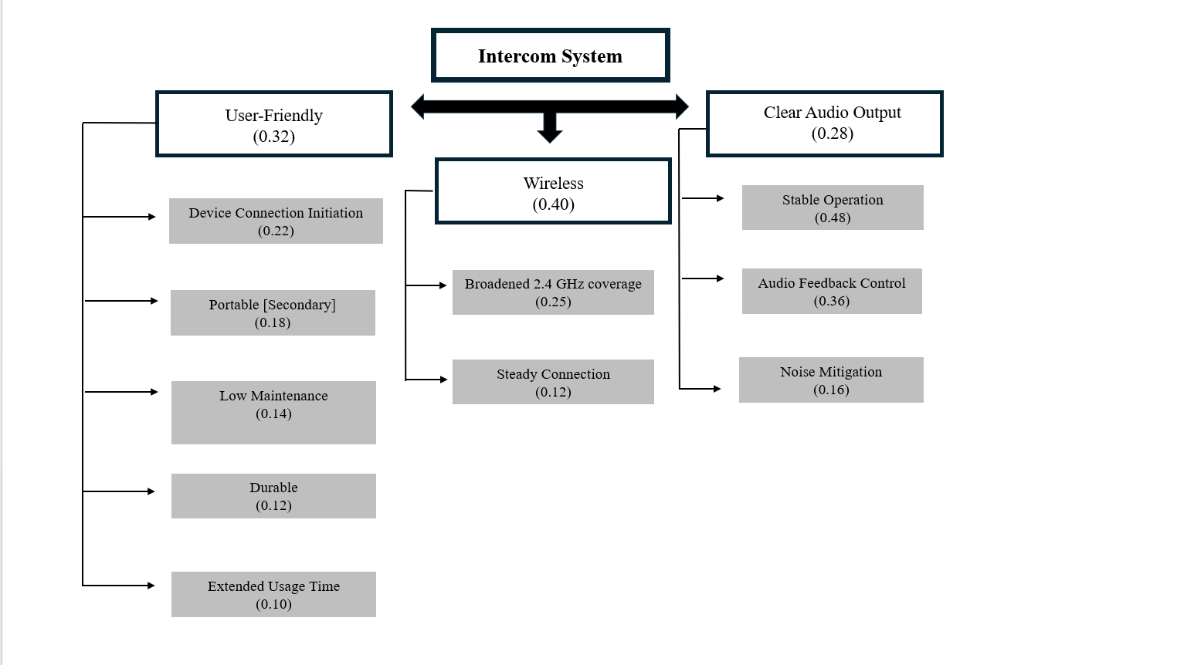

Fig. 1. Goals.

# Engineering Design Alternatives

In Appendix B, the concept map for the Acoustic Chamber intercom system is presented. This content is visually represented for the primary and secondary systems, which provides a high-level overview of three design structures emphasizing functionality and key components. Also, the graphics will help configure the Level 0 schematics, detailing the specific inputs and outputs to emphasize similarities and differences across all options curated by the team.

## Team Member Contributions

Each team member contributed unique expertise to developing and refining the design alternatives, including:

1. **[Neftaly Lara]**: I contributed by creating a level 0 schematic that shows analog signal transmission as a design alternative for the communication system. It highlights the pathway and components involved in transmitting an analog signal, from input to output, providing clarity on how analog methods can be integrated as a reliable option alongside digital alternatives. My work provided a comparative perspective that helped the team assess the strengths and trade-offs of using analog transmission relative to digital options, thus enriching our decision-making process and supporting a more comprehensive analysis of design alternatives.
2. **[Nikolas K Gonzalez]**: I collaborated with the group to create the concept map that conveys the different approaches to our design that we can take. I helped brainstorm different power supply options for both the primary and secondary device. Using the concept map generated in week 9, I was able to integrate these distinguishing design alternatives in the level 0 schematics.
3. **[Kayla Gardner]**: As an active team member, I contributed to integrating the Week 9 concept maps for both primary and secondary systems, focusing on refining functionality choices with a strong emphasis on UI/UX. I provided insights on control versatility to expand our design options and assisted in brainstorming additional alternatives, enhancing the overall adaptability of the system.
4. **[Moises Loera Martinez]**: I collaborated with the team to propose different functionalities and options to the design alternatives of the primary and secondary devices, specifically contributing to the power/battery, UI/UX, and wall mount options. I also provided input for the concept including the option of having both soft buttons and knobs/dials to better control certain modes and setting of the devices like volume control and power.
5. **[Thomas Tran]**: I collaborated with the team to find different project designs for the concept maps. Thinking about use cases and different functionalities of different item implementations such as battery, buttons and signal processor. I also helped guide the team to find the proper direction we need to move forward with the project. Whether it was to clear up any misunderstandings or to help find a solution to a problem that we did not previously think about.

# Design Alternative Evaluation Criteria

In Appendix C, our team established five key criteria: ease of use, suitability for the ECE 397 demo, time required for design and development, contribution to ECE education and resume enhancement, and the group's technical knowledge of the design alternatives. We incorporated each member’s ratings to develop the final decision matrix (see Table II), determining the optimal solution.

## Selection of Design Alternative & Justification

1. **[Neftaly Lara]:** Based on my own decision matrix and that of the team's, going with an analog approach best suits all our criteria. Aside from having previous knowledge gained in our coursework, analog would provide a more reliable transmission of audio while still allowing us to scale our project to include more advanced features. Given our faculty mentor’s (Dr. Corey) experience and expertise, choosing an analog approach would also provide us the opportunity to receive assistance and have a wider body of research to reference in our development of the communication system.
2. **[Nikolas K Gonzalez]:** It turns out from this week's assignment thatan analog communication system suits this project's application best. This project's focus is real-time audio transmission, and this is a well-traveled lane for analog communication systems. Generally, the other alternatives are more advanced in the noise cancelation, data encoding, and bandwidth, but, for our project's basic case, we can achieve a cost efficient, shorter time to develop, and easier to use communication system that is often less susceptible to interference than digital systems [3].
3. **[Kayla Gardner]:** An analog communication system is ideal for the acoustic chamber, offering user-friendliness, reliable ECE 397 presentation performance, and cost-effectiveness. Analog (RF) provides direct, real-time audio feedback with high sound quality and no Wi-Fi/Bluetooth interference. It simplifies development, using affordable, readily available components, and aligns with Prof. Corey’s recommendation as a practical upgrade from the inadequate baby monitor.
4. **[Moises Loera Martinez]:** An analog intercom system is better suited for our application because of its reliability, effective real-time voice transmission, ease of use, and simplicity in construction. Although Bluetooth was my highest rated choice, discussion with the team convinced me that an analog system checks all of Dr. Corey’s requirements and best satisfies all our criteria.
5. **[Thomas Tran]:** After discussing with the group, we have concluded that implementing an analogue intercom system was our way forward with this project. I had the same score for both Bluetooth and analog, so I was fine with either option. With analog there is little to no latency between the signals meaning real time communication and we would be less prone to software issues such as connectivity. While Bluetooth has the advantage of being able to scale up between multiple devices and more features such as noise cancelation.

Table II

Design Alternatives Pairwise Matrix

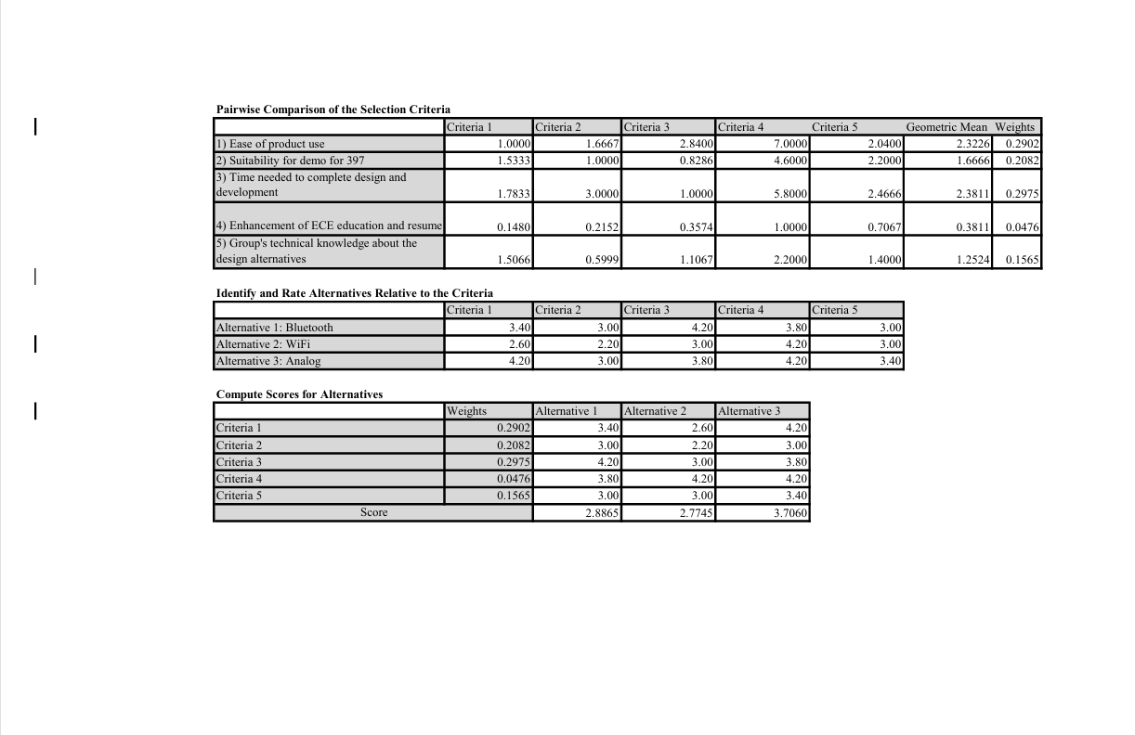

# Preliminary Design

This report presents the preliminary design of our system, focusing on the selected design alternative: an analog communication system (see Figures 3 and 4). This approach was chosen as it best aligns with the needs and requirements of the acoustic chamber intercom. The analog design and associated technical components establish a proof of concept that enables interconnected audio feedback with feasible sound quality and minimal interference. The system is structured to leverage both primary and secondary components to ensure reliability and functionality.

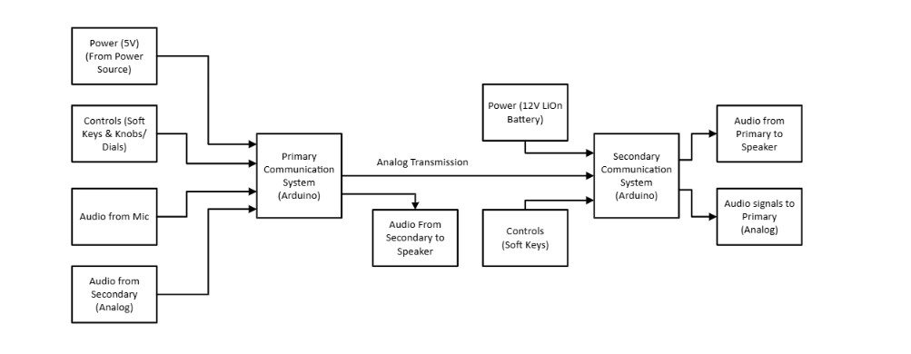Fig. 2. Level 1 Schematic.

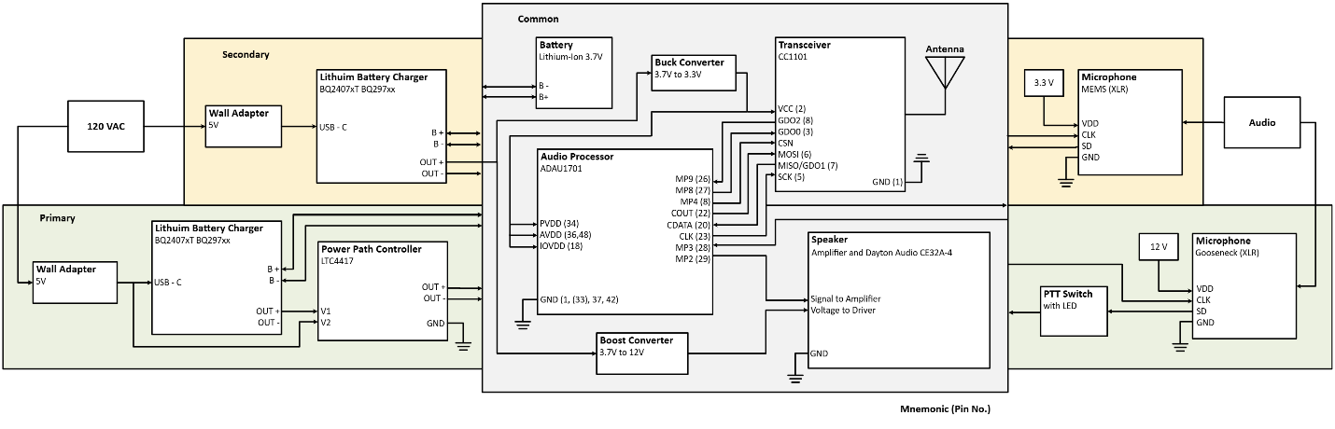Fig. 3. Circuit Design.

# Testing

## Unit Testing

The unit testing for this system focused primarily on the audio components, specifically the electret microphone and the speakers. The audio processor is designed to provide appropriate audio enhancements, while the audio and headphone amplifiers boost the low-power signals into larger signals to produce sound. Although the Gooseneck microphone was intended as the primary input device, it was not tested initially due to its higher cost. To avoid risking damage from incorrect wiring, testing was postponed. The off-the-shelf Gooseneck microphone is known to be functionally capable. Power delivery was verified in the lab using voltage measurements taken with a multimeter, which served as an indirect confirmation that power could be effectively supplied to the necessary modules.

**Ins**

**Electret Microphone**

The electret microphone, along with a pre-amplification circuit, was tested for functionality as shown in Fig. 4. We applied a 5V power supply from the lab, connecting the oscilloscope probes to the microphone output and ground. When sound was present, the oscilloscope displayed a sinusoidal waveform, indicating a 3.3V bias voltage. The clean periodicity of the waveform confirmed that the microphone was operational and effectively detected sound.

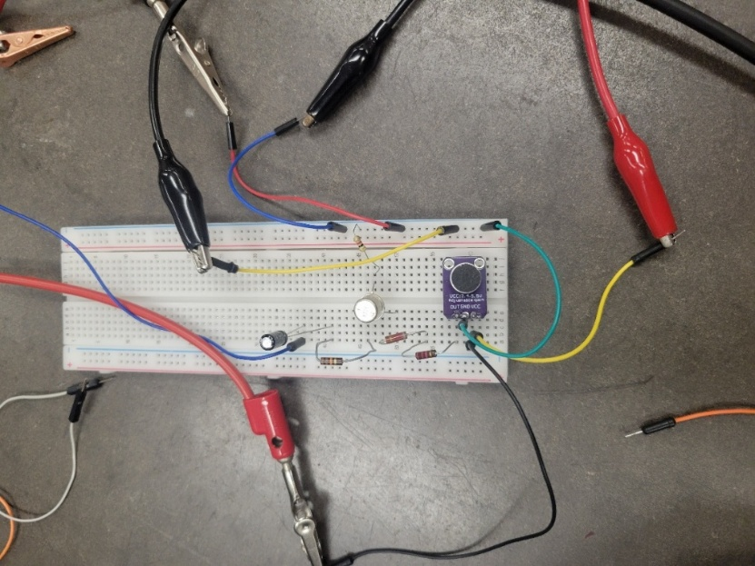  
Fig. 4. Electret Microphone Testing Setup

**Speakers**

The operation involves three speakers: two are designed for primary two-way communication, while one is implemented in the secondary device design. Each speaker was tested by first performing a continuity test with a multimeter to ensure there was a complete circuit. Next, we verified the impedance, which was found to be within 10% of its rated 4Ω. Finally, a waveform generator was used to assess the frequency response of the speakers, ranging from 100 to 10,000 Hz.

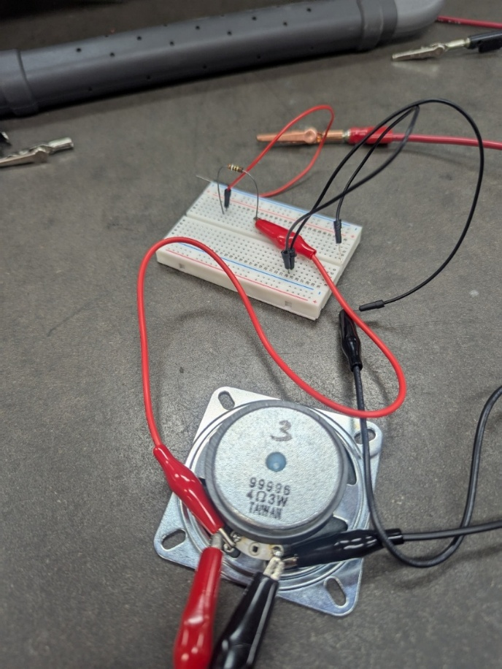

Fig. 5. Speaker Testing Setup

## Integration Testing

The first step we took in integration testing was to establish a wireless connection between devices. We began by integrating the microcontrollers (Arduino Nano ESP32) with the transceiver modules (NRF24L01+PA+LNA with SMA Antenna). The transceivers utilize the Serial Peripheral Interface (SPI) communication protocol. Since the microcontroller has default pins configured for this protocol, establishing the hardware and software connections between the devices was straightforward. We followed guidance from the Arduino IDE to include all necessary libraries and script commands. For simplicity, we conducted a push-button test to verify the connection. This test involved using a push button on one end to request a response from the other end. The output window on the Arduino IDE for the receiving system confirmed that the two systems had successfully established a wireless connection. Next, we incorporated a microphone (Electret Microphone with amplifier module) and a speaker amplifier module. Sticking to one-way traffic testing, we replaced the push button with the microphone module on the transmitting side and made the appropriate software adjustments. After confirming that the microphone was picking up audio signals, we moved to the receiving end and implemented the speaker amplifier module. Once we heard the audio signal from the transceiver side on the receiver side, we shifted focus on integrating the audio processor (ADAU1701) to clean up the signal. Due to several limitations*, we began designing and incorporating filters for the audio signal received through the mic. We proceeded to incorporate the power path controller module on the transceiver side and a USB-C breakout board on the primary side for power.

## Acceptance Testing

Based on our engineering requirements, we successfully accomplished a substantial portion of our goals within the allotted timeframe for this project.

### Engineering Requirements (1-5)

The Wireless Audio Communication System is engineered for reliability and user-friendliness, establishing connections through compliant wireless communication protocols (ER #1). We verified this by ensuring seamless connections at varying distances during startup. By using the NRF24L01, we operated within the 2.4 GHz frequency band, which allows us to avoid the necessity of filing for an FCC license unless we decide to commercialize our project.

The system features a modular design to simplify repairs and upgrades, incorporating components such as batteries, speakers, buttons, and microphones. This design allows for a mean time to repair or replace of just 30 minutes for non-technical users (ER #3). The casing for both the primary and secondary devices is designed with accessible screws and wide openings, making it easy to remove parts when necessary. Importantly, non-passive components like Arduinos, microphones, and speakers are not permanently soldered, allowing for straightforward part replacements. Communication operates in half-duplex mode, facilitating bidirectional speech while preventing overlapping transmissions (ER #4). We guarantee real-time voice communication with a latency of less than 100 ms (ER #5).

### Engineering Requirements (7-11)

Our testing indicated an average delay of approximately 50 ms, well within our target. The system complies with energy efficiency standards (IEEE 1680) and operates on a power supply ranging from 5V to 12V (ER #7, #8), being powered and charged via a USB receptacle (ER #9). All selected components typically function at a maximum voltage of 5V, and we observed full functionality when powered through a USB source. Designed for portability and safe handling, the secondary system includes safety labels and non-slip grips (ER #11). We ensured that the size is manageable while allowing sufficient space for internal components

### Engineering Requirements (Residual)

Additionally, warning labels on the device's back opening serve as a reminder not to open the system while active. The user interface is intuitive, enabling the system startup within 30 seconds and operation through three key directives (ER #14). Physical pushbuttons are clearly labeled with universally recognized symbols, enhancing usability (ER #15). The design avoids culturally insensitive elements, adhering to guidelines for user-friendly and respectful interfaces (ER #16). The system also includes self-diagnostic tools to identify and report connectivity issues (ER #2). Employing protocols compliant with ISO/IEC 24792 and ISO 26262 ensures data integrity, legal compliance, and functional safety (ER #6). The secondary units are designed to provide a minimum battery life of three hours, featuring a clear battery status indicator (ER #10).

Both primary and secondary units are ruggedized to withstand electrical surges and physical impacts, such as drops from up to 5 feet, ensuring user safety and system durability (ER #12). Audio transmission achieves a signal-to-noise ratio of at least 70 dB, with integrated filters to isolate the speaker's voice for enhanced clarity (ER #13). The system also provides real-time visual and auditory feedback within 0.25 seconds of user actions, with the interface operating in compliance with ADA standards (ER #17).

**Inse**

# Final Design

The final design is represented in a high-fidelity format as printed circuit boards (PCBs) that were manufactured based on the initial schematics made using Altium and 3D-printed casings designed using OnShape and printed at the UIC Makerspace. The PCBs include the following components: Audio Processors, Primary and Secondary Audio Amplifiers connected to designated speakers, a Headphone Amplifier, a Gooseneck Microphone with pre-amplification circuitry, an EEPROM, and a Power Path Controller. The intercom system employs the NRF24L01+PA+LNA transceiver module to link the primary external base station with the secondary internal unit for transmission and signal reception. Each PCB breakout has been tested for continuity, has had all components soldered, and has passed final unit testing. The materials used are listed in the Bill of Materials. Additionally, the software for the microcontroller units is documented and stored in a GitHub repository. The final 3D-printed design features two casings. The first casing is for the primary device, which includes push buttons, two speakers, and a gooseneck microphone. This casing has a detachable lid for easy access. The second casing is inspired by John Hancock Tower, reflecting the design of the Listening Technology Lab’s logo. It contains push buttons, one speaker, and has both a detachable backing and a top lid for necessary access. Both casings are equipped with appropriate power delivery entries.

## System Descriptions

The communication system integrates several key components to achieve high-fidelity, low-power, and reliable wireless audio transmission between devices. At the core of the system is the **ADAU1701JSTZ**, a 28/56-bit audio processor selected for its powerful DSP capabilities and built-in A/D-D/A conversion. It is responsible for signal conditioning and compensating for speaker and amplifier limitations, significantly enhancing overall audio quality. Controlling system operations is the **Arduino Nano ESP32**, a flexible and cost-effective microcontroller. All Arduino software programming has been stored on an **EEPROM**. It is ideally suited for unit and integration testing, supporting seamless hardware integration with peripheral components. In particular, the Arduino Nano ESP32 interfaces with the **NRF24L01+PA+LNA** transceiver module, enabling robust, bidirectional wireless audio communication across three selectable channels in the 2.4 GHz band. The NRF24L01+PA+LNA was chosen for its compact size, high transmission power, and integrated LNA for enhanced receiver sensitivity. Power management within the system is carefully designed to ensure both reliability and flexibility. The primary device is powered through a **USB Type-C port** capable of supplying 5V at 3A. An internal 3.3V buck converter steps down the voltage for the Arduino Nano ESP32 and associated peripherals while providing phantom power to the **TA312S Gooseneck Microphone**. The secondary device incorporates a **3.3V, 3Ah rechargeable lithium-ion battery** for backup operation but remains primarily powered through its USB Type-C connection. Audio amplification is handled by the **PAM8406DR**, a low-distortion, high-efficiency Class-D audio amplifier from an **MAX4466** **electret microphone** speech input. It was selected for its ability to drive system speakers reliably while minimizing power consumption, critical for maintaining extended operation under battery power. For headphone users, the **MAX97220 headphone amplifier** provides a clean and high-fidelity audio output. Its low-noise design and compact footprint eliminate the need for large coupling capacitors, contributing to a streamlined and space-efficient system layout. Together, these components form a scalable and robust wireless audio communication system optimized for quality, efficiency, and reliability in the Listening Technology Lab environment.

## Circuit Designs & Features

The circuit designs presented below were carefully developed using Altium Designer software. Fig. 7 illustrates the intricate schematic of the primary device, incorporating all essential subsystems. Fig. 8 displays the schematic for the secondary device, emphasizing its versatility—capable of operating via either a rechargeable battery or a standard wall power supply. This dual-power feature enables flexible deployment across various environments.

In contrast, the primary device is exclusively powered through a wall outlet, providing a stable and reliable energy source for continuous operation. A distinguishing feature of the secondary device, or external base station, is the inclusion of a headphone amplifier, which enhances audio performance and enriches the user experience.

Both designs share a cohesive embedded subsystem structure, underscoring the thoughtful engineering that supports their intended functionality. These detailed circuit schematics were developed over several weeks by our dedicated team, with careful optimization to ensure seamless integration with the printed circuit boards (PCBs) at the core of the acoustic chamber intercom system.

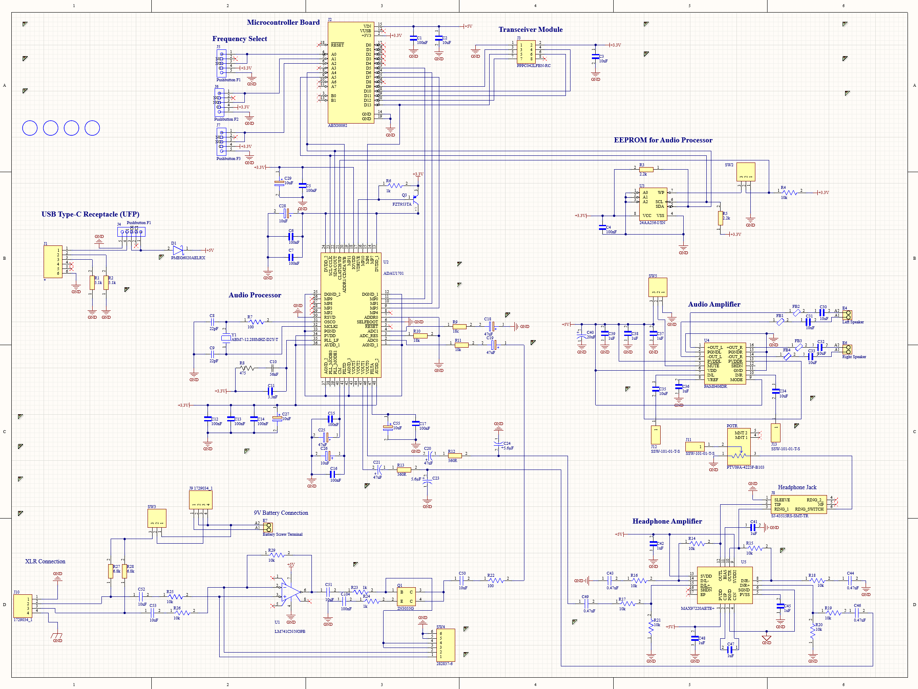Fig. 7. Primary Device Complete Schematic

The figure above shows the initial overall schematic of the primary device. Text blocks are placed near each respective subsystem, except for the microphone section in the bottom left corner. This schematic guided the design of a single printed circuit board (PCB) that integrated all subsystems; however, it was too expensive to manufacture and lacked modularity. In addition to the microcontroller and transceiver, we developed individual PCBs for each subsystem, and further details on each will follow.

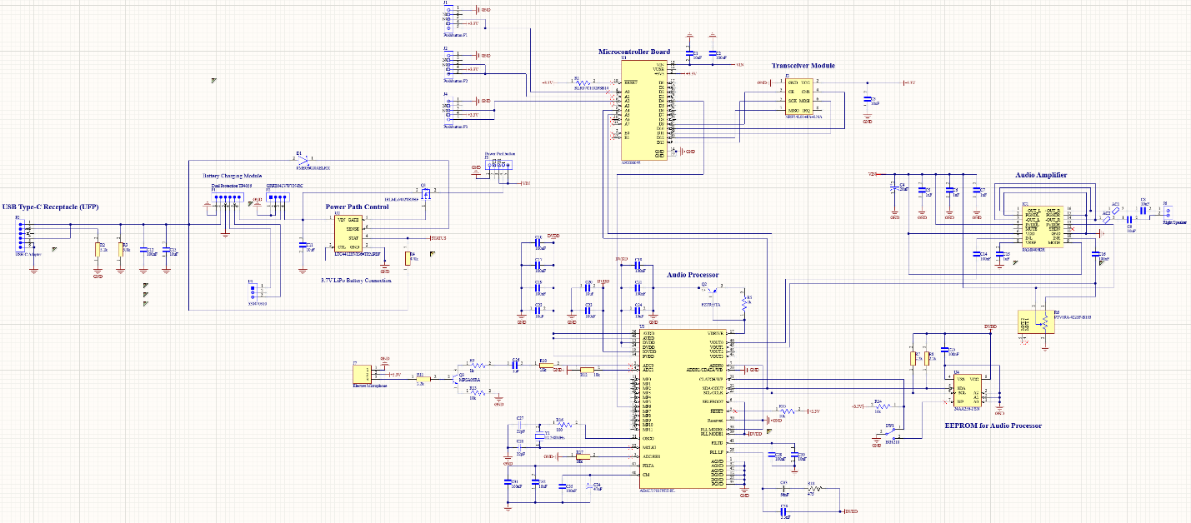

Fig. 8. Secondary Device Complete Schematic

Fig. 8 presents the schematic for the secondary device, highlighting key differences from the primary device. It includes a power path controller that allows power to be drawn from a wall outlet or battery. The schematic also features a different microphone and audio amplifier designed for speaker configuration. Like the primary device, each subsystem, except for the microcontroller and transceiver, has its own printed circuit board (PCB). More details are provided in the following figure descriptions.

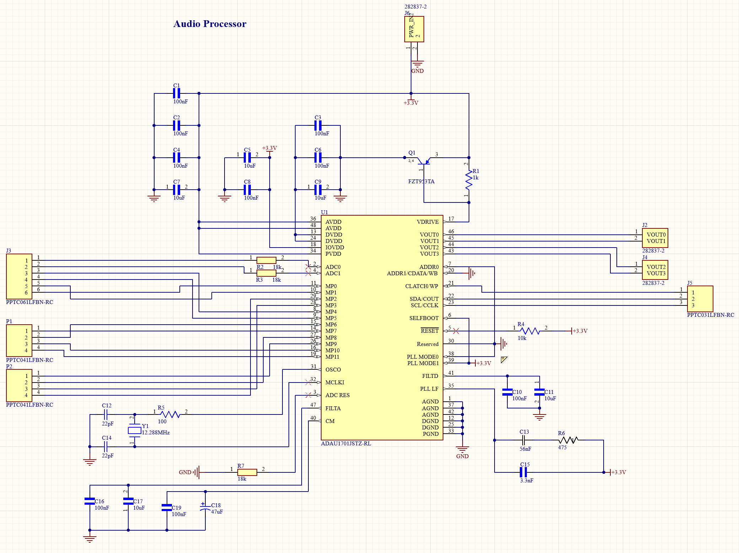

Fig. 9. Audio Processor Module

Fig. 9 shows the ADAU1701JSTZ-RL audio processor module/breakout board. The module receives a 3.3V power supply from the two-port screw terminal located at the top of the schematic, which is connected to the 3.3V pin on the Arduino Nano ESP32 microcontroller board. This voltage source is routed to the appropriate components and pins, following the examples provided in the audio processor's datasheet.

Moving clockwise around the audio processor chip from the VDRIVE pin, the four VOUT pins are connected to two-port screw terminals. These VOUT pins serve as digital-to-analog converter (DAC) output pins that lead to the audio amplifier subsystem. The specific pins configured to output the analog audio signal can be selected by the user using SigmaStudio.

The WP, SDA, and SCL pins connect to headers that interface with the serial EEPROM, which stores the processor's configuration. More detailed information regarding these pins and their functions is included in the datasheet. Additionally, several other pins are connected either directly to ground or to 3.3V through various passive and active components. The reasoning behind these configurations can also be found in the processor's datasheet.

It is important to note that the audio processor is set to automatically read its configuration from the serial EEPROM upon startup. More information about the SELFBOOT pin and its relationship with the OSCO pin is available on the datasheet.

Moreover, headers are connected to multiple multipurpose pins to facilitate additional development in the future. Lastly, the two ADC pins are connected to headers to accommodate incoming audio signals from the microphone modules. This audio processor was designed to be used in both primary and secondary devices.

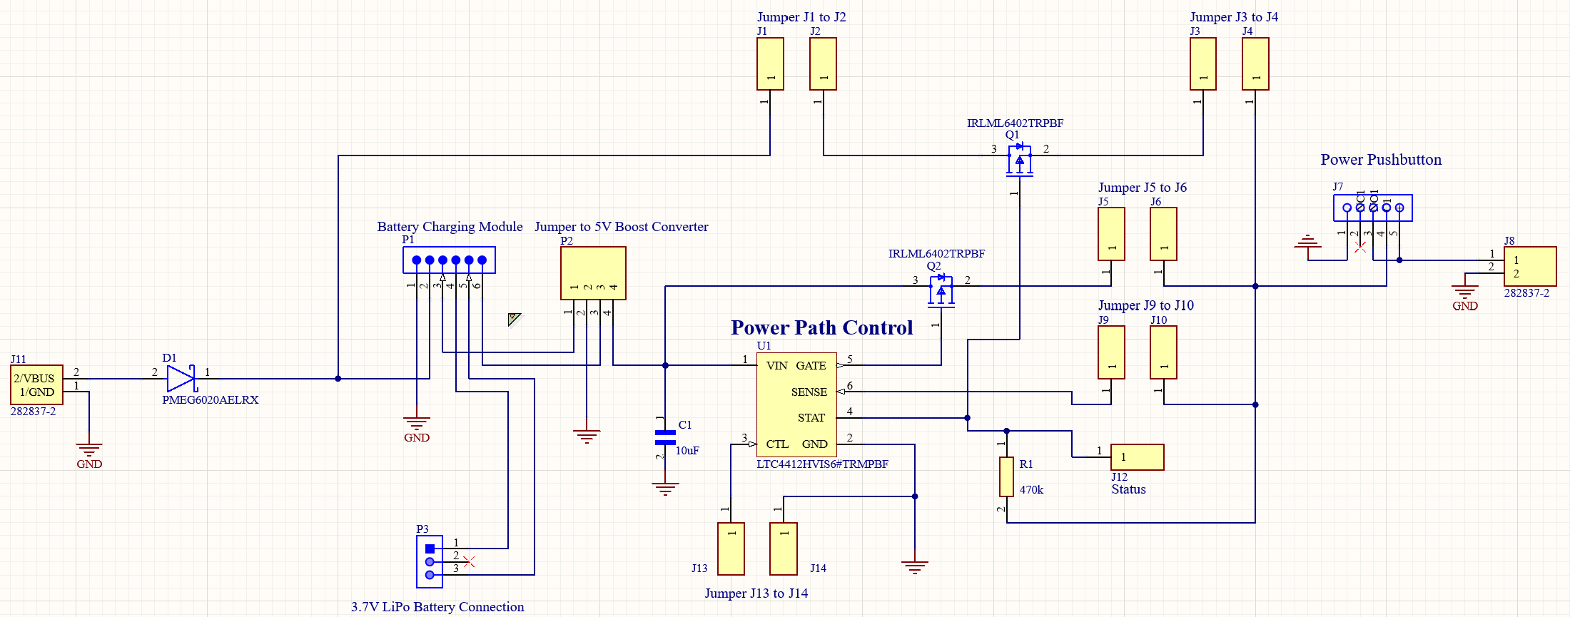

Fig. 10. Power Path Controller Module (Secondary)

The diagram illustrates the power path controller circuit for the secondary device. The VBUS and Ground pins from the USB Type-C breakout board are connected to a two-port screw terminal on the left side. The wall outlet power supply is designed to provide power to the system and charge the battery when connected. The battery is connected to a battery charging module, which then connects to a 5V boost converter to supply the desired voltage level to the system. Additionally, a power button is incorporated into this module. The module features several jumpers, included by design, which allow for the expansion of certain functionalities of the power path controller IC. These jumpers facilitate the correct implementation of the IC. For more information on the chip's specifications, please refer to the chip's datasheet.

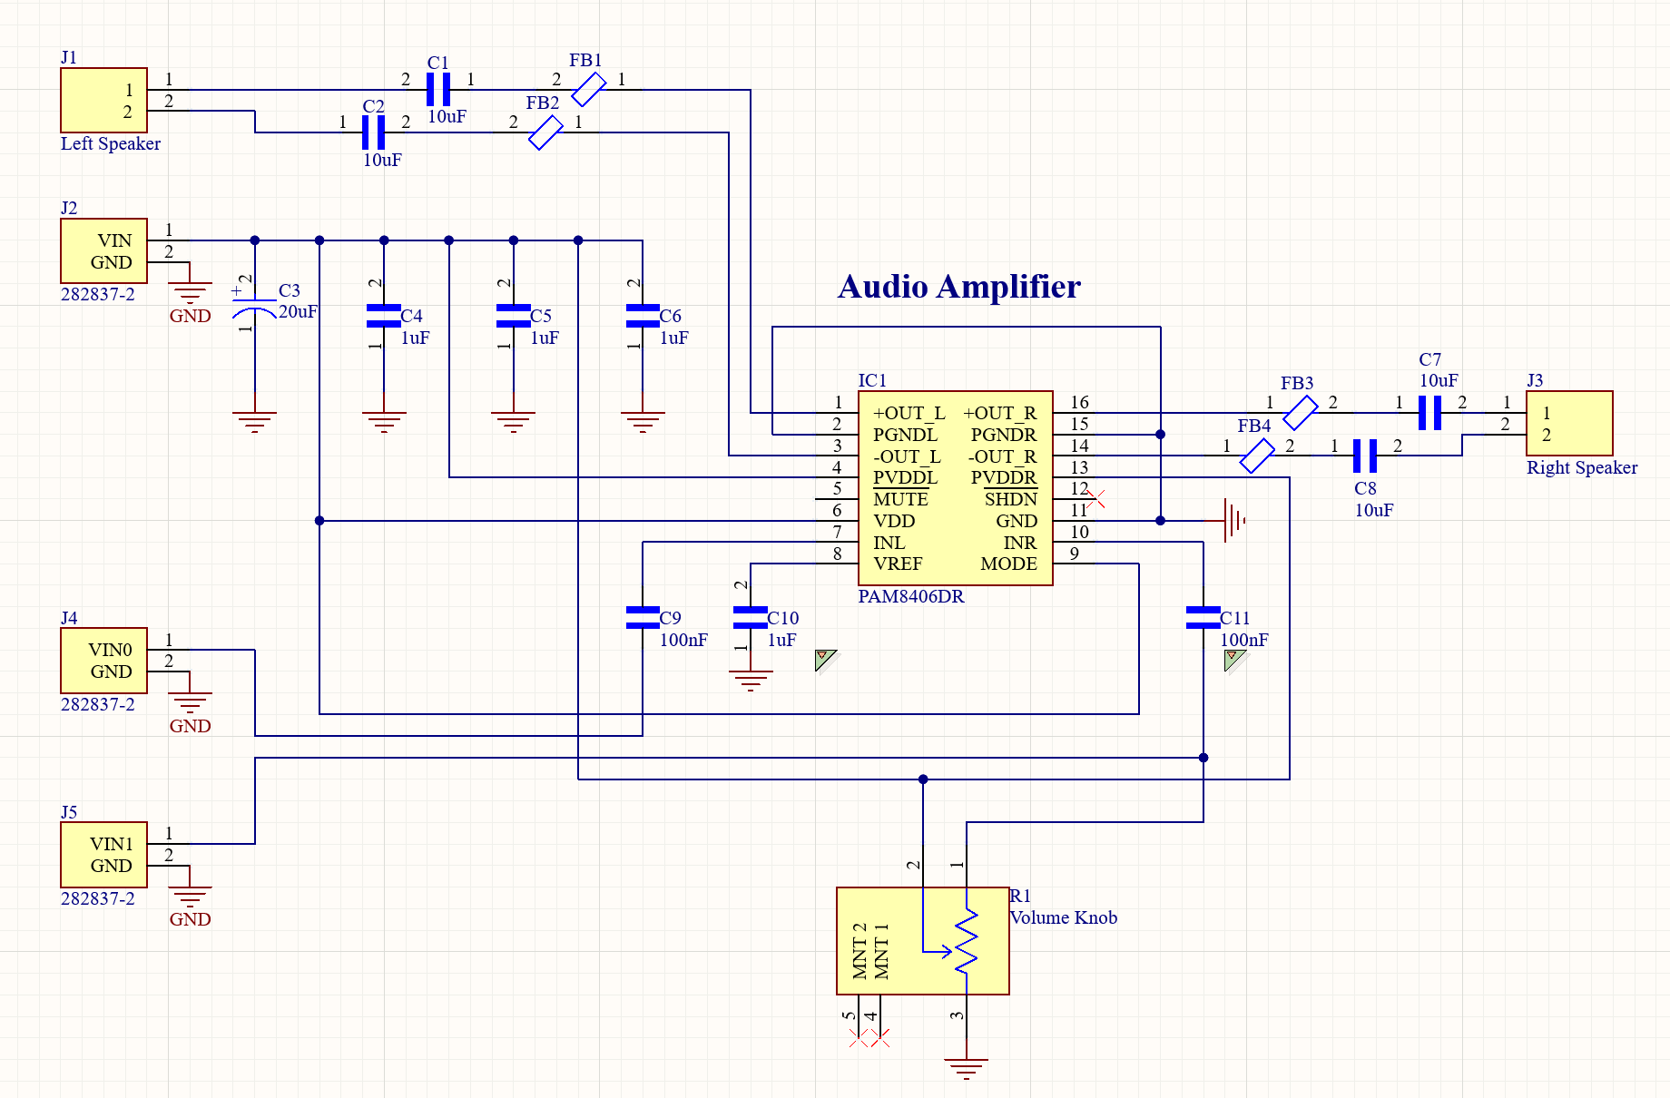

Fig. 11. Audio Amplifier Module (Secondary)

The audio amplifier module for the secondary device is illustrated in Fig. 11. This module receives the audio signal from the audio processor and transmits it to the integrated circuit (IC) through the INL and INR pins. The amplifier then outputs the signal to two stereo speakers.

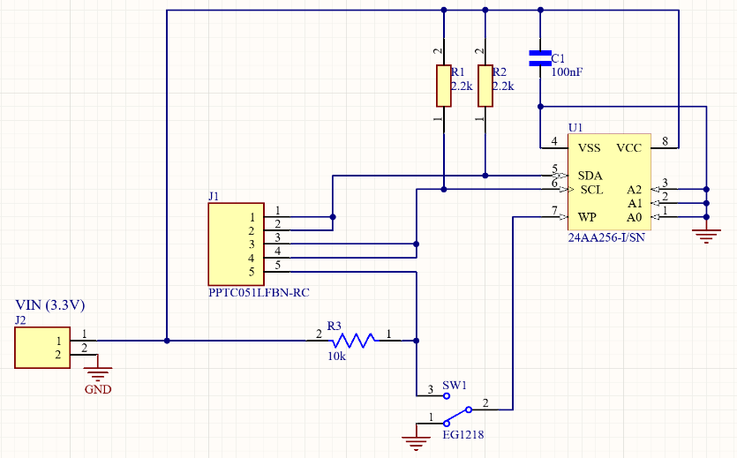

Fig. 12. EEPROM Module

Fig. 12 is the serial EEPROM module for the audio processor. The SDA and SDL pins are connected to both the microcontroller and audio processor. This is because our approach to uploading the audio processor's information to the EEPROM was to be from the microcontroller. The SigmaStudio files would be set and converted to the appropriate file format to be delivered from the microcontroller to the EEPROM. The audio processor would then read the file from the memory chip upon startup. The WP pin is set to either be connected to ground or the WP pin on the audio processor. More information can be found on this in the audio processor's datasheet.

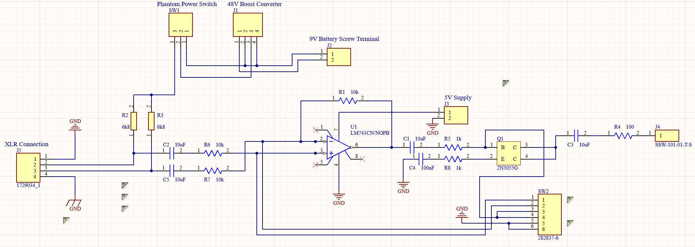

Fig.13. Gooseneck Microphone Module

The circuit diagram (Fig. 13) illustrates the design for the gooseneck microphone on the primary side. This module serves as a preamplifier and includes optional phantom power for the microphone when needed. Additionally, there is a switch located at the bottom right of the schematic, which functions as the push-to-talk feature.

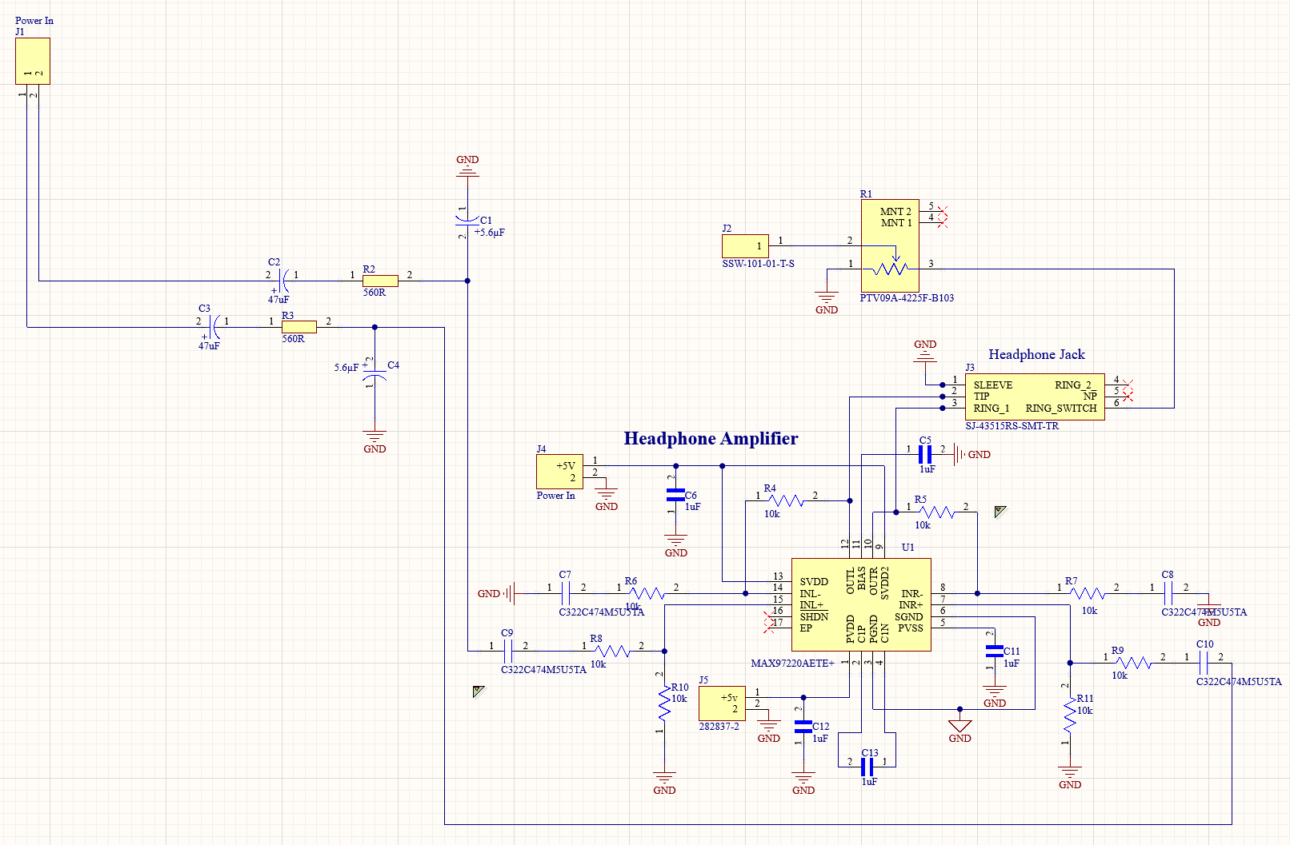

Fig. 14. Headphone Amplifier Module

Fig. 14 illustrates the headphone amplifier module for the primary audio system. The input signal is received from the VOUT pins on the audio processor and fed into the input pins of the amplifier IC. The output from the amplifier is then sent to the headphone jack, which passes the audio signal through directly when no headphones are connected.

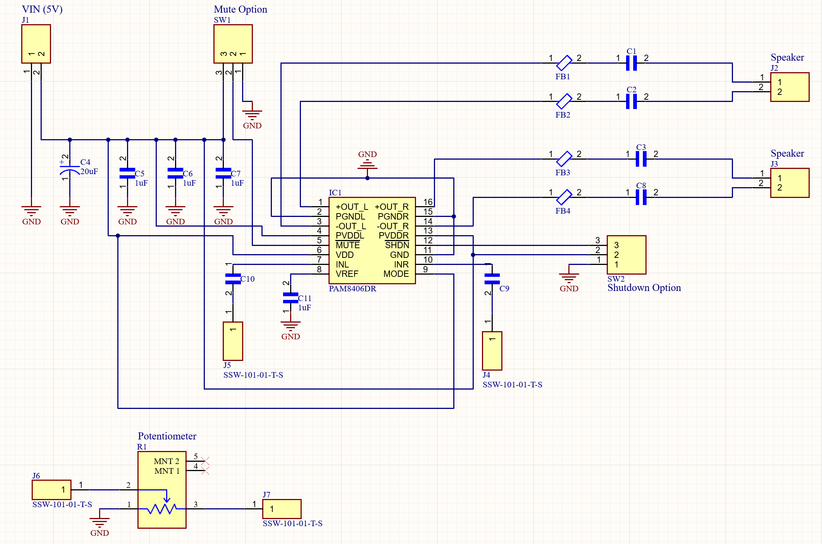

Fig. 15. Audio Amplifier Module (Primary)

Fig. 15 illustrates the audio amplifier module designed for the primary device. The audio signal is meant to be sourced from the microphone amplifier module. This design includes several headers that can be utilized to add functionality as desired by the user. For more information, please refer to the datasheet of the audio amplifier IC.

## Printed Circuit Boards (PCBs)

Below is the 3D visualization of the Printed Circuit Boards (PCBs). Each breakout was created using Altium schematics, which detail the pinouts for all modules. This was done in accordance with the PCB designer's specifications, including customized board layout dimensions, trace widths, and component placement. Finally, the PCBs were ordered through JCL PCB, a prototype manufacturer.

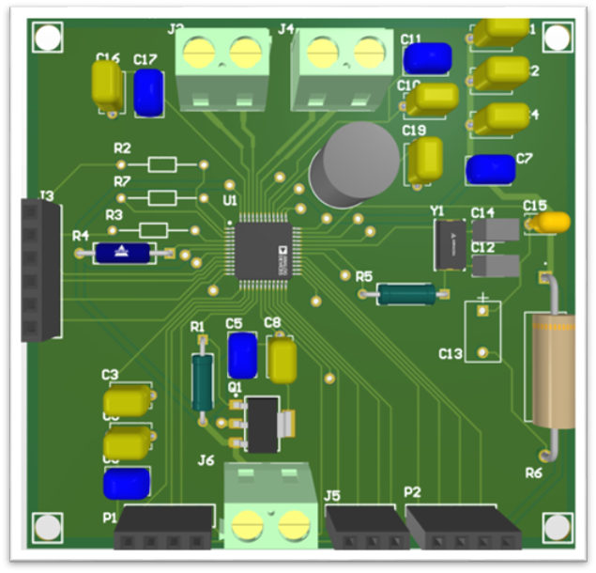

Fig. 16. Audio Processor for Primary & Secondary Devices

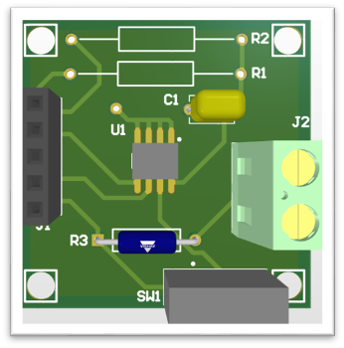

Fig. 17. EEPROM

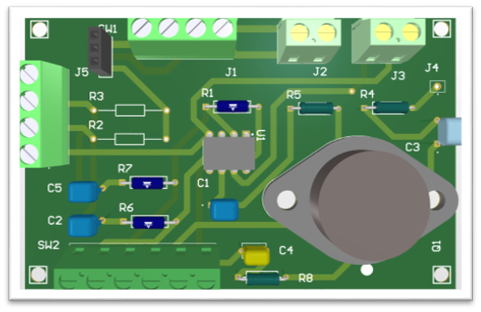

Fig. 18. Gooseneck Microphone

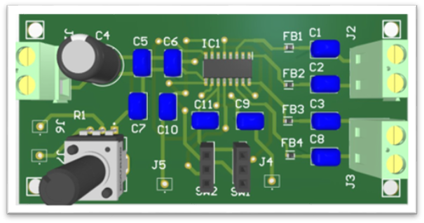

Fig. 19. Speaker Amplifier for Primary Device

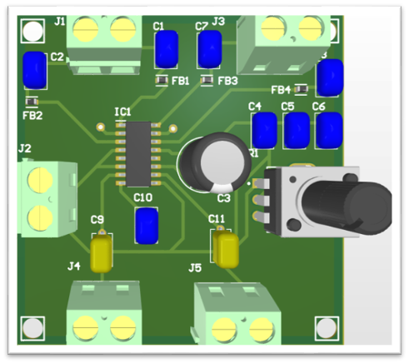

Fig. 20. Speaker Amplifier for Secondary Device

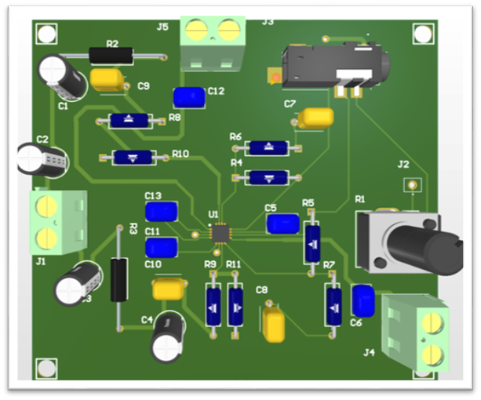

Fig. 21. Headphone Amplifier for Primary Device

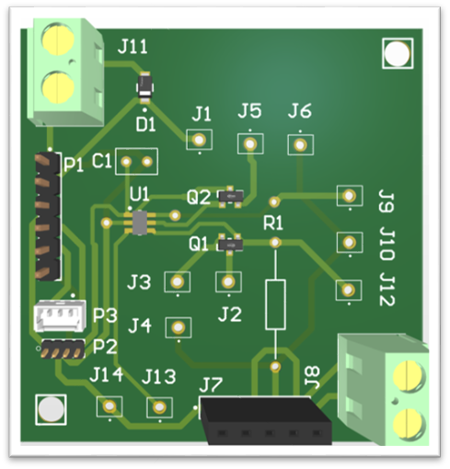

Fig. 22. Power Path Controller

## CAD Designs

Below are the 3D visualizations of the CAD designs for the casings of the primary and secondary units. Each design was created using OnShape, with the intention of being 3D printed with PLA, a cost-effective material. The consideration of the material used to print is important due to the relatively large size of the casings. The casings were ultimately exported as STL files and submitted to the UIC Makerspace, who provided the requested number of copies and in the requested colors.

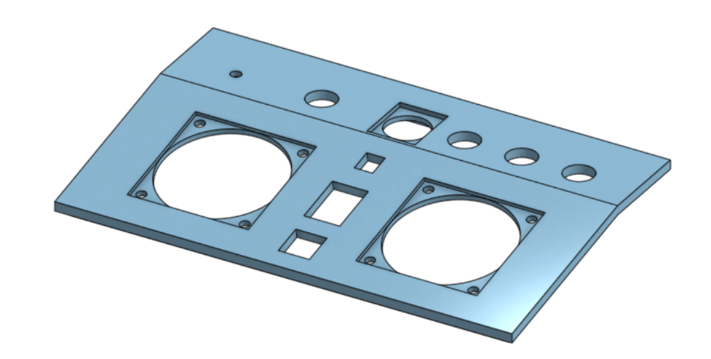

Fig. 23. Casing for Primary Unit (Lid)

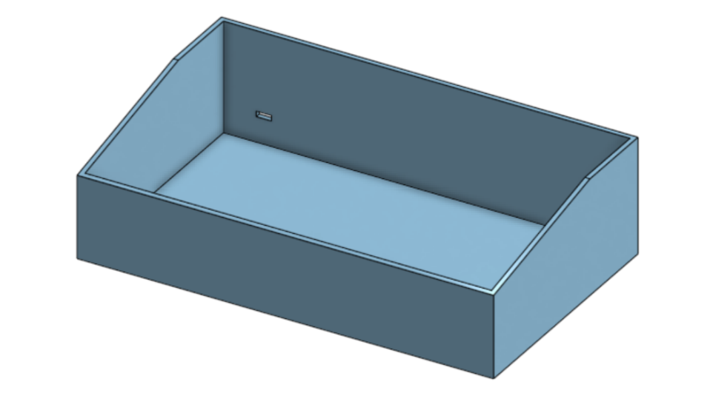

Fig. 24. Casing for Primary Unit (Base)

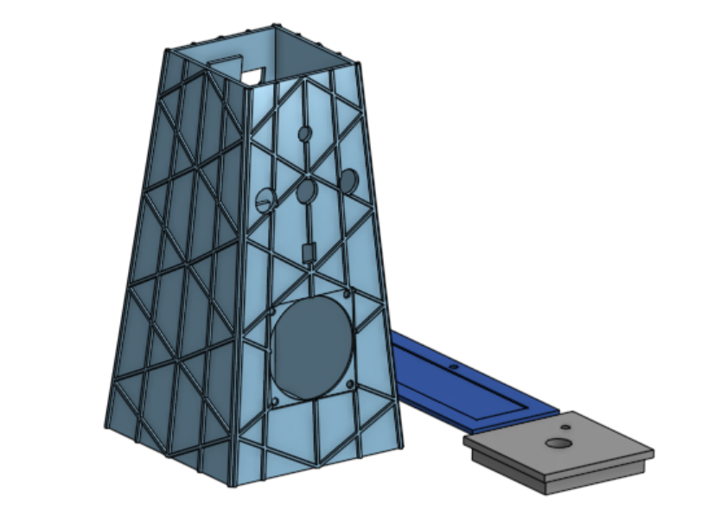

Fig. 25. Casing for Secondary Unit (Base, Lid, Backing)

## Product Cost Analysis and Budget

Our intercom system is meticulously crafted to deliver outstanding quality and advanced customization, employing cutting-edge technology to ensure precise and reliable performance for high-end research. With a strong emphasis on enhanced durability and user-friendliness, it not only streamlines operations but also offers significant long-term cost savings. This makes it an astute investment for those striving to achieve the highest standards in audio and acoustic research, providing a distinct advantage over less expensive alternatives.

The budget consists of several components tailored to each subsystem: Power Delivery, Microcontroller, Audio Processor, Speaker and Headphone Amplifiers, Transceiver, and PCB manufacturing.

Table III

Bill of Materials

|  |  |  |  |
| --- | --- | --- | --- |
| **Product** | **Quantity** | **Unit Cost** | **Total** |
| [Audio Processor - ADAU1701JSTZ](https://www.digikey.com/en/products/detail/analog-devices-inc/ADAU1701JSTZ/1246074?gclsrc=aw.ds&&utm_adgroup=&utm_source=google&utm_medium=cpc&utm_campaign=PMax%20Shopping_Product_Medium%20ROAS%20Categories&utm_term=&utm_content=&utm_id=go_cmp-20223376311_adg-_ad-__dev-c_ext-_prd-1246074_sig-CjwKCAiA6t-6BhA3EiwAltRFGBpCopHg7t5CtdvDSHw7_36d6Fh9MKRPurdMhKPTLtE7kACn1-7uMxoC19QQAvD_BwE&gad_source=1&gclid=CjwKCAiA6t-6BhA3EiwAltRFGBpCopHg7t5CtdvDSHw7_36d6Fh9MKRPurdMhKPTLtE7kACn1-7uMxoC19QQAvD_BwE&gclsrc=aw.ds) | 4 | $14.68 | $58.72 |
| [Power Path Controller - LTC4412](https://www.digikey.com/en/products/detail/analog-devices-inc/LTC4412HVIS6-TRPBF/1621436) | 1 | $9.03 | $9.03 |
| [CC1101 Wireless Module with SMA Antenna Wireless Transceiver Module (2 Sets)](https://www.amazon.com/DWEII-Wireless-Antenna-Transceiver-Arduino/dp/B0CSYX1454/ref=sr_1_2?crid=341240DVQI8Y&dib=eyJ2IjoiMSJ9.ZDKdXpcd3zm_tdbl7fYIWZaDiCm91LD2CQtpDk7McsJELRqItVY26X_FVB5ZsTMhtaPyt0KkLfaqAkMI08wrP0_mfWIx3VTL0qI2_AGeVFR8zT79Z3QNpXzemZpqOko6h0KqVSvLW-Hs-tpOVSN6Gw.YaH6s46mtSDPXZFaKHrL4GcE2jZ6YX3dM2J8F3nbIhs&dib_tag=se&keywords=CC110L&qid=1732987958&sprefix=cc110l%2Caps%2C364&sr=8-2) | 1 | $18.99 | $18.99 |
| [HiLetgo 2pcs NRF24L01+PA+LNA Wireless Transceiver RF Transceiver Module with SMA Antenna 2.4G 1100m](https://www.amazon.com/HiLetgo%C2%AE-NRF24L01-Wireless-Transceiver-Compatible/dp/B00WG9HO6Q/ref=sr_1_2_sspa?crid=1XSJ8X20RNNJN&dib=eyJ2IjoiMSJ9.QUJu9P7emtcMKxUO2DrtddWXAd2f1QoTG4y6sFWD6ZoQGUY4uhIzXRysn0dJ4YxaZ9yD3VkpPSlZT0Zm1I8QdQv5eB2w20arqns0tTLGW6v0zniWryL2xH2RMJNO0KgsP8f-0W7v0bANPERleBXVP5idUjtcZBxmQAuE9KPyQCj-HIjeq_y21_ry5Iuys2Rkq-31H3yKDjmGZagNhj-twjl-WLUadKaBjtKYh1_BGVY.o6vTonIBuZi6dqPKiqbm6snFOr_lT4iWU_Ocjrg5BDM&dib_tag=se&keywords=nrf24l01&qid=1740515310&sprefix=nrf24l01%2Caps%2C115&sr=8-2-spons&sp_csd=d2lkZ2V0TmFtZT1zcF9hdGY&psc=1) | 1 | $8.49 | $8.49 |
| [IC EEPROM 256KBIT I2C 8TSSOP](https://www.digikey.com/en/products/detail/microchip-technology/24AA256-I-ST/442755?gclsrc=aw.ds&&utm_adgroup=&utm_source=google&utm_medium=cpc&utm_campaign=PMax%20Shopping_Product_Medium%20ROAS%20Categories&utm_term=&utm_content=&utm_id=go_cmp-20223376311_adg-_ad-__dev-c_ext-_prd-442755_sig-Cj0KCQiA8fW9BhC8ARIsACwHqYo1IkNM7ipEhi_jav-qJI7yXgsqj9i0Htqk_uFMWC6uQytZ533StNgaAljSEALw_wcB&gad_source=1&gclid=Cj0KCQiA8fW9BhC8ARIsACwHqYo1IkNM7ipEhi_jav-qJI7yXgsqj9i0Htqk_uFMWC6uQytZ533StNgaAljSEALw_wcB&gclsrc=aw.ds) | 2 | $1.09 | $2.18 |
| [PAM8406DR - IC AMP D/AB STEREO 5W 16SOP](https://www.digikey.com/en/products/detail/diodes-incorporated/PAM8406DR/4033289) | 2 | $1.34 | $2.68 |
| [PAM8403 Mini 2 Channel 3W Stereo Class D Audio Power Amplifier Module Board (2 Pieces)](https://www.amazon.com/PAM8403-Channel-Amplifier-Envistia-Mall/dp/B07N12VPTS) | 1 | $5.49 | $5.49 |
| [Li-Ion Polymer Battery Pack](https://www.digikey.com/en/products/detail/globtek-inc/BL3000F9031781S1PCNC/14829887) | 2 | $19.03 | $38.06 |
| [Battery Charger Module Type-C (15 Pieces)](https://www.amazon.com/Lithium-Charging-Protection-Function-Interface/dp/B0DDGSHXQD/ref=asc_df_B0DDGSHXQD?mcid=8f68b73803a333c8b9375be65c31b936&tag=hyprod-20&linkCode=df0&hvadid=714317175551&hvpos=&hvnetw=g&hvrand=11494591945711188065&hvpone=&hvptwo=&hvqmt=&hvdev=c&hvdvcmdl=&hvlocint=&hvlocphy=9199173&hvtargid=pla-2366975780321&psc=1) | 1 | $9.99 | $9.99 |
| [USB-C 20W Power Adapter with Cables (2 Pieces)](https://www.amazon.com/Charger-2-Pack-Charging-Adapter-Samsung/dp/B0D8JDSYZB/ref=sr_1_19?crid=1S6IH8BNRRFHD&dib=eyJ2IjoiMSJ9.5NBi6Stow__NYCzeQrf0GdP1TaWZKNQslwjDJn5-aQhD7gkTX89pkcaGqZT9bjMF2gpMqVmiSo-yCS7uNC19A6iZIFxi23FLLE3SU2aofciNDrC-iQsXhVfCGKSokoC5EIEmD34sLNKOfkaj2ZClnftyqNZwJuZ_qbAG86YJxGtgmkzVurLIyk9rArogsbfU4EeMw23Y1_KUbyRm3uoVJUE54v2Md9gra6TNMx-Gr3hoJZ2VvHApdR76JCRgP7kAmgb0FAsKlVJvORzPzVWLQrCQ7ngNqdDtKHBofdD9Z5k.xc9Ewo6lH2JNYmHGhSkwhk4Z7TwhYioghiVLEXmQ8Iw&dib_tag=se&keywords=5v%2Bwall%2Badapter%2Btype%2Bc&qid=1733863508&s=electronics&sprefix=5v%2Bwall%2Badapter%2Btype%2Bc%2Celectronics%2C107&sr=1-19&th=1) | 1 | $5.99 | $5.99 |
| [Dayton Audio CE Series CE32A-4 1-1/4" Mini Speaker Driver 4 Ohm](https://www.parts-express.com/Dayton-Audio-CE32A-4-1-1-4-Mini-Speaker-4-Ohm-285-103?quantity=1&utm_source=google&utm_medium=cpc&utm_campaign=20348422537&utm_content=158719109919&gadid=692364698573&gad_source=1&gclid=CjwKCAiA6t-6BhA3EiwAltRFGAaSYBwWJ8xcgfM5dXus0J5F0Xobg_G9zhRe04Z8CkZSR5NoWMW2QxoCNMsQAvD_BwE) | 3 | $3.98 | $11.94 |
| [Electret Microphone Amplifier Module MAX4466 (6 pieces)](https://www.amazon.com/Electret-Microphone-Amplifier-Adjustable-Breakout/dp/B08N4FNFTR?crid=6FVEUYMERF89&dib=eyJ2IjoiMSJ9.BgxK82Qddp4Vgito_5dKCx4V02k1pfX_GSUdL1_Et1kJCBFeeXhrlw5z7KrP4hAFpjR6iYKZ1_t3CluYDC_rvhuxrXqqTdGsleFifO6cTH1lTIvAjDjGns6bZkzAq67kxZkF_7yT9G_S_hR8NtbwQRwNo0-jF0pGKoAT0128TWCH1S8cANpcq7KQabfOtqBZEMbZq2-0rOmIBfsHtj4MDeHtRqzKfqAnvOcVZ7oKXTq9y7fuk9j05kUaeJAIWQi6fsfQwL8UsVqhP8sQvrJbCgBxbTSBzvkK2yjtYsPesxM.5C2k1NLUS5Ndon3s0m4dBO1zQfZXmssLvBVqrTM8whE&dib_tag=se&keywords=mems+microphone&qid=1733860021&sprefix=mems+mi%2Caps%2C116&sr=8-12) | 1 | $10.99 | $10.99 |
| [Audio Amplifier - MAX97220AETE+T](https://www.digikey.com/en/products/detail/analog-devices-inc-maxim-integrated/MAX97220AETE-T/2744332) | 1 | $3.15 | $3.15 |
| [Behringer TA5212 Gooseneck Condenser Microphone](https://www.sweetwater.com/store/detail/TA5212--behringer-ta5212-gooseneck-condenser-microphone/reviews?gQT=1) | 1 | $25.00 | $25.00 |
| [XLR Connector](https://www.digikey.com/en/products/detail/switchcraft-inc/E3FRA/1289115) | 1 | $8.23 | $8.23 |
| Buck/Boost Converter | 2 | $12.82 | $25.64 |
| [Boost Converter](https://www.digikey.com/en/products/detail/sparkfun-electronics/BOB-15100/9770720) | 1 | $6.49 | $6.49 |
| [Arduino Nano ESP32 w/ Headers](https://www.amazon.com/Arduino-ABX00083-Bluetooth-MicroPython-Compatible/dp/B0C947BHK5/ref=sr_1_1_sspa?crid=1H9O2UCQ3HT2B&dib=eyJ2IjoiMSJ9.AXdJZcJJjSWWgBrTnzqiqnyqZiqypNR-QHQwRacqa7qanBf8znehr33F-CMqHa-5gkh6YX-TJz94gZSLBBkHP7oXf4Mhq2xV8F0btjCrJRA8OY6OBWbk5guZfdKvYWcts6odxcoOG_goT2Pg8IhCTxnMKG1bBr7jFIrZlr82aAcXEB4mDN2WuMkMnHJWO3ZxxrcdDSBcOLPWAAbsZkHJU9ScLIs2egnfKicr5g5uLQE.2UiXWzr1fPoG_LIUmv-f1Nx4Y15qKzm9yJpg1tGgGTM&dib_tag=se&keywords=arduino+nano+esp32&qid=1740516241&sprefix=arduino+nano+%2Caps%2C112&sr=8-1-spons&sp_csd=d2lkZ2V0TmFtZT1zcF9hdGY&psc=1) | 1 | $23.00 | $23.00 |
| [Volume Dial – Black Anodized Aluminum Machined Knob](https://www.adafruit.com/product/5527) | 4 | $2.95 | $11.80 |
| [LED Push-Button (Blue)](https://www.adafruit.com/product/915) | 2 | $4.95 | $9.90 |
| [LED Push-Button (Green)](https://www.adafruit.com/product/482) | 2 | $4.95 | $9.90 |
| [LED Push-Button (White)](https://www.adafruit.com/product/917) | 2 | $4.95 | $9.90 |
| [LED Push-Button (Red)](https://www.adafruit.com/product/916) | 2 | $4.95 | $9.90 |
| [USB-C Breakout Board](https://www.digikey.com/en/products/detail/sparkfun-electronics/BOB-15100/9770720) | 2 | $4.95 | $9.90 |
| [Headphone Jack - CONN JACK 4COND 3.5MM R/A](https://www.digikey.com/en/products/detail/tensility-international-corp/54-00174/12140150) | 1 | $0.66 | $0.66 |
| [Headphone Jack w/ Switch - CONN JACK 4COND 3.5MM SMD R/A](https://www.digikey.com/en/products/detail/same-sky-formerly-cui-devices/SJ-43515RS-SMT-TR/669722) | 2 | $0.93 | $1.86 |
| [Potentiometer – 10 k Ω](https://www.adafruit.com/product/4133) | 3 | $1.25 | $3.75 |
| [Ferrite Bead 220 Ω 0603 1LN](https://www.digikey.com/en/products/detail/tdk-corporation/MPZ1608S221ATA00/571872) | 10 | $0.10 | $1.00 |
| [USB C Cables 100W 2 Packs, Short USBC](https://www.amazon.com/SUMPK-Charging-MacBook-Samsung-Display/dp/B09Z6J21LY/ref=sr_1_2_sspa?crid=2WTTM451E644T&dib=eyJ2IjoiMSJ9.tBOfJjxjTBOeOxpd3WXO8wwcGPqhzZ5MfUSgJTAQ03PGslEtmmEsP6E-F1vrZKdvVh_LlnCfY3XH8hv50bz7TStOG4qt2nNgLBb3X-nWlEYRMP65H3hkTmEnSlzkRiEIeHjVqC10WUerL8Cb1SO25qEC-7VDqdvIn0bUnDe8oacP8QgZoX0jupjJy-0uEJk8HrqTfFXcDVyoyfH8jDMFuHSd3QIBYtSw0YOMlz2gwd8.IjP5HenQC4WUbzxg6joK-zzYoPykA-Ib88RJOoQf638&dib_tag=se&keywords=usb%2Bc%2Bto%2Busb%2Bc%2Bdata%2Bcable%2B1ft&qid=1740517060&sprefix=usb%2Bc%2Bto%2Busb%2Bc%2Bdata%2Bcable%2B%2Caps%2C194&sr=8-2-spons&sp_csd=d2lkZ2V0TmFtZT1zcF9hdGY&th=1) | 1 | $8.99 | $8.99 |
| Amazon Orders | 2 | ---- | $46.10 |
| DigiKey Orders | 2 | ---- | $78.79 |
| JCL PCB Orders | 11 | ---- | $98.71 |
| Microcenter Order | 1 | ---- | $50.00 |
|  | **Total Cost:** | | $625.22 |

The design and development cost for the intercom system is $625.22 (see Table III). This system strikes a balance between affordability and the advanced features required for research conducted in the anechoic acoustic chamber of the Listening Technology Lab. Since two devices are necessary, the original budget exceeded $300. The team also accounted for personnel expenses of $194.55, while the PCB manufacturing cost amounted to $98.71. With a 100% markup applied, our system is priced strategically between low-cost consumer-grade wireless home intercoms, which start at around $40, and high-end professional studio systems that often exceed $1,000. Unlike consumer-grade options, our pricing reflects the specialized requirements of auditory technology research environments. The system is designed to meet our user’s specified standards for audio clarity and reliability. It offers a high signal-to-noise ratio (SNR), robust structural durability, and minimal maintenance needs. These features ensure that it performs well under the unique constraints of acoustic research while delivering exceptional long-term value as a cost-effective solution tailored to the needs of research institutions.

# Contribution of Work

For this project, each team member played a vital role in contributing to various assignments throughout the semester, ensuring a well-rounded and effective collaboration.

**Kayla** took charge of curating the Team Task Management Document, which organized and tracked the team's progress and responsibilities. Additionally, she meticulously created Altium schematics and developed printed circuit boards (PCBs) for the subsystems of the primary system. To enhance the project's visibility, she also played a key role in designing and assembling the EXPO poster and brochure, showcasing the team's achievements. **Moises** focused on creating detailed Altium schematics and developing PCBs for the secondary system's subsystems. His skills were pivotal during the hands-on phase, where he successfully managed the soldering tasks, ensuring that all connections were precise and reliable, ultimately contributing to the robustness of the system. **Neftaly** was responsible for several critical design aspects, including the soldering tasks that required careful attention to detail. She designed the final enclosure housing for both systems, considering factors such as durability, aesthetics, and functionality. Additionally, she collaborated with her teammates to assist in the assembly of the EXPO poster and brochure, ensuring that the materials were cohesive and effectively communicated the project's objectives. **Nikolas** contributed significantly by creating Altium schematics and developing PCBs for the primary system's subsystems. His technical expertise also extended to performing soldering tasks, where he ensured high-quality connections and adherence to safety standards, which enhanced the overall efficiency of the project. **Thomas** was instrumental in the software development aspect of the project. He designed and implemented the SigmaStudio software programming for the microcontroller, transceiver, and EEPROM components of both systems. His programming expertise enabled seamless communication between components, thereby enhancing the overall functionality of the systems.

Through this collaborative effort, the team successfully combined their diverse skill sets to achieve project goals and create a comprehensive, multi-faceted solution.

## Personal Contribution Statements

**Kayla**

My work on the project involved a mix of written content and technical assembly for the printed circuit boards (PCBs) used in the Acoustic Chamber Intercom. Initially, I aimed to organize our agenda to ensure our Altium schematics were well-curated and properly integrated, capturing both primary and secondary systems. A key focus was perfecting the PCB circuitry for components such as the Audio Processor, amplifiers, power delivery, and microcontroller, which required considerable time and effort. I contributed to research and played a crucial role in selecting the Audio Processor and other passive resistors and capacitors components. My responsibilities included assembling the circuitry, which integrated the TA312s Behringer and electret microphones. The process began with utilizing datasheets and suggested analog-to-digital converters along with amplification circuitry. My significant contribution was in developing the Altium schematics for the main device, the Gooseneck Microphone in the primary schematic, the Electret Microphone in the secondary schematic, correcting the various errors on the residual schematics documents used for the acoustic system in Altium. Upon finalizing the schematics, I performed Design Rule Checks, Electrical Rule Checks, quality checks ----net connectivity, footprint accuracy using SnapEDA libraries, and passive component values to identify and rectify errors. After implementing some last-minute changes, I proceeded to the PCB assembly within Altium. In addition to my Altium-related work, I supported and taught team members, made helpful inquiries during Sadegh Esmaeilirad's office hours, and communicated updates to my team. When we faced challenges with signal tracing discontinuities and high PCB manufacturing costs, we opted to transition to individual PCB breakouts. I also aided in developing the following PCB breakouts and schematics: the Power Path Controller, Gooseneck Microphone with pre-amplifier circuit, and Headphone Amplifier. In terms of PCB assembly and orders, our team shared costs, and I covered my part to finalize the JCL PCB order. I sourced passive components like resistors and capacitors from the Senior Design laboratory and proposed bookkeeping methods for any remaining unordered parts. I set up a Purchasing BOM and helped with the DigiKey order, placing an additional order for passive resistor items myself.

On top of that, I led the EXPO Poster and Handout project from start to finish, assigning specific tasks to our team members. I was responsible for creating the Abstract, Introduction, Engineering Requirements selection, Results, Methodology graphics only, and Conclusion statements—prioritizing readability, cohesive design, and clarity. Throughout the semester, I ensured consistent communication with my team via Teams and Blackboard, actively seeking feedback and input before making final decisions. I revised both drafts of the Abstract and Introduction and smoothly integrated those into the Poster. The project title was proposed by me and finalized collectively, and I submitted the Project Title, Abstract, and Poster through the EXPO Portal. For the One-Page Handout, I collaborated with Simona Narubin Durbin to ensure that supplementary project information was included. I made revisions to the Objective Tree and Cost Budget entities, curated Schematic statements for the Audio Processor, and enhanced the Power Delivery and Microcontroller components. Additionally, I took photos of the Listening Technology Lab, which were incorporated into the Handout. Overall, I compiled the Team Task Management Logs and maintained general notes in our Group Log from our Monday and Tuesday meetings throughout the semester. I was instrumental in the curation, organization, and submission of all in-class presentations, submitted several Blackboard and EXPO deliverables for the team.

In the Final Report, I was responsible for several key components, including the Team Task Management Document and the Final Design Bill of Materials. I drafted the paragraphs for the Conclusion section and the introduction to the Circuit Design section. Additionally, I improved the readability of the schematic descriptions and edited the Acceptance Testing section to enhance clarity, incorporating Professor Renata's comments. I also wrote introduction paragraphs for the Contribution of Work and Lessons Learned sections, updated the Table of Contents, and created the Acknowledgment section independently, which is featured on the Cover Page.

**Moises**

My contribution involved the design and creation of PCB layouts for three subsystems: the ADAU1701JSTZ-RL audio processor module, the secondary speaker amplifier module, and the external EEPROM module. I managed component selection and part requests, keeping track of costs against our budget and ensuring timely delivery. Throughout the design cycle, I performed quality checks—verifying footprint accuracy, net connectivity, and component values—to catch errors early. On the documentation side, I wrote the unit testing section of our final report, co-wrote both the abstract and basic theory sections, and drafted the methodology portion of our EXPO poster to clearly communicate our process.

I also assisted with soldering components to our PCBs, teaching my teammates proper soldering techniques, and leading an Altium workshop to boost our team’s productivity. I supported integration testing of all modules by creating a bandpass filter to improve audio quality captured by the electret microphone and troubleshooting as needed. I also supplied our team with my personal equipment and made personal purchases to facilitate our testing process.

**Neftaly**

At the beginning of the semester, we focused on creating the necessary schematics on Altium. I set up the collaborative workspace and worked on the audio amplifier subsystem. I conducted research to confirm the audio amplifier that we would utilize and settled on PAM8406. In conducting this research, I found that more components would be needed, specifically for the primary device. We wanted to give the user the ability to plug in their own headphones, so I added a headphone jack to the schematic and to our ordering list. The audio amplifier is connected between the audio processor and the speakers on our original design, so I had to ensure that I communicated with my team members to ensure that all the connections were made correctly. Once some parts arrived, I had to make modifications to the schematic for the audio amplifiers to include a headphone jack with a switch and a headphone amplifier, both of which I needed to research to find the best fit for our needs and then implement on the Altium schematic.

While the rest of the team created PCBs, I began updating the initial CAD design for the primary casing and creating the CAD design for the secondary casing. I did not have prior experience with CAD, so I selected OnShape based on the recommendations I found on UIC Makerspace’s website. Updating the design for the primary device required checking which components we ordered, researching their dimensions, and making sure that the layout was intuitive for user friendliness. For the secondary casing, I took inspiration from the Listening Technology Lab’s logo and decided to create a replica of the John Hancock Tower. When I was ready to submit the designs, I investigated the material and color options available for 3D printing at UIC Makerspace. I went with clear PLA filament for the draft copy of the secondary casing, and upon receiving it, I was able to validate dimensions and make changes as needed to the CAD files for both the primary and secondary casings. The final designs were printed based on the adjustments made from the draft and the final integration of the details to mimic the John Hancock Tower. Due to poor tolerance, I had to use creative techniques with a hot air gun and Dremel to carve out the spacings to ensure the components fit when assembling the prototypes.

Once the PCBs arrived, I aided in soldering the components onto the boards. When doing so, I helped my team identify which components we were still missing – I purchased many passive components myself to speed up the process. I also helped identify PCBs that were not printed or designed accurately (namely the audio processor module) since I made continuity checks as I soldered. To make the soldering process more efficient, I brought my own soldering equipment to campus and was able to reserve the backroom of the Equity and Inclusion in Engineering Program’s (EIEP) lounge for team meetings. In addition to passive components, I also purchased soldering paste, paintbrushes, heat shrink tubing, wires, and more. The soldering paste and paintbrushes were crucial to being able to solder on our miniscule ICs – such as the audio processor and headphone amplifier – in a technique I was able to come up with on a whim. Given that we had so many components, I also did my best to keep all of our material organized with labeled Ziploc bags and boxes.

For the EXPO poster and handout, I helped create a cohesive design for each, ensuring their readability. I helped with writing the introduction and the prototype section; I also reviewed my teammates’ material. In preparation for EXPO, I also created a foamboard prototype of the primary casing since our design from UIC Makerspace was delayed. For the report, I helped with the needs and objective statements, the CAD design section, the conclusion, and the user manual.

**Nikolas**

I took on the responsibility of the power aspect of the project. I designed the overall primary devices and power path controller modules schematic and PCB. I designed the EEPROM modules schematic and the gooseneck microphone modules PCB. I also assisted in the design of several other schematics: the overall secondary device, the audio processor module, and the primary audio amplifier module. I assisted in determining component acquisition and with soldering on said components, headers, and conductors onto PCBs. I acquired and implemented boost converters, first iteration digital-to-analog converters, and first iteration audio amplifiers modules. I assisted financially in acquiring PCBs. I assisted in integration and acceptance testing. I created block diagrams for presentations and reports. I cowrote the poster board conclusion section. I wrote the final reports integration testing and circuit design sections. I assembled PDF files of all schematics and Altium zip files for module and overall project documents to share with our sponsor.

**Thomas**

For the Acoustic Chamber Intercom project, my focus was making sure all the different parts worked together smoothly. This involved taking the electronic boards (PCBs) and other components we had and testing them to ensure they communicated and functioned correctly as a system. To control the Arduinos, I used the Arduino IDE software to code the functions we desired. I first started with one Arduino to test some cases like a button push to turn on an LED light. From there I added the components of our project such as the NRF24L01 transceiver to connect two different Arduinos to each other. Once connection was established. I built up from there, introducing some tests to check speaker and microphone functionality through wireless communication. After confirming that each of the components we had worked together one way or another, my final task was to integrate all the components into one system.

Another responsibility I had was to check if the final devices met the project's requirements, going through the engineering requirements we laid out for ourselves and making sure that we accomplished them to the best of our abilities. When it came near to the end of our project, I supervised the final implementation, making sure that the individual systems made it off of the breadboard and into the casing we designed.

Some other things I have done for this project were to acquire additional components when needed, learn Sigma Studio to integrate the audio processor we used, made the initial protoype of the primary device housing, and wrote the initial user manual.

## Lessons Learned

The senior design experience involved both collaborative and independent elements of administrative, engineering, and artistic tasks. Our team conducted interviews with our faculty advisor, Professor Ryan Corey, to understand his needs, scheduled meetings, and managed deadlines for ECE 397. Without strategic planning and selective assignment of leadership roles, we would not have been able to finalize the project's construction. Below, you will find each team member’s feedback regarding the 2024-25 Senior Design course and College of Engineering’s EXPO.

**Kayla**

After completing two semesters of both ECE 396 and 397, I'd like to share my insights on the Senior Design Lab regarding its difficulty, content, and organization. The course is fast-paced and requires a significant amount of work, making it comparable to a four-credit course despite it being only two credits. The difficulty is above average, demanding innovative thinking and creative problem-solving with limited resources for tasks like abstracts and posters. Group collaboration can be challenging, especially when students with diverse backgrounds try to merge their ideas. I often felt unprepared for ECE 397, as I rushed to convert our research into a physical product. However, I developed my resourcefulness and improved my ability to compromise during group work, realizing when to adapt and when to assert my ideas. Addressing organizational issues would benefit future students, as the workload can be overwhelming; I managed 18 credit hours this semester. Technically, I gained valuable experience with Altium Design software, enhancing my circuit design skills. I also improved my writing and communication abilities through various projects, boosting my confidence in group settings. Additionally, I observed vital soldering techniques from team members when connecting PCB components, ensuring stability for our acoustic chamber intercom.

**Moises**

My biggest takeaway from senior design was learning the design process to move our idea from concept to a working intercom. Breaking the work down and building/testing one component/subsystem at a time proved far more manageable than integrating everything at once and then debugging. Equally critical to our project’s success was our team’s diversity. Each of our unique skillsets not only strengthened the technical design and construction but also enriched our project presentation. I also saw major improvement in my communication and presentation skills.

**Neftaly**

Going into the year-long course, I knew that it was going to be difficult and time-consuming due to feedback I received from my peers. It was.

I wish the workshops led by the TAs had been more thorough and available online (in a useful format), and that we would have been provided with a list of useful software and accompanying free lessons that could be found online. Given that I had no previous experience with OnShape or Altium, I spent too much time learning this software during 397 when it could have been done in 396. I would encourage future Senior Design students to spend 396 teaching themselves Altium at a bare minimum. This way, by the end of 396, the schematic designs are complete, and the PCBs can be ordered during winter break.

Given the limited (but brilliant) staff at the Senior Design Lab, orders were understandably not processed quickly. To ease the pressure on both staff and students, a first round of part orders should be made prior to winter break so that once 397 rolls around, students can start working on their prototypes immediately.

If not clear already, I learned that we began many steps of our project too late – from learning how to use Altium, to ordering components and PCBs. This prevented us from achieving our design goals and from being able to rely solely on the College for ordering. Though I am grateful for some of the content that was taught in 396 and 397, I do wish many of the assignments had better instructions and updated examples (i.e. abstract, testing). It is my belief that too much time was spent on team building and covering ethics when those are skills and lessons that are learned through the hands-on work of building the prototypes and going through the iterative design process. I learned to be proactive and not wait for the relevant lectures to get started on tasks.

I juggled a full course load and a co-op this academic year, and I found myself overwhelmed with this course despite its assigned credit value. I urge the department to reconsider the credit value of the course or the scope of the projects. Nonetheless, I gained time management, communication, and presentation skills. I was able to learn from the project itself, but more importantly from my team members. They made the experience enjoyable and memorable.

**Nikolas**

I learned a lot from my time in senior design over this school year. From my perspective, more time and effort goes into the design and realization of a project than this course gives credit for. I value the time I took to learn Altium Designer, but I wish it was clear earlier that we would have benefited from buying off-the-shelf component modules to potentially achieve a more finished product.

**Thomas**

I had to learn on the fly on the different software we had to integrate such as Arduino IDE, Altium and Sigma Studios. Each of these programs was like learning a new language within a 3-week span. When we were done with Altium, I had to move to using Arduino IDE, then when we had a connection, I tried to learn and implement filters with Sigma Studios for our audio processor.

Another thing I was able to learn with this project was to not let failures and pivoting hold me back. There was a point where I fried half of our system by implementing the power incorrectly, but my team reassured me things were going to be okay, and mistakes happen to the best of us. Then we quickly came together on what to do next and we were able to come together and finish our project.

# Conclusion

The final design of the acoustic chamber intercom comprises two distinct devices: the external base station (the primary device) and the internal unit (the secondary device). The external base station's design integrates the foundational subsystems necessary for analog-to-digital (ADC) and digital-to-analog (DAC) speech and signal processing, power delivery, and software programming. In contrast, the internal unit exclusively utilizes the speaker amplifier, while the external base station retains the capability to support both speaker and headphone amplification. A comprehensive Bill of Materials is provided, detailing each subsystem employed in the design.

## Future Improvements

Several areas of the system design could be improved with additional time and budget.

One of the main issues encountered during the integration of the printed circuit boards (PCBs) was power delivery; the 5V supply voltage dropped to 3V, while the 3.3V supply voltage fell to 2V under load. This decline in power compromised the ability of the ADAU1701JSTZ-RL audio processor to perform its digital signal processing tasks effectively due to insufficient power. We also were not able to integrate a bar graph LED display to show the remaining battery life on the secondary device.

Furthermore, using breadboard circuitry and the Arduino IDE for programming, instead of SigmaStudio — which is specifically designed for tuning the ADAU1701JSTZ-RL integrated circuit — led to inefficiencies in the system's audio processing performance. If SigmaStudio could be integrated, it would in theory significantly improve the quality of the audio being delivered through the speakers.

Another challenge arose during the design of the device housings. The UIC Makerspace was used for printing the designs using readily-available PLA material for both the primary and secondary casings – but the tolerance was poor. As a result, the drill holes for the channel buttons and speakers were slightly undersized, resulting in a less-than-ideal fit for the components. To ensure fit, a hot air gun was used to essentially melt the PLA, and a combination of screwdrivers and scissors were used to reach the needed measurements. The final casings still did not achieve the refined quality that a higher-end, custom housing solution could offer. Better printers could be used in the future, and to fully ensure a modular design for the secondary casing, shelving and a magnetic backing could be employed.

With additional time and a larger budget, several design improvements could be implemented. These include optimizing the power delivery circuits, utilizing printed circuit boards that host all system modules for full integration, employing SigmaStudio for more precise audio tuning, and producing more professionally crafted housings to enhance both functionality and aesthetic appeal.

For demonstration purposes, we utilized the university Wi-Fi network to showcase the one-way communication performance of our system, highlighting its reliability and audio clarity under real-world conditions. Future iterations could demonstrate high-end two-way audio transmission and reception to more accurately reflect intended use. This would involve implementing dynamic channel selection within the 2.4 GHz frequency band to reduce interference and optimize signal quality in environments with multiple wireless devices.

# Works Cited (Background Research)

[1] D. Kwak, M. Krzyżaniak, A. Danielsen, and Alexander Refsum Jensenius, “A mini acoustic chamber for small-scale sound experiments,” Sep. 2022, doi: https://doi.org/10.1145/3561212.3561223.

[2] Z. Zhang, K. Long, A. V. Vasilakos, and L. Hanzo, “Full-Duplex Wireless Communications: Challenges, Solutions, and Future Research Directions,” vol. 104, no. 7, pp. 1369–1409, 2016, doi: 10.1109/JPROC.2015.2497203.

[3] M. Zhang and H. Zhang, “Design and Implementation of Wireless Transceiver System Based on FPGA,” 2010, vol. 4, p. 355, doi: 10.1109/cicc-itoe.2010.96.

[4] Wang Zhengyan, Y. Wei, Shao Xingling, and Zhai Hongqiang, “Design and Research about Voice Communication System Based on Bluetooth Module,” Jan. 2011, doi: <https://doi.org/10.1109/icmtma.2011.228>.

[5] V. Macri, "Introduction," in SBE Broadcast Engineering Handbook: Hands-On Guide to Station Design and Maintenance, 1st ed., J. C. Whitaker, Ed. New York: McGraw-Hill Education, 2016, ch. 5.1. [Online]. Available: https://www-accessengineeringlibrary-com.proxy.cc.uic.edu/content/book/9780071826266/toc-chapter/chapter36/section/section2

[6] “Comparing Three Major Wireless Communication Protocols: Bluetooth, WiFi, ZigBee,” *ZedIoT*, Dec. 04, 2023. https://zediot.com/blog/comparing-three-major-wireless-communication-protocols-bluetooth-wifi-zigbee/ (accessed Oct. 06, 2024).

[7] Seferyan, “Understanding Wireless Communication Protocols: NFC, Bluetooth, WiFi, and More,” *FindLight Blog*, Aug. 07, 2024. <https://www.findlight.net/blog/wireless-communication-protocols/>

[8] A. A. Eltholth, “Improved Spectrum Coexistence in 2.4 GHz ISM Band Using Optimized Chaotic Frequency Hopping for Wi-Fi and Bluetooth Signals,” *Sensors*, vol. 23, no. 11, p. 5183, Jan. 2023, doi: <https://doi.org/10.3390/s23115183>.

[9] Mussawir Ahmad Hosany and Luxshmana Chooramun, “Performance Analysis of a Data Communication System Employing Bluetooth and Wi-Fi Standards,” Dec. 2018, doi: https://doi.org/10.1109/iconic.2018.8601283.

[10] T. Canada, “VTech® Communications, Inc. Expands Family of Baby Monitors with First-Ever LeapFrog® Line,” *GlobeNewswire News Room*, Feb. 09, 2022. https://www.globenewswire.com/news-release/2022/02/09/2381881/0/en/VTech-Communications-Inc-Expands-Family-of-Baby-Monitors-with-First-Ever-LeapFrog-Line.html (accessed Oct. 06, 2024).

[11] M. Sher, “What is Push-to-Talk over Wi-Fi? Hytera US,” *Hytera.us*, Nov. 17, 2022. https://www.hytera.us/resources/what-is-push-to-talk-over-wi-fi-how-does-it-work/ (accessed Oct. 06, 2024).

[12] “US7697891B2 - Baby monitor system - Google Patents,” *Google.com*, Mar. 28, 2006. https://patents.google.com/patent/US7697891B2/en (accessed Oct. 07, 2024).

## 

# Works Cited (Engineering Requirements)

[13] “ISO 26262-1:2018.” [Online]. Available: <https://www.iso.org/standard/68383.html>

[14] “IEEE 802.11.” [Online]. Available: <https://standards.ieee.org/beyond-standards/the-evolution-of-wi-fi-technology-and-standards/>

[15] “ISO/IEC 25010.” [Online]. Available: <https://iso25000.com/index.php/en/iso-25000-standards/iso-25010>

[16] “IEC 61000.” [Online]. Available: [1] “IEC 61000 Testing Lab with EMC / EMI Experts | Keystone Compliance,” Keystone Compliance, Mar. 21, 2022. https://keystonecompliance.com/iec-61000/ (accessed Oct. 20, 2024). ‌

[17] “IEEE 602-2007.” [Online]. Available: https://standards.ieee.org/ieee/602/833/

[18] “ISO 9241-11:2018(en).” [Online]. Available: <https://www.iso.org/obp/ui/#iso:std:iso:9241:-11:ed-2:v1:en>

[19] IEC 62133-2:2017.” [Online] Available: <https://webstore.iec.ch/en/publication/32662>

[20] “Universal Serial Bus Power Delivery Specifications.” [Online] Available: <https://www.usb.org/document-library/usb-power-delivery>

[21] "ISO/IEC/IEEE International Standard - Systems and software engineering -- Life cycle processes -- Requirements engineering," in ISO/IEC/IEEE 29148:2018(E) , vol., no., pp.1-104, 30 Nov. 2018, doi: 10.1109/IEEESTD.2018.8559686.

[22] “IEEE 3006.7-2013.” [Online]. Available: <https://ieeexplore.ieee.org/document/6493367>

[23] “ISO/IEC 27001:2013.” [Online]. Available: https://www.iso.org/obp/ui/#iso:std:iso-iec:27001:ed-2:v1:en.

[24] “ISO/IEC/IEEE International Standard - Systems and software engineering - Life cycle management - Part 1: Guidelines for life cycle management,” in ISO/IEC/IEEE 24748-1:2018(E), vol., no., pp.1-82, 1 Nov. 2018, doi: 10.1109/IEEESTD.2018.8526560.

[25] “ISO 639.” [Online]. Available: <https://www.loc.gov/standards/iso639-2/iso639jac_n3r.html>

[26] “ISO 9241-151:2008” [Online]. Available: https://www.iso.org/obp/ui/#iso:std:iso:9241:-151:ed-1:v1:en

[27] “ISO 9241-171:2008” [Online]. Available: https://www.iso.org/standard/39080.html

[28] “ISO 9241-125:2017” [Online]. Available: https://www.iso.org/standard/64839.html

[29] “IEC 60068-2” [Online]. Available: <https://www.desolutions.com/testing-services/test-standards/iec-60068-2/>

[30] “ISO 20653:2023” [Online]. Available: <https://www.iso.org/obp/ui/#iso:std:iso:20653:ed-3:v1:en>

[31] “IEC 62368-1” [Online]. Available: [IEC 62368-1:2018 | IEC](https://webstore.iec.ch/en/publication/27412)

[32] “IEEE 1625- 2008” [Online]. Available: <https://standards.ieee.org/ieee/1625/4382/>

[33] “ISO 9241-210:2019.” [Online]. Available: <https://www.iso.org/standard/77520.html>

[34] “ISO 14040:2006.” [Online]. Available: <https://www.iso.org/standard/37456.html>

[35] “IEEE 1680-2009.” [Online]. Available: <https://standards.ieee.org/ieee/1680/4746/>

[36] ADA, "Americans with Disabilities Act Standards for Accessible Design," U.S. Department of Justice, 2010.

[37] “IEEE C64.3-2014” [Online]. Available: <https://ieeexplore.ieee.org/document/7373538>

[38] “ISO/IEC 11801-2:2017.” [Online]. Available: <https://www.iso.org/standard/66183.html>

[39] “IEC 61672-1.” [Online]. Available: <https://webstore.iec.ch/en/publication/5708>

[40] “ISO 1996-1.” [Online]. Available: <https://www.iso.org/standard/59765.html>

[41] “ISO 3382-2:2008.” [Online]. Available: <https://www.iso.org/standard/36201.html>

# Works Cited (Design Alternatives)

[42] E. 396, “Week 9 - Design Alternatives Case Study (16),” 21-Oct-2024. [Online]. Available: https://uic365.sharepoint.com/:p:/r/sites/O365-ECE3963972425/_layouts/15/Doc2.aspx?action=edit&sourcedoc=%7Bea4f84cd-2ed2-4db5-ad9f-1d9b6f16aabb%7D&wdOrigin=TEAMS-MAGLEV.teamsSdk_ns.rwc&wdExp=TEAMS-TREATMENT&wdhostclicktime=1730472916328&web=1. [Accessed: 01-Nov-2024]

[43] E. 396, “Week 10 - Functional Decomposition in your Design (16),” 28-Oct-2024. [Online]. Available: https://uic365.sharepoint.com/:p:/r/sites/O365-ECE3963972425/_layouts/15/Doc2.aspx?action=edit&sourcedoc=%7Bc3a6986b-f73a-4be0-835b-20e8a5b02730%7D&wdOrigin=TEAMS-MAGLEV.teamsSdk_ns.rwc&wdExp=TEAMS-TREATMENT&wdhostclicktime=1730468772923&web=1. [Accessed: 01-Nov-2024]

[44] M. Z. Win and R. A. Scholtz, “Comparisons of analog and digital impulse radio for wireless multiple-access communications,” presented at the Proceedings of ICC’97 - International Conference on Communications, 1997, vol. 1, pp. 91–95 vol.1, doi: 10.1109/ICC.1997.605160.

# Works Cited (Preliminary Design)

[45] “ADAU1701 - SigmaDSP® 28/56-Bit Audio Processor with Two ADCs and Four DACs.” [Online]. Available: https://www.analog.com/media/en/technical-documentation/data-sheets/ADAU1701.pdf. [Accessed: 26-Nov-2024]

[46] “MEMS: MAX4466.” Available: https://www.analog.com/en/products/max4466.html#part-details. [Accessed: 11/29]

[47] “Gooseneck: ES925H6/XLR.” Available: <https://www.audio-technica.com.hk/templates/index/file/ES925H_XLR_UM_EN.pdf>

[48] “E07-M1101D-TH User Manual," RCS Components, version 1.20, pp. 4-5, [Online]. Available: https://www.rcscomponents.kiev.ua/datasheets/e07-m1101d-th_usermanual_en_v1_20.pdf. [Accessed: 11/30/24].

[49] “Li-Ion Polymer Battery Pack.” Available: https://www.globtek.com/pdf/manual-datasheets/BL3000F9031781S1PCNC.pdf. [Accessed: Nov. 30, 2024]

[50] L. Technology, “Prioritized PowerPathTM Controller.” Available: https://www.digikey.com/htmldatasheets/production/1251470/0/0/1/ltc4417.pdf. [Accessed: Nov. 30, 2024]

[51] T. Instruments, “BQ2407xT Standalone 1-Cell 1.5-A Linear Battery Charger with Power Path and Voltage-Based TS,” Dec. 2019.

[52] T. Instruments, “BQ297xx Cost-Effective Voltage and Current Protection Integrated Circuit for Single-Cell Li-Ion and Li-Polymer Batteries,” Aug. 2024. Available: https://www.ti.com/lit/ds/symlink/bq2972.pdf. [Accessed: Nov. 30, 2024]

[53] “CE32A-4 1-1/4" Mini Speaker Driver 4 Ohm,” Dayton Audio, https://www.daytonaudio.com/product/1138/ce32a-4-1-1-4-mini-speaker-driver-4-ohm (accessed Dec. 1, 2024).

[54] Diodes Incorporated, “PAM8403-247318.” Mouser Electronics.

# Appendix A – User Interview

## Notes from October 9th Meeting with Dr. Corey:

1. Are there alternate devices like baby monitors that could communicate inside/outside the chamber?

* Nothing (waving)
* Using talkback feature built into studio equipment (mixer, through speakers, monitors)
* Paging system (think like at airport gates) → Usually overkill

2. How much effort are you willing to put into maintaining the communication system?

* Use for many years (dream: decades)
* Will have steady stream of capable engineers in the lab
* Low effort (tightening screws, wiping down, changing batteries)
  + Problem: Breaks and difficult to repair
* Does not have to be foolproof
* Will have visitors (not only engineers, including undergraduates)

3. In your research fields, what common needs would this communication system achieve?

* Spoke to other profs to get inspiration for this chamber - was told to get this comm system b/c they do not have one
* Best ex is recording studio (but they change things around more than needed)

*Functionality:*

4. Do you see yourself frequently adjusting the location of the device that will be in the chamber between tests? The one outside of the chamber?

* Outside: Will sit on the desk outside the window most of the time
* Inside: Potentially could move more (want to reconfigure furniture, wall panels a lot)
  + Portability not too important
  + Something mostly fixed okay

5. What modes do you see yourself using the most (mute one or all mics, PTT/Hot/VOX)?

* Most common would-be PTT for the person outside
* More of less continuous going on from the inside to the outside
* Switching modes would be useful

6. How would you like to know what mode of operation you are in?

* Indicator lights (seen on most systems)
* Potentially have lights on both sides (inside and outside)

7. Do you see yourself needing a display?

* No, indicator lights are good (but might want to go above and beyond for a better senior design project → best if modular)
* Maybe display with progress bar

8. Would you want sound to be recorded?

* Recording will be done separately
* This project is more instantaneous
  + IRB approval, for example

9. Do you see a need for this device to focus its sound capturing ability on a single subject or person?

* Minimum: Listener on the outside to hear everything in the chamber
* PTT to inside: Everyone inside can hear
* Potential add-on: Each person in chamber has their own mic

Appearance:

10. For appearance, do you have a preference for material, color, and/or size?

* Professional
* Control desk will be much photographed
  + They paid $300K!

*User Interface:*

11. Do you prefer physical keys that are pre-determined, or would you want them to be programmable?

* Up to us!

12. Do you prefer physical or soft keys?

13. Do you have a preference on the sound of the button when pressed (haptic feedback, clicky)?

* Button sound press is okay
  + Doesn’t matter on the outside

14. What settings would you access most frequently?

*Power Requirements:*

15 How long do tests performed in the chamber last?

* Lovely if it can work a full day without charging (at least several hours)
* Bare minimum 2-3 hours
* Prefer uninterrupted tests of several hours
  + Ex: Urbana has robotic systems that change placement of microphones
  + Like if it is automated

16. Preferred weight of the device?

* Be mindful of weights

17. Want your own speakers or built-in?

* Have option for both
* Inside devices should have built-in speakers
* Outside will have nicer speakers, may want to hook it up to comm system
  + But still have built-in speakers

18. Preference for microphone placement?

* Aesthetically gooseneck is cute
* Maybe give option to plug in your own mics
* If you have your own mic, want it to be a studio type (XLR connectors)

19. Accessibility?

* Nothing comes to mind, but should be kept in mind
* Being able to make loud enough
* Accessible design
  + Mostly with switches and buttons (shapes, textures)
  + Braille not necessary

20. Other notes:

* Inside device should be unobtrusive
* Name of lab: Listening technology
* Inside device should be near the window
  + Suction cups okay
  + Magnets okay
* Settings
  + On/off switch
  + Volume
  + Outside: Switching b/w built-in mic/speaker
  + Multiple outside mics (would increase complexity dramatically)
  + USB power might be convenient outside
* Colors
  + Inside match walls
  + Outside - match logo
    - Monitors
    - Black speakers or sparkly silver
* Furniture
  + Bar height table with stools
  + Desks with workstations
    - Second control position would be here if one
  + Moveable folding tables
* Visitors
  + Electronic visualization lab
* Dimensions for the outside
  + Do not take up the whole desk
  + Sportscaster/train announcer
* Don’t forget analog as an option
  + Digital = “headache”
* T60 measurement
* WiFi works (tested w/ Nefty’s laptop)
* Bluetooth works (tested w/ Thomas’s earbuds)
* Get baby monitor spec sheet (so we have it for reference)
* Undergrad: Optical signal processing
  + Started working on audio and hearing couple of years into grad school

## Notes from September 25th Meeting with Dr. Corey:

* Dimensions of the acoustic chamber: outside is 18 ft by 12 ft. inside is subtract 4 inches from each dimension.
* What types of sounds are coming from the chamber? Echo sound
* How does listening inside work? How does communicating inside work? Walkie talkie. Many design solutions.
* Questions to ask in the survey?
* How would indicator lights work?
* What are the key deliverables? Improving sound quality. No feedback, easy to use (own its own, self-evident).
* What is the biggest limitation right now? I.e. biggest pain point. The sound quality is quite poor. Gets noisy. Get feedback when the door is open (if baby monitor is on and volume is loudest). ***
* What does future interaction look like for the chamber? Graduate students and collaborators doing similar work. Audiologists are able to conduct experiments.
* What is the chamber used for?
* What do other chambers have? UIUC has an audio booth. Audiogram resemblance.
* Do you want one product for one specific use case, or do we want multiples? Most common chambers are studio and audiology booths. The setup is very similar to a recording studio.
* How durable do you want it to be? Used for several years and easily repairable. Professional looking
* How do you define durability? The material is steel. Long-lasting.
* Does it have to be mounted or portable?
* Wi-Fi can get through. Wireless communication >> short-range. No specific interference issues as of now.
* Set meeting times with him! Meet every other week. Monday + Wednesday Prof. Corey is on campus.

## 

# Appendix B – Concept Map

Table V

Concept Map

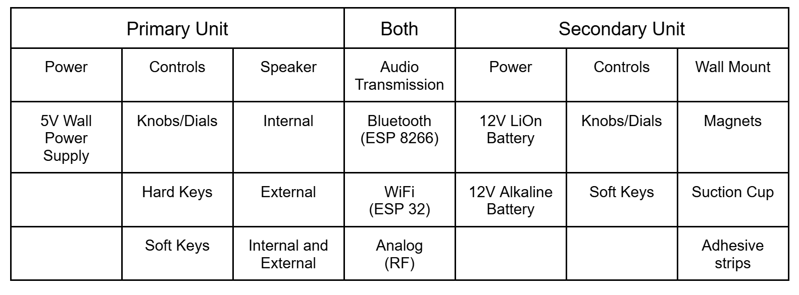

# Appendix C – Individual Pairwise Comparisons

Table VI

Team Decision Matrix

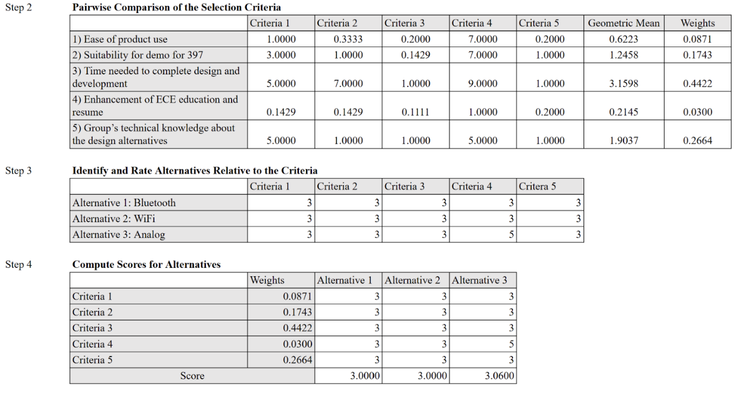

Table VII

Neftaly Lara - Decision Matrix

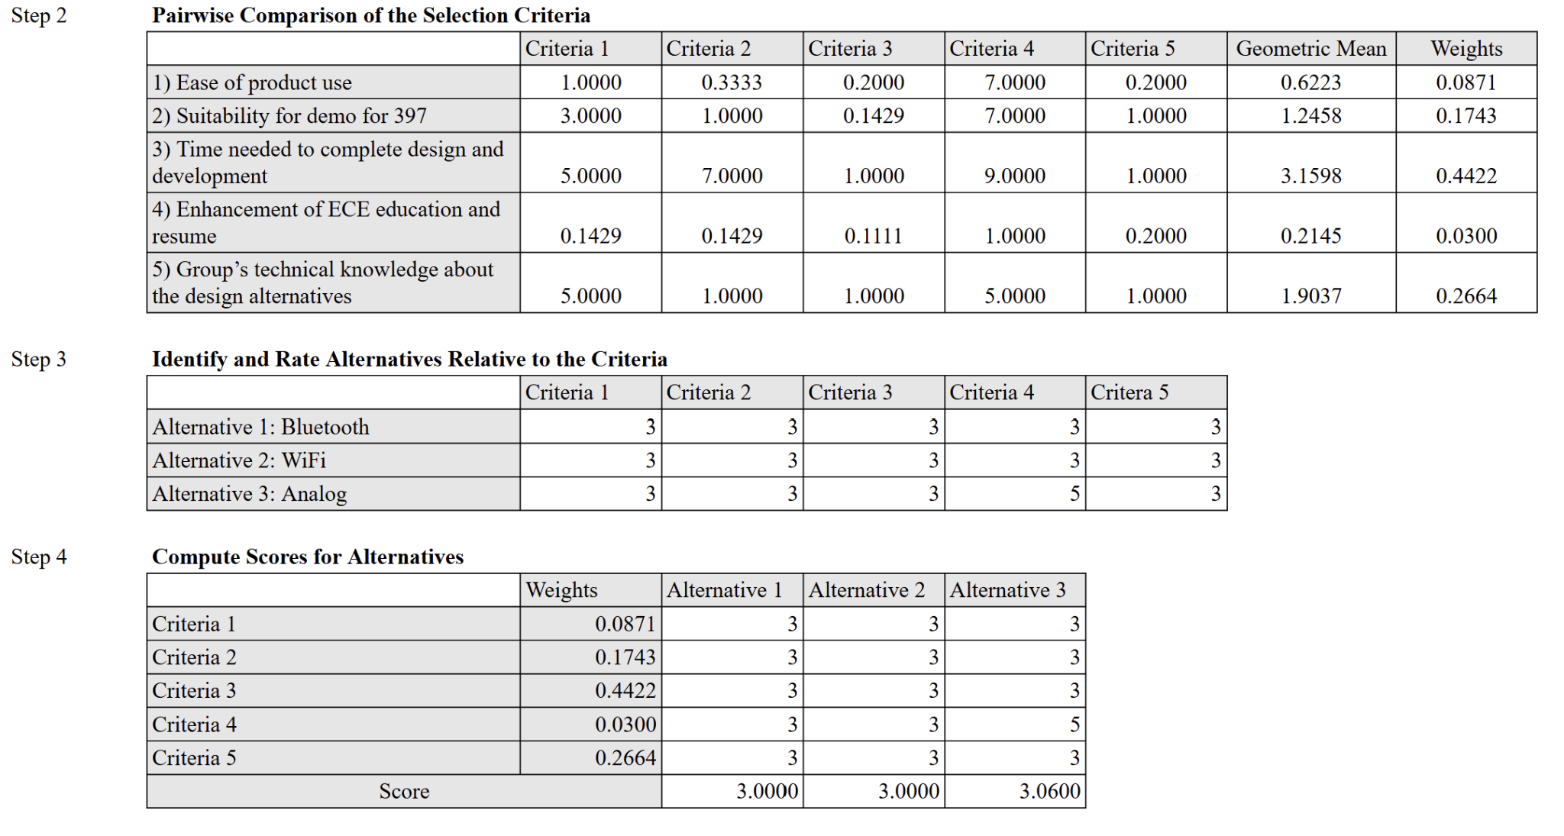

Table VIII

Nikolas Gonzalez - Decision Matrix

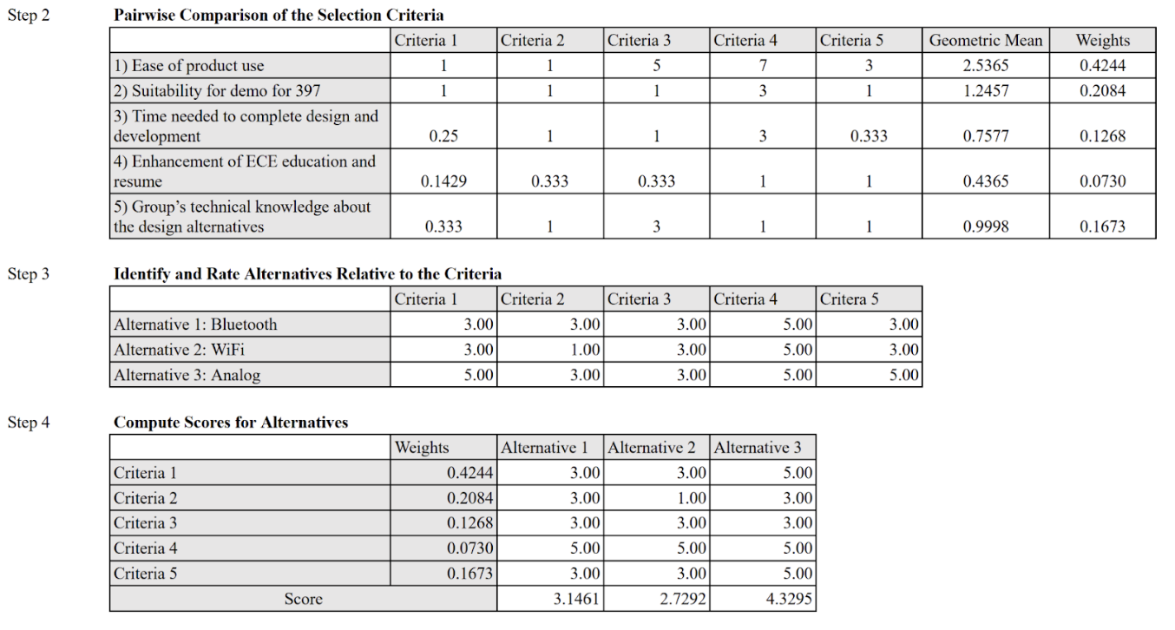

Table IX

Kayla Gardner - Decision Matrix

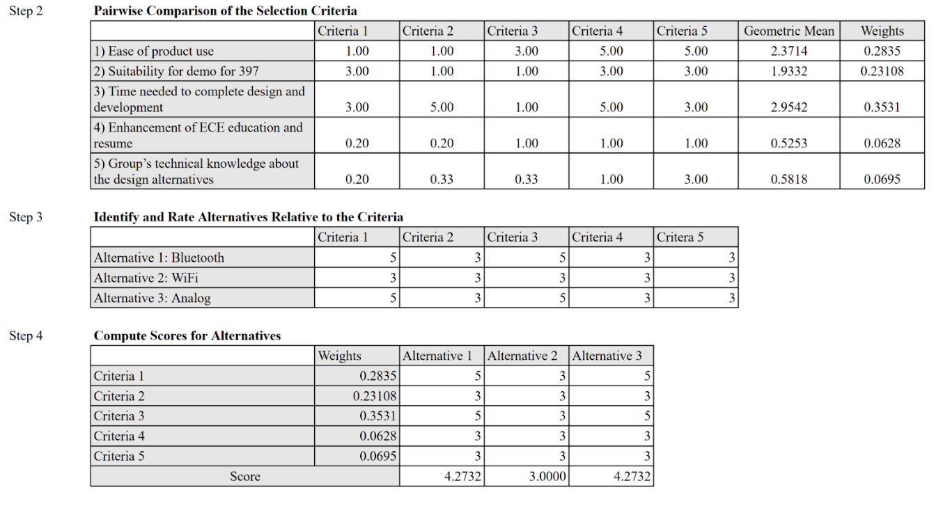

Table X

Moises Loera Martinez - Decision Matrix

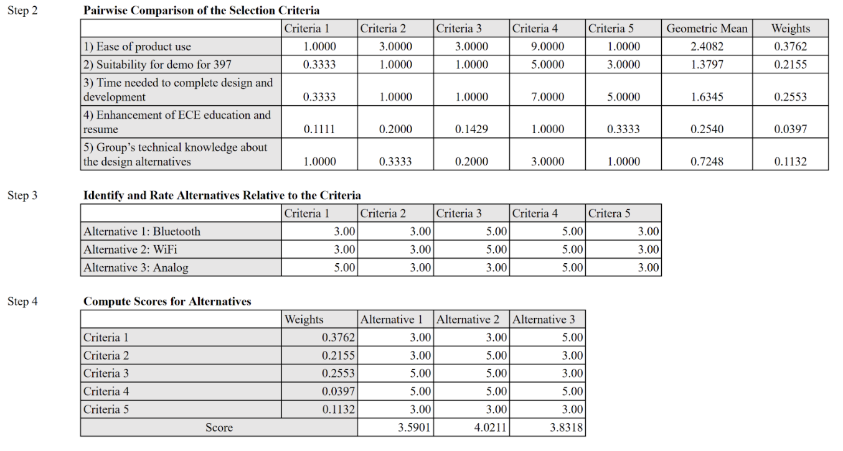

Table XI

Thomas Tran - Decision Matrix

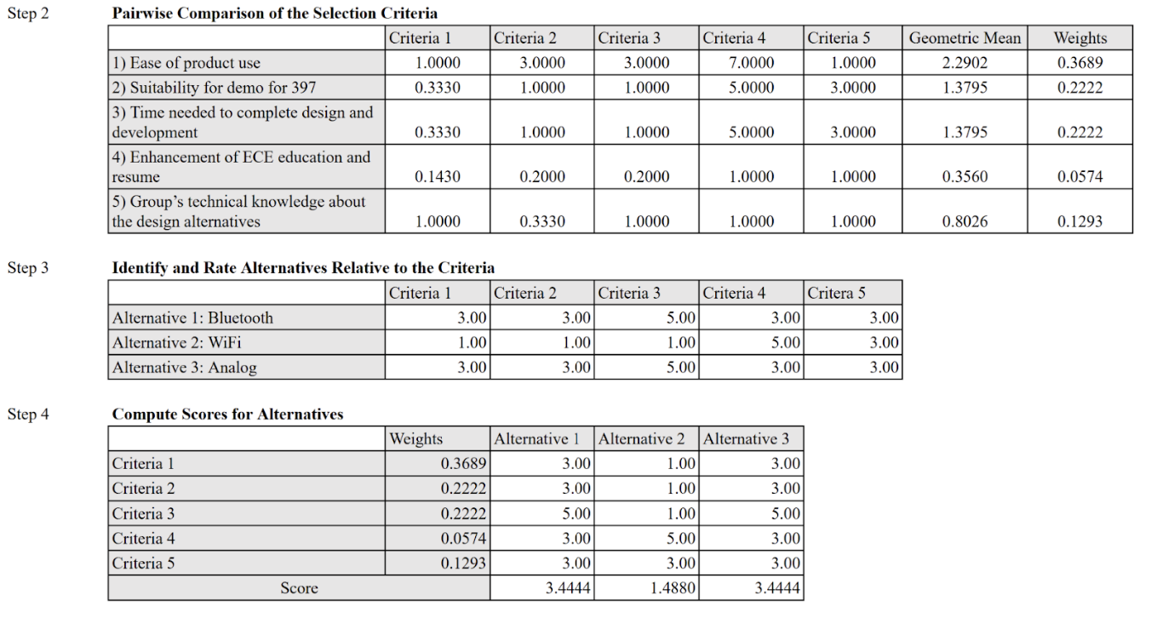

# Appendix D – Datasheets

## Audio Processor

Table XII

ADAU1701 IC Data Sheet

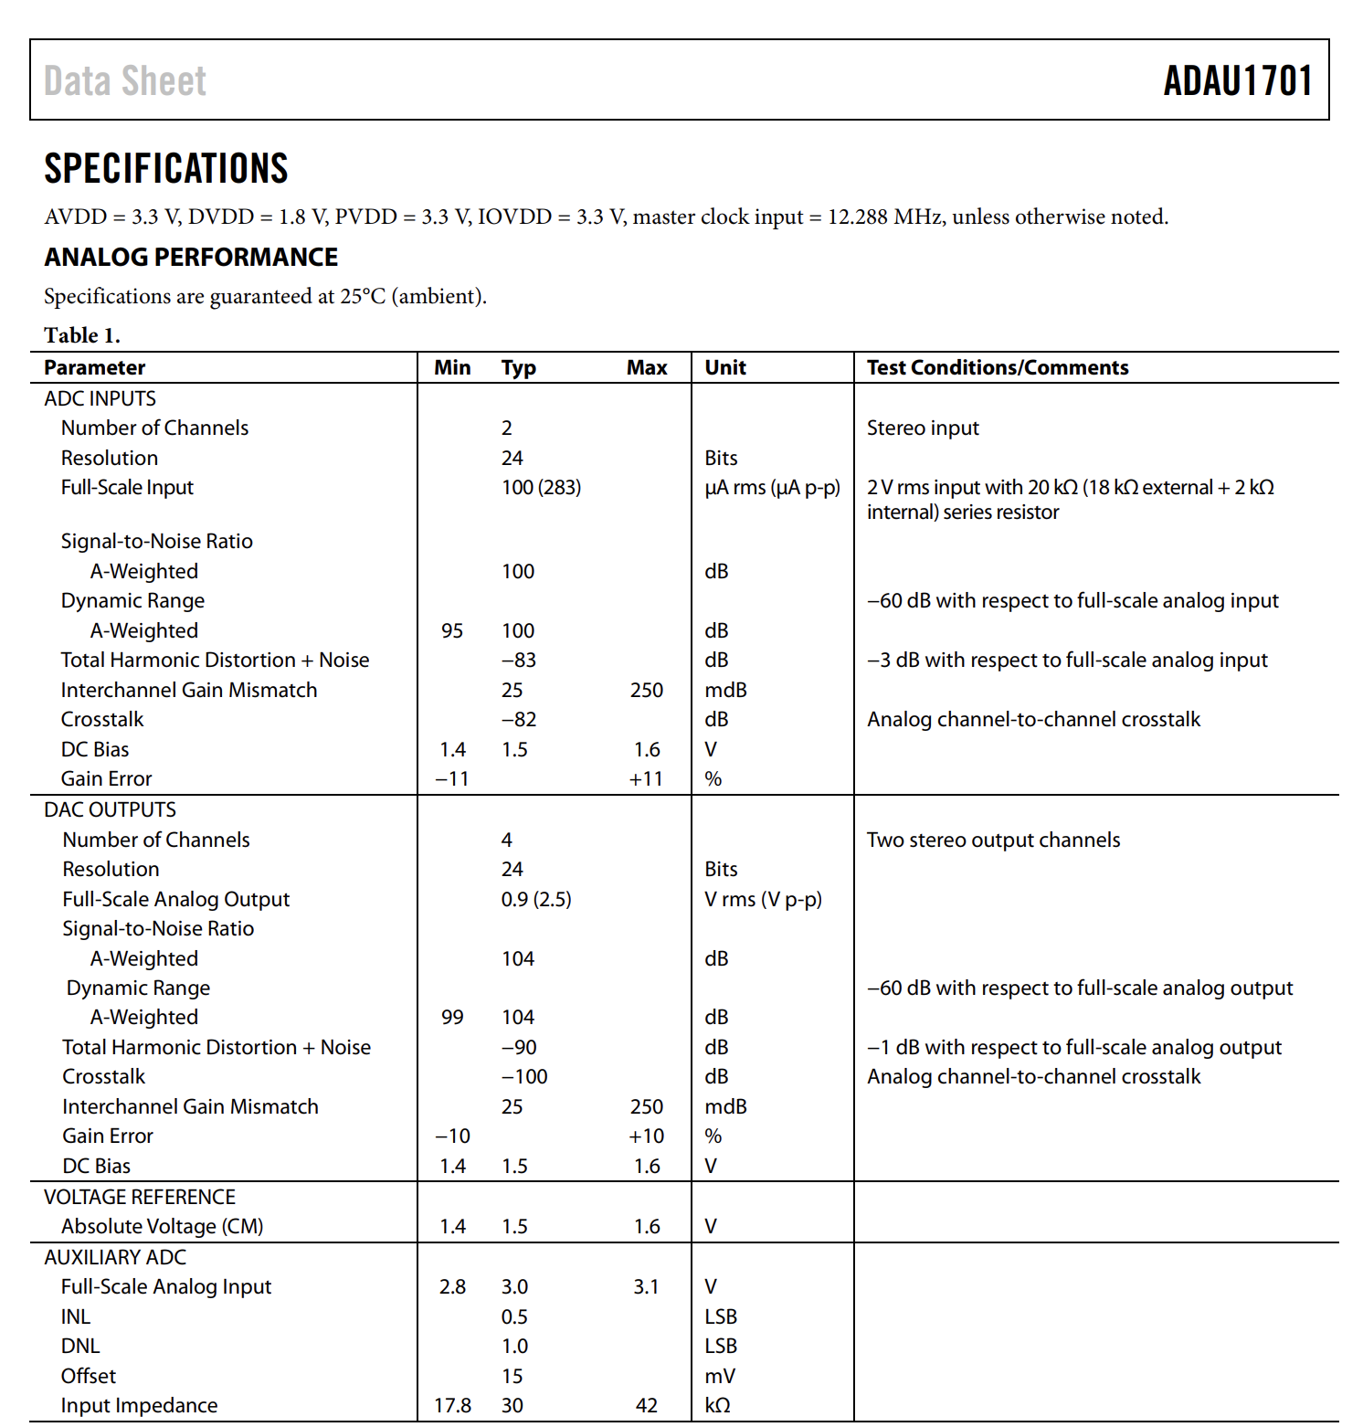

## Speakers

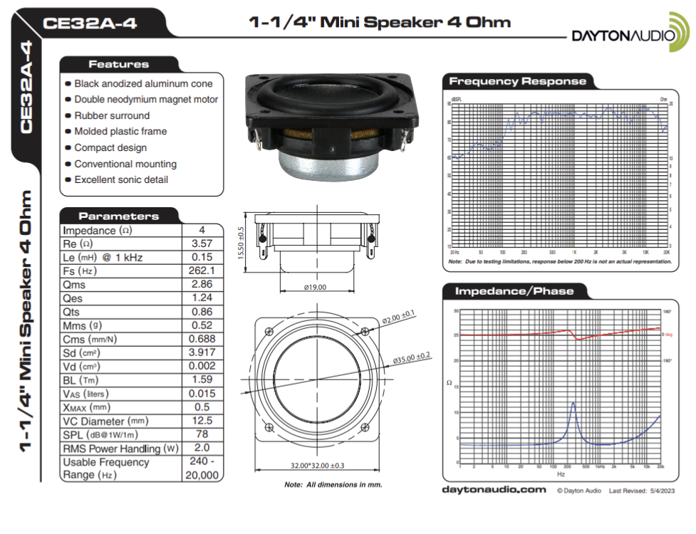

Fig. 4. Speakers Datasheet.

## Amplifier

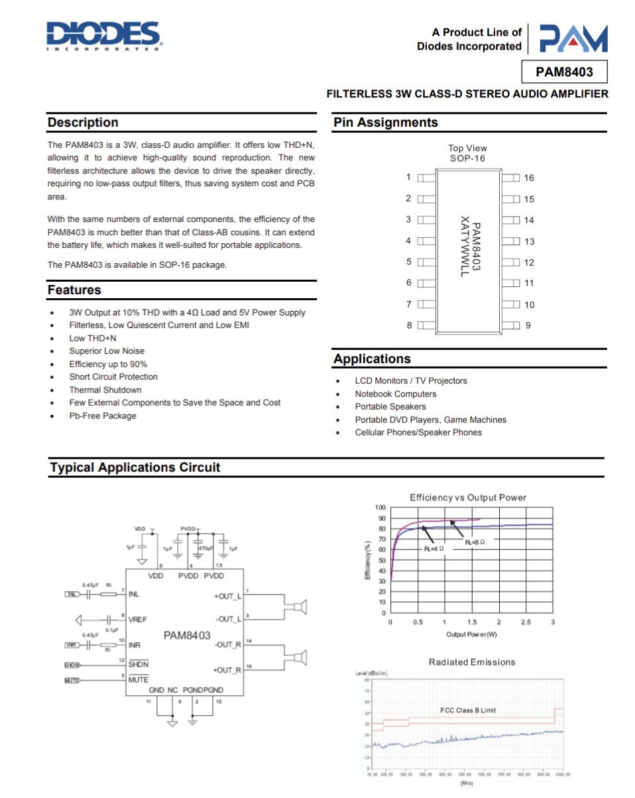

Fig. 5. Amplifier Datasheet.

Table XIII

Amplifier Datasheet

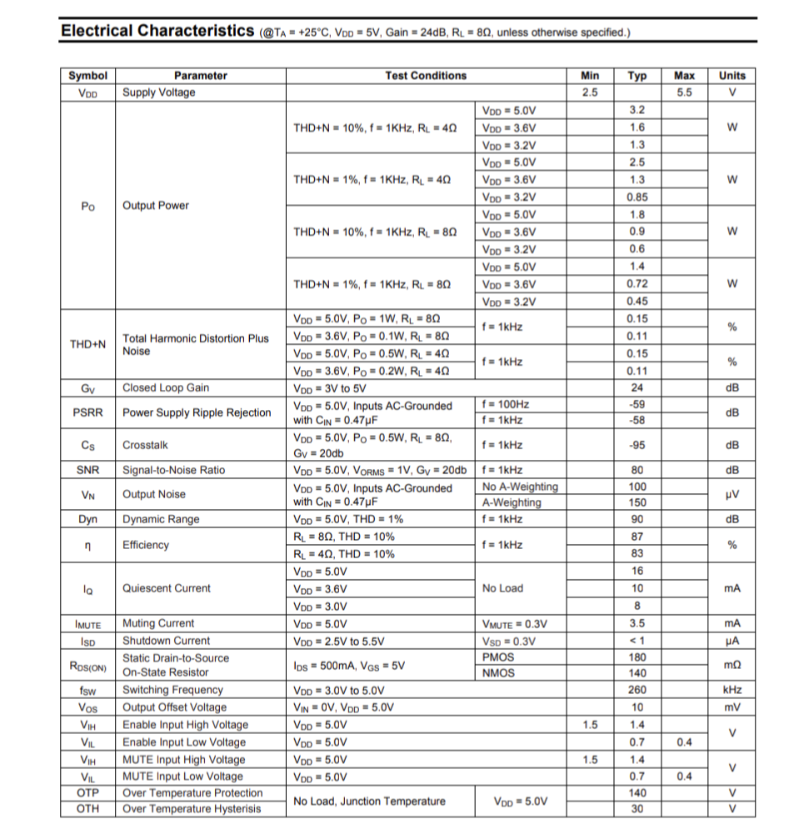

## Antenna

Table XIV

Antenna Datasheet

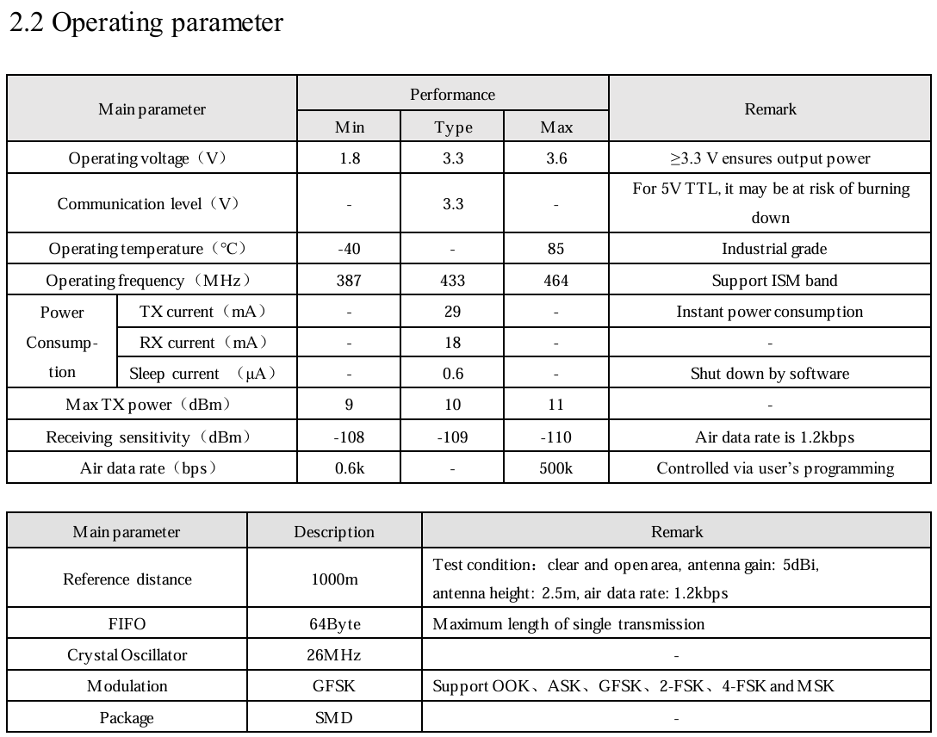

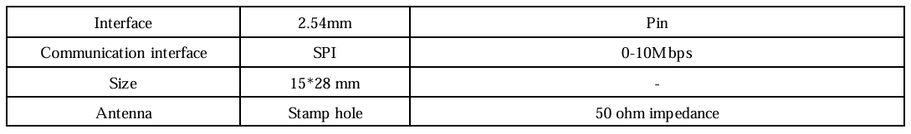

## Microphones

### Gooseneck

Table XV

Gooseneck Microphone Datasheet

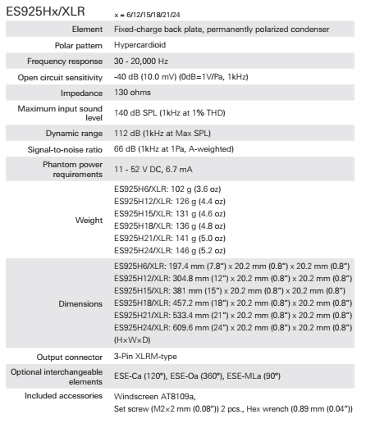

### Electret

Table XVI

Electret Microphone Datasheet

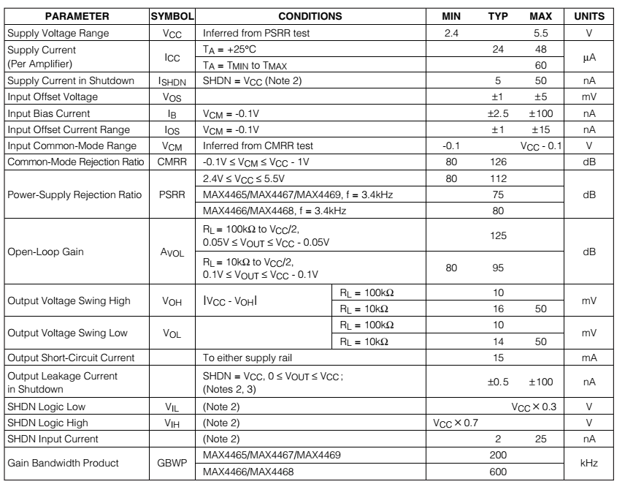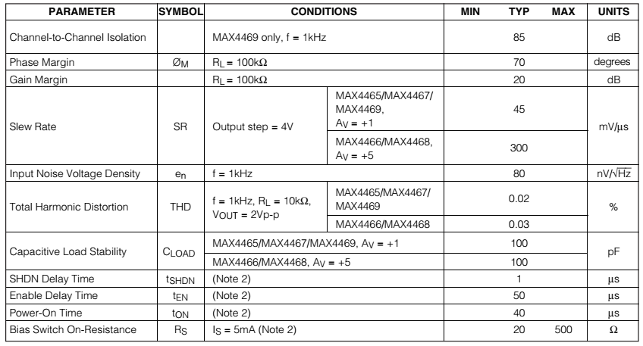

## Battery

Table XVII

Lithium-Ion Polymer Battery Datasheet

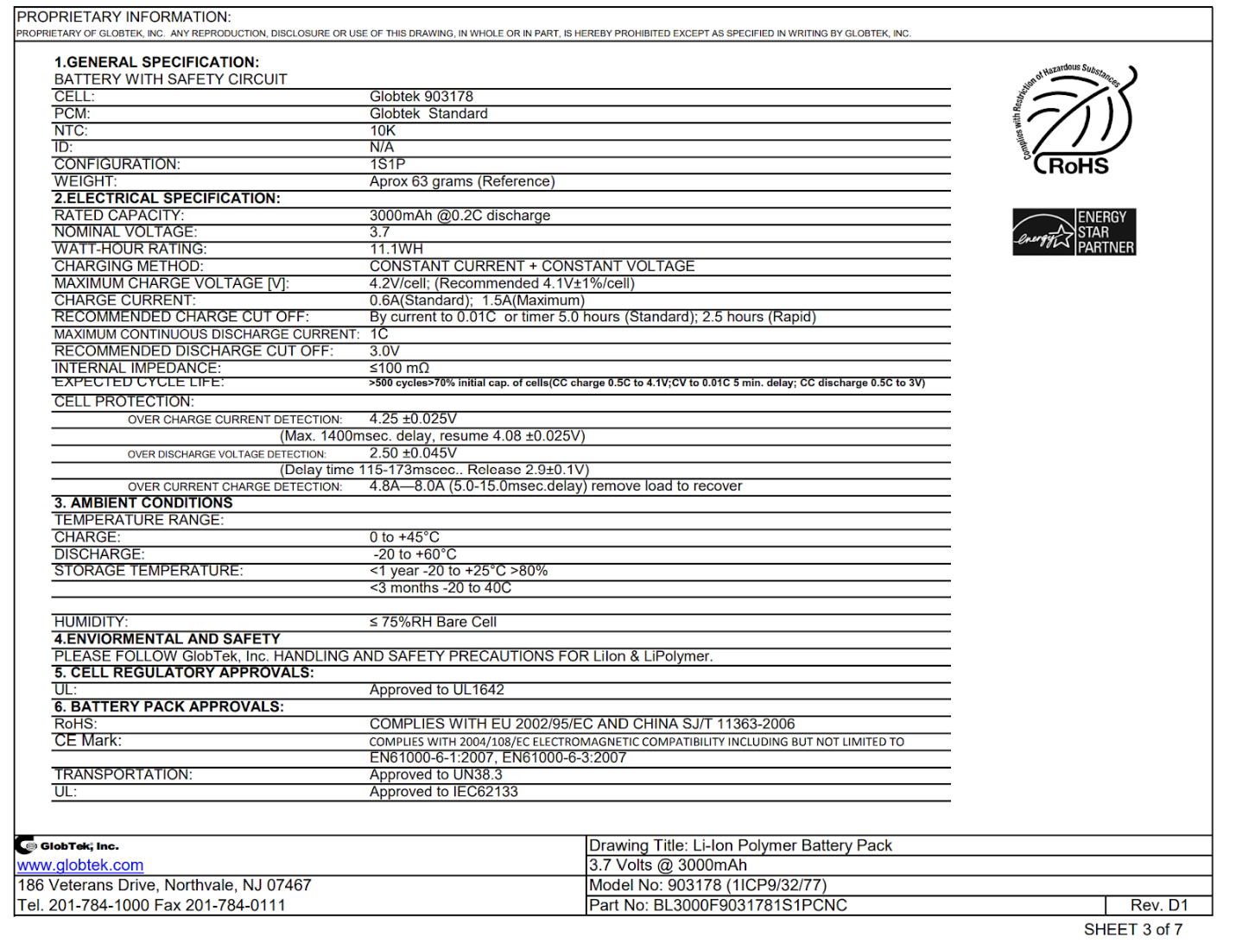

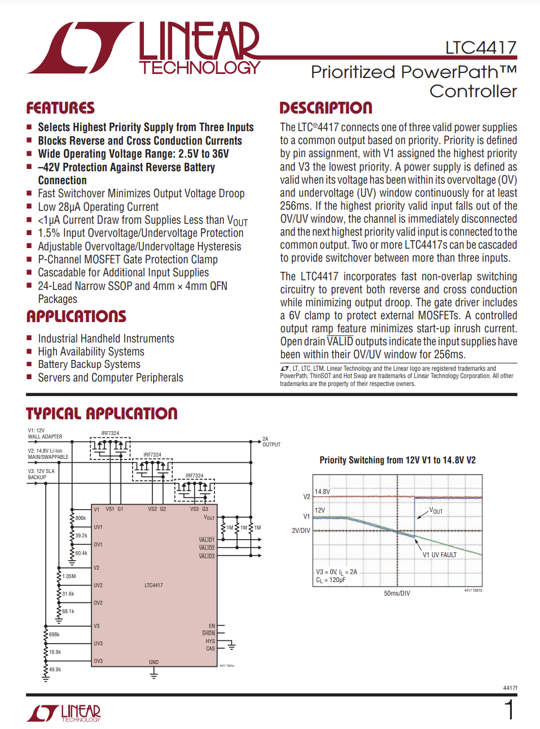

Fig. 6. Power Path Controller Datasheet.

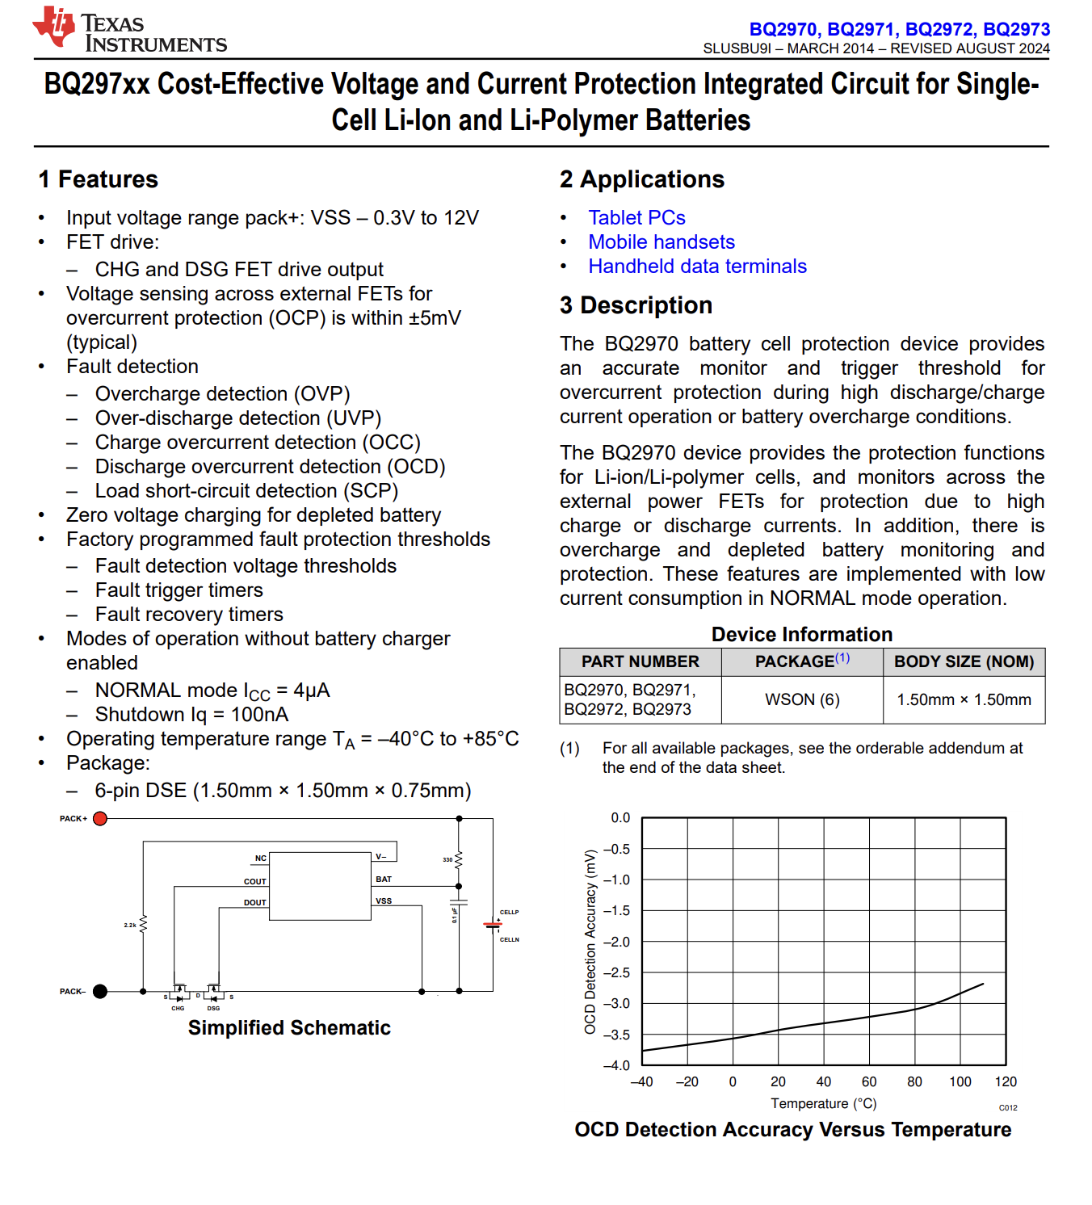Fig. 7. Battery Protection IC Datasheet.

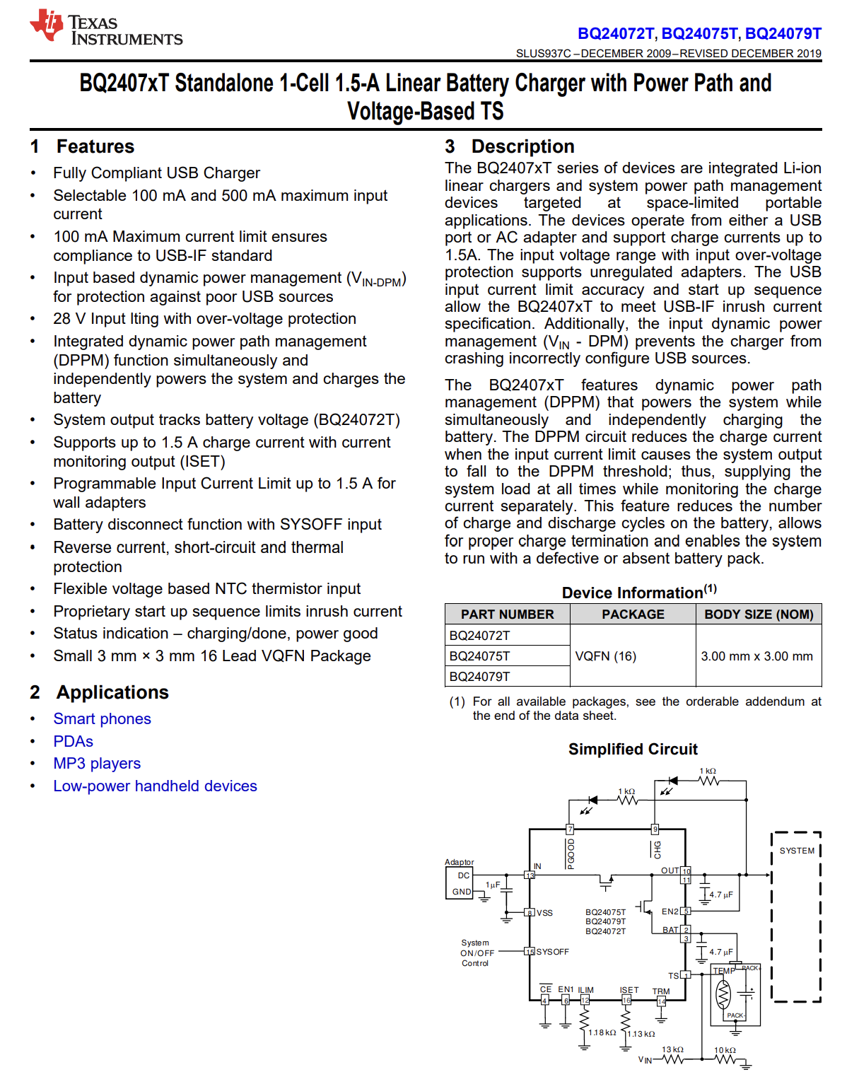

Fig. 8. Battery Charger IC Datasheet.

# Appendix E – Team Task Management Document

The team will allocate weekly tasks fairly (refer to Table IV) to facilitate the development of the system and ensure efficient use of time. All five members will collaboratively manage the team management document, with a weekly rotation of a designated lead to oversee and monitor task progress. Teams are encouraged to come together to complete the Task Management List (TML) collectively. The TML is designed to promote accountability and coordination within the group. It is important to note that teams are advised against assigning the completion of the TML to a single member. Tasks should be clear and specific, as points will be deducted for tasks that lack detail. The tasks need to align with the development of the prototype (for example, a task simply stating "attend a meeting" does not need to be reported). Each task must be achievable within a one-week timeframe; vague or overly broad tasks will result in point deductions. Furthermore, tasks should not be repeated for more than two consecutive weeks, as this may suggest that the task was not feasible within the one-week limit (refer to the previous point). This approach serves as a checkpoint to ensure that all goals are met and that progress is being made.

Table IV

Team Task Management Allocation

|  |  |  |  |  |
| --- | --- | --- | --- | --- |
| Week (Spring 2025) | Team Management Leader | Task Description | Task Deliverable | Assign To |
| Week 2  Jan 19 - 25 | Nikolas Gonzalez | Design the system schematic in Altium Designer (Primary) | Create a mock-up Altium CircuitMaker schematic for Wednesday's meeting with Sandegh (include most if not all components on list with apporpriate substitutions for those that don't have models) | Kayla Gardner |
| Design the system schematic in Altium (Secondary) | Nikolas Gonzalez |
| Housing CAD Design (Primary) | Create a mock-up CAD Design for the housing | Thomas Tran |
| Housing CAD Design (Secondary) | Create a mock-up CAD Design for the housing | Neftaly Lara |
| Update Final Report | Edit last semester's final report given TA Furkan's comments. Reference this report frequently to finalize project documentation (for EXPO, project poster (abstract, title)). | Everyone |
| Senior Design Lab component check | Meet 01/22/25 to inventory which components are available in the senior design lab | Everyone |
| Week 3  Jan 26 – Feb 1 | Kayla Gardner | Design the system schematic in Altium Designer (Primary) | Re-create mock-up schematic from Altium CircuitMaker to Altium Designer (include most if not all components on list with appropriate substitutions for those that don't have models) | Kayla Gardner |
|  | Nikolas Gonzalez |
| Complete Ordering Parts form | Using finalized component list - Team Representative should place order | Moises Loera Martinez |
| Senior Design Component Check | Check lab inventory to determine existing materials needed for project (no additional purchases required) | Everyone |
| Set up bi-weekly schedule for team + Dr. Corey/TAs to meet | Pre-determine dates to meet and discuss project statuses. In-person chamber experimentation with supervision (TA or Dr. Corey) | Everyone |
| Housing CAD Designs (Primary and Secondary) | Present and discuss CAD Designs for the device | Neftaly Lara; Thomas Tran |
| Week 4  Feb 2 - 8 | Neftaly Lara | After Tuesday meetings >> Divide each component (primary schematic) for each person >> Assemble in Altium | Utilize Ordering form to help with Altium Schematics development (reference parts for component placement) | Everyone |
| Transceiver | Moises Loera Martinez |
| Power Path Controller & Converters | Nikolas Gonzalez |
| Audio processor and microcontroller | Thomas Tran |
| Speakers | Neftaly Lara |
| Audio processor and microphones | Kayla Gardner |
| After Tuesday meetings >> Use feedback from team and Dr. Corey to make adjustments to the CAD drafts | Updated CAD for primary shell | Thomas Tran |
| Updated CAD for secondary shell | Neftaly Lara |
| Week 5  Feb 9 - 15 | Moises Loera Martinez | Present and share individual Altium schematics | Present Altium schematics to the team (Monday-Tuesday, 02/10-02/11 meeting). Create space to ask and answer questions | Everyone |
| Compile individual schematics into one file | Work in Senior Design Lab (Tuesday, 02/11) to develop 1 Altium Designer file with all subcomponents present |
| Draft and submit second order form | Order 3 potentiometers, 3.5mm audio connector, momentary switch and find replacements for the RF transceiver and speaker amplifier |
| Week 6  Feb 16 - 22 | Thomas Tran | Altium (DRC) | In Altium, perform a DRC to identify and fix outstanding issues. | Everyone |
| Register for EXPO | EXPO registration required [Team 16] |
| Week 7  Feb 23 – Mar 1 | Nikolas Gonzalez | Makerspace Submissions | A resin and PLA housing prototype for primary device | secondary device | Neftaly Lara/Thomas Tran |
| Schematic Layout [Primary] | Combine Altium schematics into one schematic project utilizing templates to improve professional appearance and readability | Everyone |
| In-Class Presentations: Testing Share | Begin developing testing procedure benchmarks for organization and presentation purposes | Kayla Gardner |
| Validate components | Test components to verify datasheet details | Everyone |
| Research how to switch between frequencies on the transceiver | Code that uses 3 switches to change between 3 different frequencies | Moises Loera Martinez |
| Week 8  Mar 2 - 8 | Kayla Gardner | Book appointment with the writing center to evaluate our EXPO Abstract & Introduction | Abstract that clearly states our motivation, scope/needs, objective, and conclusion | Kayla Gardner |
| PCB Footprints | Create footprints: Audio Processor, Electret Mic, Boost Converter, Battery Charging Module, Power Path Controller, Speaker [already accounted for] | Everyone |
| Rotary Encoder, Potentiometer | Kayla Gardner |
| Transceiver | Moises Loera Martinez |
| Speaker Amplifier | Neftaly Lara |
| Battery Charging Module, USB Type-C Receptacle | Everyone |
| Review PCB Footprints Manager to ensure all components are accounted for. |
| Schematic Layout [Secondary] | Combine Altium schematics into one schematic project utilizing templates to improve professional appearance and readability |
| Week 9  Mar 9 - 15 | Neftaly Lara | In-Class Presentations: Testing Share | Divide speaking portions amongst the team (last 5 minutes) | Everyone |
| Introduction/Type of testing done | Neftaly Lara |
| Include information about subsystems tested | Kayla Gardner |
| Type of connections tested | Thomas Tran |
| Type of parameters applied | Moises Loera Martinez |
| Conclusion | Nikolas Gonzalez |
| EXPO Poster | Submit Project Information on Blackboard (*Abstract*) due March 12th | Kayla Gardner |
| Testing Share | Complete respective testing share sheets for each component to assist with in-lab integration testing | Everyone |
| Microcontroller | Thomas Tran |
| Power | Nikolas Gonzalez |
| Transceiver | Moises Loera Martinez |
| Pre-Amplifier for Microphones | Kayla Gardner |
| Speaker and Headphone Amplifier | Neftaly Lara |
| PCB Manufacturing | Submit a JCLPCB order (Week 10) | Moises Loera Martinez/Nikolas Gonzalez |
| Week 10 Mar 16 - 22 | Moises Loera Martinez | EXPO Handout ~ Meeting with Simona Narubin (03/20) | Decide on information that brochure style document will include (*any detail or graphics that might not have a place on your poster but will enhance judges' ability to understand the depth & scope of work*) due *April 16th. Divide tasks between two members (*utilize Canva platform to construct the document). | Kayla Gardner/Neftaly Lara |
| EXPO Poster Task Assignments [Leader] | Poster Layout / Prototypes / One-Page Handout (Cost Section) | Neftaly Lara |
| Poster Layout / Materials / Engineering Requirements / One-Page Handout (Photos & Formatting) | Kayla Gardner |
| Methodology | Moises Loera Martinez |
| Conclusion | Nikolas Gonzalea |
| Results | Thomas Tran |
|  | Re-Submit Project Information (Abstract) due April 2nd after reviewing BB feedback and making edits (*if applicable)* | Kayla Gardner |
|  | Testing Share | Complete respective testing share sheets for each component to assist with in-lab integration testing and PPT | Everyone |
| Microcontroller | Thomas Tran |
| Power | Nikolas Gonzalez |
| Transceiver | Moises Loera Martinez |
| Pre-Amplifier ~ Microphones | Kayla Gardner |
| Speaker and Headphone Amplifier | Neftaly Lara |
| PCB Manufacturing | Construct individualized PCBs (cost-friendly) to generate 1 JCLPCB order | Everyone |
| EEPROM, Electret mic (w/ pre-amp circuit), Audio Processor | Moises Loera Martinez |
| Gooseneck mic (w/ pre-amplifier circuit), power path controller, headphone amp | Kayla Gardner |
| Audio Amplifier | Nikolas Gonzalez |
| PCB Continuity Check (Week 11) | Ensure electrical continuity exists between pads per our schematic and the only short present are those by design (Primary & Secondary) | Everyone |
| Transceiver | Moises Loera Martinez |
| Speaker and Headphone Amplifier | Neftaly Lara |
| Power Path Controller, Battery Charging Module | Nikolas Gonzalez |
| Microcontroller | Thomas Tran |
| Audio Processor | Kayla Gardner |
| EXPO Equipment | Reach out to Prof. Revelo mentioning the need for power supply via outlet for demonstration>>From A. Flower Teams | Nikolas Gonzalez |
| Week 11 Mar 23 - 29 | Thomas Tran | EXPO Poster | Add remaining written statements [final drafts] to EXPO Poster | Everyone |
| One-Page Handout (Cost & Formatting) / Prototypes (Primary & Secondary Device) | Neftaly Lara |
| Methodology | Moises Loera Martinez |
| Conclusion | Nikolas Gonzalez |
| Abstract & Introduction / One-Page Handout (Photos & Formatting) | Kayla Gardner |
| Results | Thomas Tran |
| EXPO Submission | Re-submit EXPO Abstract after reviewing BB feedback & making edits (April 2nd deadline) | Kayla Gardner |
| PCB Continuity Check | Solder [Primary] & Secondary ~ ICs, passive components, headers pin & remaining purchases | Ensure electrical continuity exists between pads per our schematic and the only short present are those by design (Primary & Secondary) | Divide Souldering PCB portions | Everyone |
| Use PCBs_BOM Excel sheet to curate a purchasing List [passive components] to complete the PCBs | Kayla Gardner |
| Power Path Controller, Battery Charging Module, USB Breakout [headers] | Nikolas Gonzalez |
| Integration testing >> connecting Electret Mic, Speaker, USB Receptacle, Arduino [new] & coding | Thomas Tran |
| Audio Amplifier [Primary] | Moises Loera Martinez |
| Audio Amplifier [Secondary] | Neftaly Lara |
| Week 12 Mar 30 – Apr 5 | Nikolas Gonzalez | EXPO Poster & One-Page Handout [Final Review] | Review drafted EXPO Poster. Look for any misspellings and complete grammar check. | Everyone |
| Review Methodology section | Kayla Gardner |
| Review Conclusion section | Neftaly Lara |
| Review Abstract section | Thomas Tran |
| Review Results | Moises Loera Martinez |
| Review Introduction | Nikolas Gonzalez |
| EXPO One-Page Handout Submission | Submit EXPO Handout (April 15th deadline) via portal | Neftaly Lara |
| EXPO Abstract & Project Title Submission | Submit Abstract & Project Title (due April 9th) via portal | Kayla Gardner |
| PCB Continuity Check | Solder [Primary] & Secondary ~ ICs, passive components | Headphone Amp [IC included] Buttons, Speakers, Power Path Controller, Audio Processor (IC only) & EEPROM (IC only) | Neftaly Lara |
| Audio Processor (passive components) | Moises Loera Martinez |
| In-Class: Final Presentation | Divide speaking portions amongst the team (last 5 minutes) | Everyone |
| Introduction & Project Overview | Moises Loera Martinez |
| Meeting the Need | Nikolas Gonzalez |
| Tested Subsystems | Neftaly Lara |
| Unit Testing | Thomas Tran |
| Prototypes & Remaining Work | Kayla Gardner |
| Week 13  Apr 6 - 12 | Kayla Gardner | EXPO Scientific Poster Submission | Submit EXPO Poster (April 15th deadline) via portal | Kayla Gardner |
| In-Class: Final Presentation | Divide speaking portions amongst the team (last 5 minutes). Practice Session (0/12) | Everyone |
| Introduction & Project Overview | Moises Loera Martinez |
| Meeting the Need | Nikolas Gonzalez |
| Tested Subsystems | Neftaly Lara |
| Unit Testing/Integration Testing | Thomas Tran |
| Prototypes & Remaining Work | Kayla Gardner |
| Week 14 April 13 - 18 | Neftaly Lara | EXPO Preparation | Review EXPO Poster [grammatical errors, formatting discontinuities, etc.] | Everyone |
| Review [Abstract] | Kayla Gardner |
| Review [Methodology] | Moises Loera Martinez |
| Review [Introduction] | Neftaly Lara |
| Review [Results] | Thomas Tran |
| Review [Conclusion] | Nikolas Gonzalez |
| Review [One-Page Handout] | Kayla Gardner |
| Print One-Page Handouts [Need at least 20 copies] | Neftaly Lara |
| Bring power supply for EXPO demonstrations | Nikolas Gonzalez |
| Wrap-Up w/ Prof. Corey [04/15] | Present EXPO Poster & One-Page Handout [EXPO Deliverables] and answer any remaining questions | Everyone |
| Final Advisement meeting ~ present the primary PCB | Nikolas Gonzalez/Kayla Gardner |
| Final Advisement meeting ~ present the secondary PCB | Moises Loera Martinez/Neftaly Lara |
| Present the EXPO Poster & One Page Handout | Kayla Gardner/Neftaly Lara |
| Present microcontroller functionality >> system | Thomas Tran |
| Final Report | Assign task assignments for Final Report | Final Design [System Descriptions, Block Diagrams, Circuit Designs, Features, etc) and how it was improved based on your testing results | Everyone |
| Acknowledgements [solely], Table of Contents [updated], Task Allocation & Timeline, Product Cost Analysis & Budget [BOM], Conclusion [all paragraphs] in section, Lessons Learned & Contribution of Work, Team Task Management Document [Review & Update], Final Design [System Descriptions, Circuit Designs [intro paragraph & improved readability for remaining statements], Acceptance Testing [applied Prof. Renata’s comments & improved readability], Printed Circuit Boards [entirety] | Kayla Gardner |
| Final Design [System Descriptions], Unit Testing, Lessons Learned & Contribution of Work | Moises Loera Martinez |
| Final Design [System Descriptions], Acceptance Testing, Lessons Learned & Contribution of Work | Thomas Tran |
| Final Design [System Descriptions], User Manual [Updated] , Lessons Learned & Contribution of Work | Neftaly Lara |
| Final Design [Circuit Design], Integration Testing, Lessons Learned & Contribution of Work | Nikolas Gonzalez |

# Appendix F - Task Allocation and Timeline

The team will follow a timeline (see Table V) to guide the development of the system and ensure efficient use of time. The work will be divided into five phases: Planning and Design, Altium Layout and Fabrication, PCB Assembly and Testing, Integration and Optimization, Finalization and Engineering Expo Preparation. Each phase will last between 2 to 4 weeks, with specific tasks assigned each week to the team or designated individuals to ensure successful completion.

Table V

Weekly Task Allocation

|  |  |  |  |  |
| --- | --- | --- | --- | --- |
| Phase of Work | Week  (Spring 2025) | Weekly Team Management Leader | Tasks and Deliverables | Team Member(s) |
| Phase 1 – Planning & Design | Week 1  Jan 12 - 18 | N/A | Reconvene as a group from break; Discuss any potential changes to ICs and other components | Everyone |
| Refine system schematic design. |
| Week 2  Jan 19 - 25 | Nikolas Gonzalez | Design the system schematic in Altium Designer (Primary) | Moises Loera Martinez/Nikolas Gonzalez/Kayla Gardner |
| Assign Team Representative for Ordering Forms  Annotate schematics, assign footnotes, and prepare the Bill of Materials. | Moises Loera Martinez |
| Schedule bi-weekly meeting with both Prof. Corey (Faculty Advisor) and Hamideh Alvand (Teacher Assistant) | Everyone |
| Begin CAD models for device housings | Neftaly Lara/Thomas Tran |
| Week 3  Jan 26 – Feb 1 | Kayla Gardner | Finalize Ordering Form | Moises Loera Martinez |
| Assign subsystems to team members:  Audio & Headphone Amplifiers - Neftaly  Audio Processor – Kayla  Microcontroller – Thomas  Power Components – Niko  Transceiver – Moises | Everyone |
| Gather component(s) through Altium Content or SnapEDA integrated libraries, (DSP, power and charging modules, amplifiers, antennas) for Altium Schematics. | Kayla Gardner/Moises Loera Martinez/Nikolas Gonzalez |
| Finalize Elevator Pitch, add to Teams Channel | Everyone |
| Phase 2 –  Altium Layout and Fabrication | Week 4  Feb 2 – Feb 8 | Neftaly Lara | Finalize Altium schematic modules | Moises Loera Martinez/Kayla Gardner/Nikolas Gonzalez |
| Obtain campus locker to store tools and project components | Moises Loera Martinez |
| Verify Ordering Form for submission (next week) | Everyone |
| Week 5  Feb 9 – Feb 15 | Moises Loera Martinez | Plan power routes & account for phantom power capabilities | Nikolas Gonzalez |
| EXPO Registration opens – everyone must register | Everyone |
| Place first Ordering Form via Anthony Flowers | Moises Loera Martinez |
| Assemble individually configured Altium modules into one joint file for the primary device. | Everyone |
| Settle on prototype: low vs high fidelity | Nikolas Gonzalez/Moises Loera Martinez/Neftaly Lara |
| Week 6  Feb 16 – Feb 22 | Thomas Tran | Complete Altium schematic joint configuration | Everyone |
| In-Class: Testing Share Presentations. Assign task items | Everyone |
|  |  | Begin establishing EXPO Poster Layout & Project Title | Kayla Gardner |
| Week 7  Feb 23 – Mar 1 | Nikolas Gonzalez | EXPO Deliverables: Begin written drafts for Abstract & Introduction | Kayla Gardner |
| Confirm EXPO Poster Layout & Project Title | Everyone |
| Create and share GitHub workspace for Microcontroller programming | Thomas Tran |
| UIC Makerspace Initial Submission | Neftaly Lara |
| Phase 3 – PCB Assembly and Testing | Week 8  Mar 2 – Mar 8 | Kayla Gardner | Begin DRC, ERCs on Altium for Schematics to confirm electrical and design validity. | Moises Loera Martinez/Kayla Gardner |
| Verify Altium Footprints and ensure each component has an active and available footprint assignment | Kayla Gardner/Moises Loera Martinez/Nikolas Gonzalez |
| Complete Testing-Share documents for subsystems to assist with in-class: Testing Share Presentation. - Audio & Headphone Amplifiers - Neftaly  - Audio Processor – Kayla  - Microcontroller – Thomas  - Power Components – Niko  - Transceiver – Moises | Everyone |
| Start High-Fidelity Prototype (account for modules going to primary device’s PCBs & device housing; differentiate the secondary device PCBs & device housing. | Everyone |
| Complete premature system PCBs (primary & secondary) design and update remaining schematic changes to reflect respective PCBs. | Kayla Gardner/Moises Loera Martinez |
| Week 9  Mar 9 – Mar 15 | Neftaly Lara | Abstract [First Draft] & Blackboard Submission | Kayla Gardner |
| Assign Poster written tasks:  Introduction & Abstract/Engineering Requirements – Kayla  Conclusion – Nikolas  Methodology - Moises  Prototypes – Neftaly  Results – Thomas | Everyone |
| Assume lead for last-minute Altium schematic changes; in turn, PCB design | Moises Loera Martinez/Nikolas Gonzalez |
| Week 10  Mar 16 – Mar 22 | Moises Loera Martinez | Manufacture individual PCB breakouts for cost effectiveness | Nikolas Gonzalez/Moises Loera Martinez/Kayla Gardner |
| Confirm the surface mount and through-hole PCB components. Verify all components have at least 40V potentiality. | Moises Loera Martinez/ Nikolas Gonzalez/Kayla Gardner |
| Confirm JCL PCB Order Submission (First) | Everyone |
| Week 11  Mar 23 – Mar 29 | Thomas Tran | Perform continuity checks on PCBs | Moises Loera Martinez |
| DigiKey order 5.6 uF & EEPROM replacement, 3 or 4 position conn headers, Diode Schottky, MOSFET P-CH 20V, PNP Silicon Transistor, and 12.288 MHz Crystal Oscillator, Audio Processor ICs | Everyone |
| Amazon Order (56 nF, 47 uF, 10k, and 0.47 uF) | Neftaly Lara |
| Construct One-Page Handout | Kayla Gardner/Neftaly Lara |
| Begin soldering tasks (advanced skill set) | Nikolas Gonzalez/Moises Loera Martinez/Neftaly Lara |
| Continue SigmaStudio Unit and Integral programming; Verify communication between primary and secondary devices. | Thomas Tran |
| Edit Introduction | Kayla Gardner/Neftaly Lara |
| Phase 4 – Integration and Optimization | Week 12  Mar 30 – Apr 5 | Nikolas Gonzalez | Finalize system measurements for last UIC Makerspace submissions | Neftaly Lara |
| Edit Abstract [2nd Draft] | Kayla Gardner /Neftaly Lara/Moises Loera Martinez |
| Place written Introduction into designated EXPO Poster section | Kayla Gardner |
| Place written Methodology into designated EXPO Poster section | Moises Loera Martinez |
| Fabricate graphics for Methodology section | Kayla Gardner |
| Place written Conclusion into designated EXPO section | Kayla Gardner |
| Week 13  Apr 6 – Apr 12 | Kayla Gardner | Complete soldering tasks | Neftaly Lara/Moises Loera Martinez/Nikolas Gonzalez |
| Place written Results into designated EXPO section | Kayla Gardner |
| Submit Project Title & Abstract (Prof. Renata approved) via EXPO Portal | Kayla Gardner |
| Submit Project Document (One-Page Handout) via EXPO Portal | Neftaly Lara |
|  |  | Start fusing PCBs together (Conn headers, wires) | Moises Loera Martinez/Nikolas Gonzalez |
| Week 14  Apr 13 – Apr 19 | Neftaly Lara | Practice & make final edits to presentation | Everyone |
| Submit Final Presentation | Neftaly Lara |
| Assess and continue constructing SigmaStudio programming tasks | Thomas Tran |
| Present work to Prof. Ryan Corey and refine system. | Everyone |
|  |  | Complete PCBs fusing together | Everyone |
| Phase 5 –  Final Testing and Engineering Expo Preparation | Week 15  Apr 20 – Apr 26 | Moises Loera Martinez | Present work to Prof. Ryan Corey and refine system. | Everyone |
| Prototyping Session with Hamideh Alvand (Teacher Assistant) |
|  |  | Final Integration (PCBs and Housing) | Everyone |
|  |  | Conclude Acceptance Testing for project | Everyone |
| Week 16  Apr 26 – May 3 | Thomas Tran | Attend class & start Final Report | Everyone |
| Finish Final Report (submit draft on April |30th) | Everyone |
| Submit Final Report (May 7th deadline) | Neftaly Lara |

# Appendix G – User Manual

## User Manual for AcoustiQ: Acoustic Chamber Intercom

## Table of Contents

1. Introduction
2. System Overview
3. Safety Instructions
4. Component Overview
5. Troubleshooting
6. Maintenance Guide
7. Technical Schematic

### Introduction

AcoustiQ is a communication system that is designed for use in acoustic chamber settings. It is geared towards the needs of researchers and other users conducting experiments in such chambers. The AcoustiQ is composed of two devices: a primary device that is designed to be used outside the chamber and a secondary device that is designed to be used inside the chamber. This guide provides step-by-step guidance on how to set up, operate, and maintain your AcoustiQ appropriately.

### System Overview

**Features**

* Audio digital signal processing (DSP) powered by MAX98357A DAC/Amplifier
  + Filters audio input from secondary to be output on the primary
* Secondary Input: Electret microphone
  + Small and helps achieve secondary’s portability
* Primary Output: 4Ω, 3W speakers
  + Allows user of primary device to hear the input from the secondary device
* Secondary: Powered by lithium-ion battery with a charging module

Table I

Technical Specifications

|  |  |
| --- | --- |
| **Component** | **Specification** |
| DSP | MAX98357A DAC/Amplifier |
| Microphones | MAX4466 (Electret) |
| Speakers | 4Ω, 3W |
| Battery | BL3000F9031781S1PCNC  3.7 V Lithium-Ion Polymer |
| Wireless Module | nRF24L01+  Single-Chip 2.4GHz Transceiver |
| Power Supply | BOB-15100  USB-C 5V |

### Safety Instructions

* **Read before use:** Thoroughly review this manual to understand all operating and safety procedures.
* **Avoid moisture and extremes:** Do not expose AcoustiQ to water, high humidity, or temperatures outside 0 °C to 40 °C.
* **Secure all connections:** Inspect and firmly seat every cable and connector before powering on to prevent shorts or disconnections.
* **Use approved power sources:** Charge and operate the secondary device only with the specified BL3000F9031781S1PCNC Li-ion battery and its designated charging module; use the provided USB-C 5 V supply for the primary unit.
* **Power down for maintenance:** Unplug the USB-C supply and remove the battery before cleaning, inspection, or any maintenance work.

### Components Overview

Here is a brief component overview of AcoustiQ:

* **Primary Device (Fig. 1)**: It is meant to be used outside of the acoustic chamber as an observation station. The user of the primary device can listen to all sounds being picked up by the secondary device. To function, it must be plugged in to a wall power source.
* **Secondary Device (Fig. 2)**: It is meant to be used inside of the acoustic chamber as the “audio monitor.” The user of the secondary device will be able to speak in proximity to the device (in an acoustic chamber no more than 8’x 10’ in size) and have all speech and noise be sent to the primary device for listening. It is portable – to function, it can be plugged in to a wall power source or use the rechargeable battery.

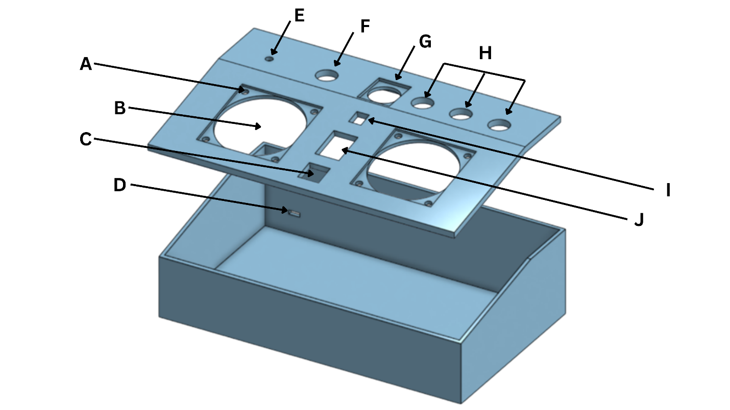

Fig. 1. Primary Device

The primary device casing can be taken apart simply by lifting the lid. To sure, place the lid in place again. The main control panel of the primary device consists of the following (see Fig. 1):

1. **Speaker Screw Hole**: Screw holes for the speakers. M3 sized screws are to be used.
2. **Speaker Hole**: Where speakers are to be placed. Preferably with a speaker mesh on top of each speaker to muffle noise.
3. **(Designed) PTT Button**: Press button to turn on microphone and have captured audio signals to be sent to the secondary device.
4. **USB-C Port**: Where to plug in power cord – automatically powers the device when plugged.
5. **Transceiver**: Where to place the transceiver unit for the primary device. Place the antenna outside and the module inside the casing. Screw the antenna onto the module once in correct position.
6. **(Designed) Power Button**: Press button to turn on device – light around button will be lit. Press button again to turn off device – light around button will be turned off.
7. **(Designed) XLR Hole**: Place XLR port for the gooseneck microphone here. Attach the gooseneck microphone to the XLR port.
8. **(Designed) Channel Buttons**: Each button corresponds to a frequency. Press button until it is lit to choose a channel. Ensure both devices are on the same channel (same button color is lit on both devices).
9. **(Designed) Volume Control**: Adjust the speaker’s output volume. Rotate to the left to decrease and rotate to the right to increase the volume.
10. **(Designed) Mode Switch**: Switch should point towards “OFF” to turn off hot mic and only have PTT mode on. Switch should point towards “ON” to turn on hot mic and turn off PTT mode.

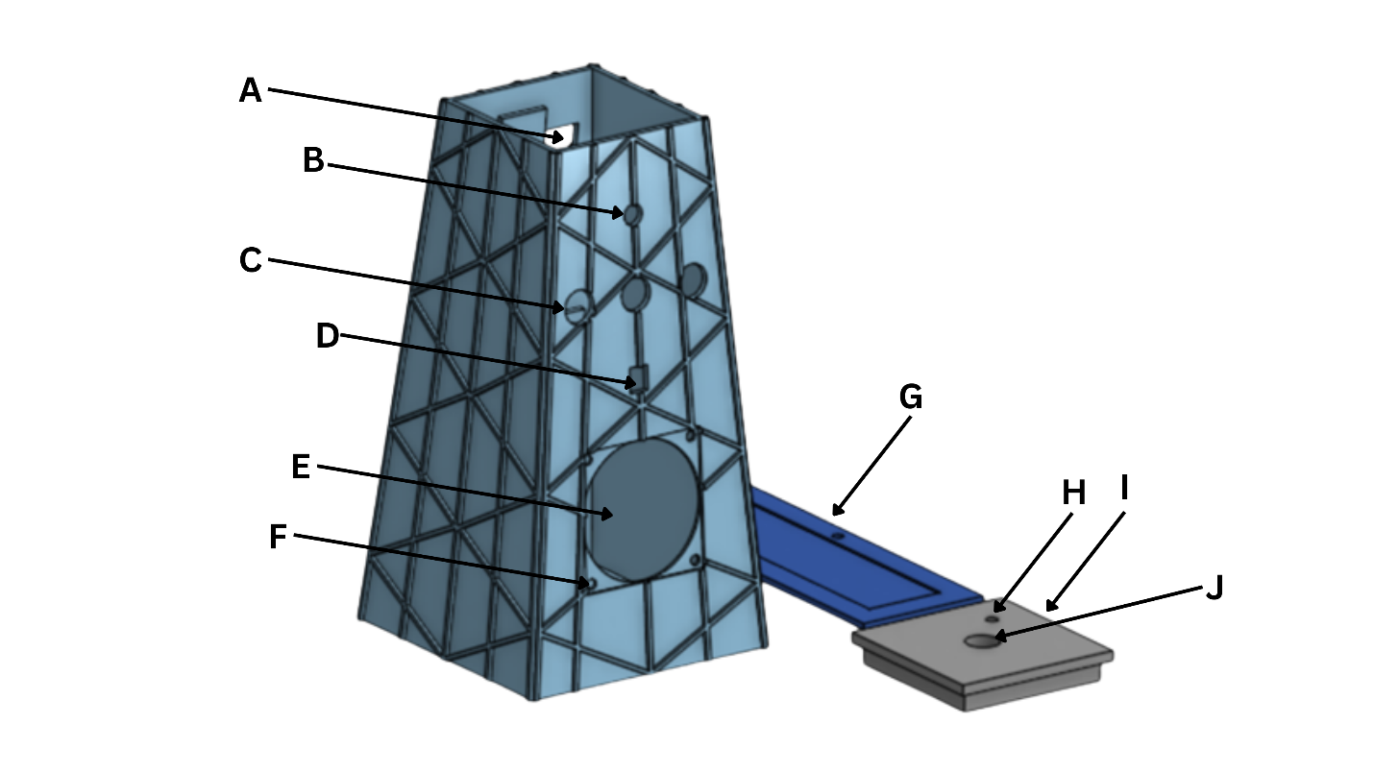

Fig. 2. Secondary Device

The casing of the secondary device can be taken apart by 1) lifting the lid off and 2) by unscrewing the screws attached to the backing on the casing opening. The main control panel of the secondary device consists of the following (see Fig. 2):

1. **Casing Opening**: The hole is meant to ease repairs. There are four slots on each edge of the rectangular opening to help secure the corresponding backing.
2. **Electret Microphone**: Where the Electret microphone is to be placed. It captures audio.
3. **(Designed) Channel Buttons**: Each button corresponds to a frequency. Press button until it is lit to choose a channel. Ensure both devices are on the same channel (same button color is lit on both devices).
4. **(Designed) Volume Control**: Adjust the speaker’s output volume. Rotate to the left to decrease and rotate to the right to increase the volume.
5. **(Designed) Speaker Hole**: Where speakers are to be placed. Preferably with a speaker mesh on top of each speaker to muffle noise.
6. **(Designed) Speaker Screw Hole**: Screw holes for the speakers. M3 sized screws are to be used.
7. **Casing Opening Backing**: Can be secured into the corresponding casing backing with M3 screws.
8. **Transceiver**: Where to place the transceiver unit for the primary device. Place the antenna outside and the module inside the casing. Screw the antenna onto the module once in correct position.
9. **Casing Lid**: Can be lifted to access the inside of the casing and the components. Can be placed back on the top opening to secure.
10. **(Designed) Power Button**: Press button to turn on device – light around button will be lit. Press button again to turn off device – light around button will be turned off.

### Troubleshooting

Problems can occur with this system like any other working electronic device. Table II provides potential problems and solutions to foreseen problems for the users' convenience.

Table II

System Troubleshooting

|  |  |  |
| --- | --- | --- |
| **Problem** | **Possible Cause** | **Solution** |
| **System Startup Failure** | Faulty wall adapter | Verify the wall adapter output with a multimeter. Replace if necessary. |
| Loose power switch or damaged connections | Inspect the power switch and internal connections. Secure any loose wires or ports. |
| Dead or damaged battery | Test the battery voltage. Replace it if below recommended levels. |
| **Microphone Malfunction** | Microphone not properly connected | Check XLR connectors (primary) and wiring (secondary) and ensure proper connection. |
| Faulty Electret or Gooseneck microphone | Replace. |
| Audio processor malfunction | Ensure the MAX98357A DAC/Amplifier is receiving the correct voltage (PVDD, AVDD). |
| **No Sound from Audio System** | Speaker wiring disconnected or damaged | Inspect and reconnect any loose or damaged speaker wires. |
| Amplifier circuit not functioning | Test the amplifier output voltage and replace components as necessary. |
| Audio signal not reaching the speaker | Verify audio signal continuity from the MAX98357A DAC/Amplifier to the speaker. |
| **Audio Output Distortions** | Speaker or microphone grille is dirty | Clean the speaker and microphone grilles with a soft cloth. |
| Amplifier or speaker is damaged | Test with a replacement speaker or amplifier. |
| Interference in the audio path | Check grounding connections and remove nearby sources of EMI. |
| **Addressing Limited Communication Range** | Faulty or damaged antenna | Inspect the antenna for physical damage and replace it if needed. |
| Transceiver module malfunction | Verify nRF24L01+ transceiver connections and replace them if unresponsive. |
| Incorrect frequency settings | Ensure the frequency changer is set to a compatible channel. |
| **Push-to-Talk (PTT) Button Malfunction** | PTT switch connection is loose or damaged | Test continuity of the PTT switch circuit and secure or replace it as needed. |
| LED indicator not functioning | Replace the LED if it does not light up when pressed. |
| **Intercom System Overheating** | Prolonged use of the boost or buck converter | Allow the system to cool and inspect heat dissipation areas for blockage. |
| Faulty battery or power regulation circuits | Test battery and converter output voltages for stability. |
| **Resolving Connectivity Problems in Wireless System** | Unstable power supply | Check for consistent 5V input from the wall adapter. Replace if intermittent. |
| Faulty transceiver or antenna | Inspect connections and replace faulty components. |
| **Volume Buttons Malfunction** | Loose or damaged button connections | Verify button contacts and re-solder or replace if necessary. |
| Processor not detecting volume commands | Check the signal path from the volume dial to the processor. |
| **Slow System Response** | Insufficient power supply | Verify all power sources and connections for stability. |
| Poor grounding in audio circuits | Ensure proper grounding and eliminate ground loops. |
| **Resolving Audio Distortion: Static and Noise Issues** | Damaged microphone or audio input components | Test and replace the microphone if static persists. |
| Interference from external devices | Remove or shield the system from nearby wireless devices. |

### Maintenance Guide for Acoustic Chamber Intercom

Regular maintenance ensures the longevity and performance of AcoustiQ. Follow these guidelines:

### 1. General Precautions

* Ensure the system is powered off and disconnected from the power source before performing any maintenance tasks.
* Use antistatic wrist straps when handling internal components to avoid static discharge damage.
* Store the device in a cool, dry place when not in use for a prolonged time to prevent damage from humidity or overheating.

### 2. Battery Maintenance

#### Components Involved:

* Lithium-Ion Battery (3.7V)
* Lithium Battery Charger (TP4056)

**Steps:**

1. **Battery Inspection**:
   * Check the battery for swelling or leaks every 3–6 months.
   * Replace the battery immediately if any damage is observed.
2. **Battery Charging Circuit**:
   * Verify that the wall adapter supplies a stable 5V output to the charger circuit.
   * Inspect the wiring and connections between the charger and the battery for any signs of wear or damage.
3. **Performance Testing**:
   * Monitor battery life during operation. Reduced runtime may indicate the need for replacement.

### 3. Audio System Maintenance

#### Components Involved:

* Electret Microphone
* Gooseneck Microphone (via XLR Port)
* Speaker and Amplifier (4Ω, 3W, PAM8406DR)
* Audio Processor (MAX98357A DAC/Amplifier)

**Steps:**

1. **Microphones**:
   * Clean the microphone ports with a soft, dry cloth.
   * Test microphone functionality by initiating a call and ensuring clear audio output.
   * Inspect the wiring and connectors for corrosion or loose connections.
2. **Speaker**:
   * Check the speaker for any distortion or reduced audio clarity. Clean the speaker grille if necessary.
   * Inspect the amplifier circuit for proper connections and voltage supply.
3. **Audio Processor**:
   * Ensure the MAX98357A DAC/Amplifier receives the correct voltage (PVDD, AVDD, IVDD).
   * Verify signal pathways from microphones and speakers to the processor for interference.

### 4. Communication System Maintenance

#### Components Involved:

* Transceiver and Antenna (nRF24L01+)

**Steps:**

1. **Transceiver**:
   * Inspect the nRF24L01+ module connections for wear or loose solder joints.
   * Test the communication range to ensure it meets the design specifications.
2. **Antenna**:
   * Check for physical damage or corrosion on the antenna.
   * Ensure the antenna is securely connected to the transceiver and not obstructed.

### 5. Power Supply Maintenance

#### Components Involved:

* Wall Adapter (5V)
* Boost Converter (3.3V to 12V)

**Steps:**

1. **Wall Adapter**:
   * Confirm that the wall adapter provides a stable 5V output.
   * Inspect the adapter plug and cable for damage.
2. **Converters**:
   * Use a multimeter to check the output voltages of the buck and boost converters.
   * Ensure proper heat dissipation by keeping the area around the converters free of dust.

### 6. Push-to-Talk (PTT) Switch (Designed)

#### Components Involved:

* PTT Switch with LED

**Steps:**

1. Verify the switch mechanism operates smoothly without sticking.
2. Check the LED functionality and replace it if it no longer lights up.
3. Inspect the wiring for continuity and secure connections.

### 8. Cleaning Guidelines

* Use compressed air to remove dust from internal and external components.
* Avoid using water or liquid cleaners on internal parts. For external parts, use a damp, lint-free cloth.

### Technical Schematics

This section aims to inform the user of the technical aspects of the communication system. The technical schematic (see Fig. 3) gives the complete overview, and the subsequent figures (Fig. 4, 5, and 6) provide a closer look at each section of the system. Fig. 7 is an overall schematic of the designed AcoustiQ.

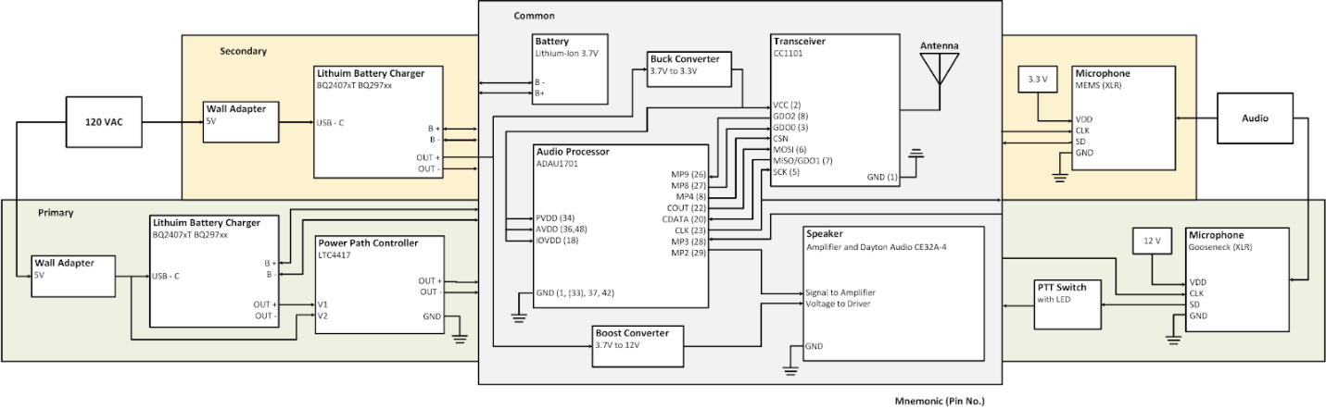Fig. 3. Technical Schematic of System

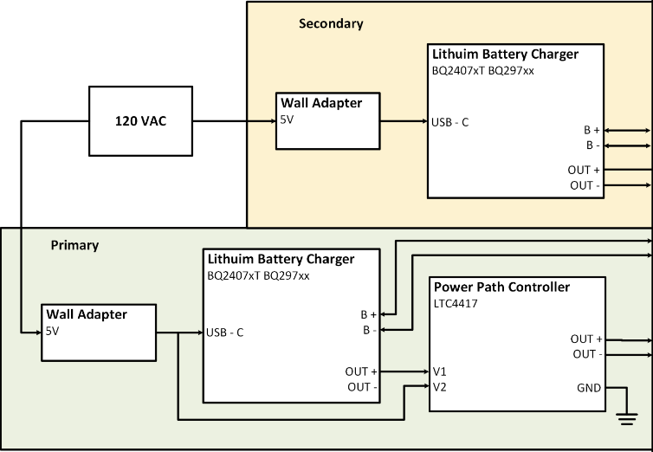

Fig. 4. Power Delivery Subsystem, for Primary (green) and Secondary (yellow) Devices

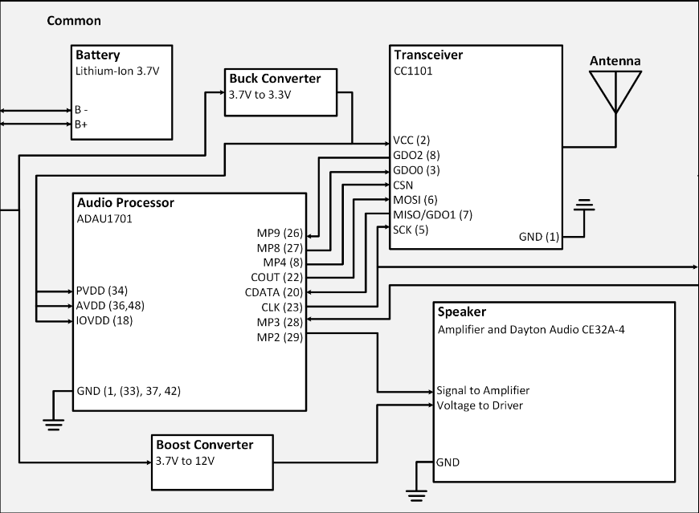

Fig. 5. Section of circuitry common to both primary and secondary devices. The battery leads to the power delivery section of the schematic.

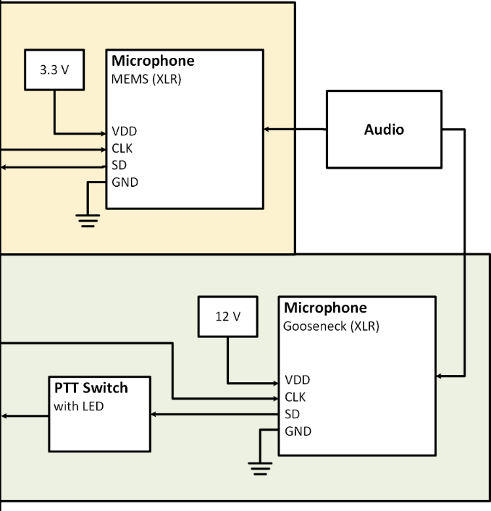

Fig. 6. Audio-Receiving Devices Subsystems for Primary (green) and Secondary (yellow) Devices. Power to the microphone in the secondary device is received from the buck converter on Fig. 4.

Fig. 7. Primary Device Designed Complete Schematic



Fig. 8. Secondary Device Designed Complete Schematic